Pumpkins Vs. Bindweed
Brooke Nicholson – Chinook High School (Junior)
Daughter of Dick and Nellie Jo Nicholson
2014

A common problem for organic farmers is the control of bindweed without the use of chemicals. Bindweed spreads extremely easily and can cause massive destruction of crops. Research is being conducted on controlling bindweed; pumpkins are part of that research. This summer I planted three plots of pumpkins to see their effect on bind weed.
I have compiled my data and it has shown the pluses and minuses of my research. One of the pluses is that I do think pumpkins could have an effect on bindweed, if done in the right manner. The pumpkins were planted too late in the spring and didn't have the opportunity to grow larger. Some research I have done on bindweed shows that shade or lack of sunlight will kill bindweed. If we can get the pumpkins larger earlier, there would be more effect on the bindweed.
This is my first time doing a research project and I have learned a lot. There are many things I need to improve on and plan on improving this next year. First, I want to plant the pumpkins earlier and on smaller test plots or more pumpkins on a larger test plot. Second, as for records, as I sat down to prepare this, I notice things missing in my data or things I should have added. Also I need to be more consistent in my data. You can see the dates I checked my pumpkins are awfully sporadic and sometimes longer than two weeks. Third, is recording the weather better, because it plays a huge part in the pumpkin’s progress. Lastly, I need better pictures so that more people can see what I see. Through these technical changes, along with trying another direction at the pumpkins, will give us more meaningful results.
The data showed different things that need to be taken in account. The first plot was hoed by hand while the other two plots were rototilled. I believe this played a part in how much moisture was in the ground. Extra foliage around the pumpkins helped protect them from the hail and rain. Plot One recovered very quickly, while Plot Three, which had no foliage, barely recovered. I think planting the pumpkins closer would show more effect then farther apart.
As of now the pumpkins didn't have any effect on the bindweed, but we will be able to tell more next spring. Next spring I would like to use my leftover pumpkin seeds to modify my approach and try it again. Like I was saying earlier the pumpkins need to be bigger to shade out the bindweed. I have talked to my FFA Advisor and he is willing to let me use part of the school greenhouse. My plan is to start growing the pumpkins early, so there is a better chance of catching the bindweed early on. Also I would like to add watering to the pumpkins when there are dry spells. I realize this is not going to work for a huge growth of bindweed. But it would show us if pumpkins actually had an effect.
Thank you for giving me this opportunity for learning and to help the organic community. I would also like to thank Hinebauch Grain Inc. for letting me use their land for my test plots. I hope my research will be of help to you, if there are any suggestions as to how to improve please contact me.

Plot One
6/10/14
Spaced-1 seed per 2"
Soil Type- loam clay
Soil Temp- 65 F
Soil Moisture- 2
Weed Density (2' by 2' plot) - 21plants
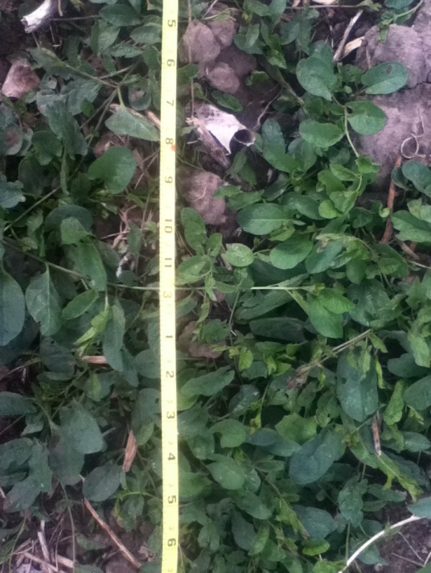
Weather Conditions- 60 F, sprinkles of rain
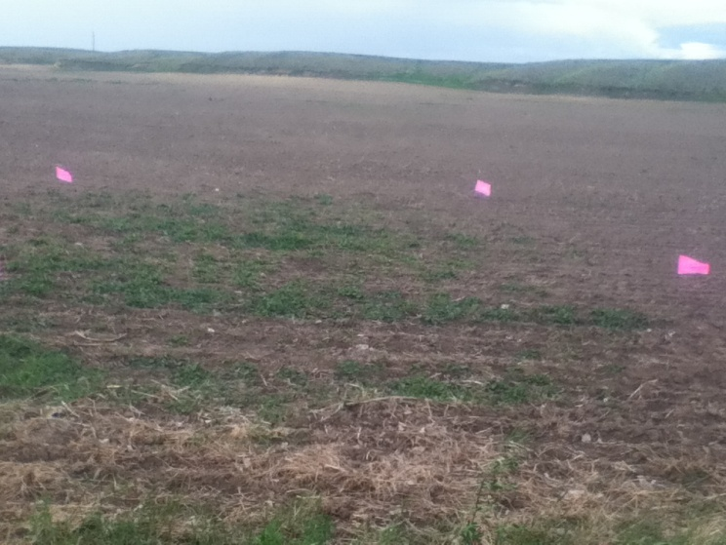

Before Being Hoed Weed Density
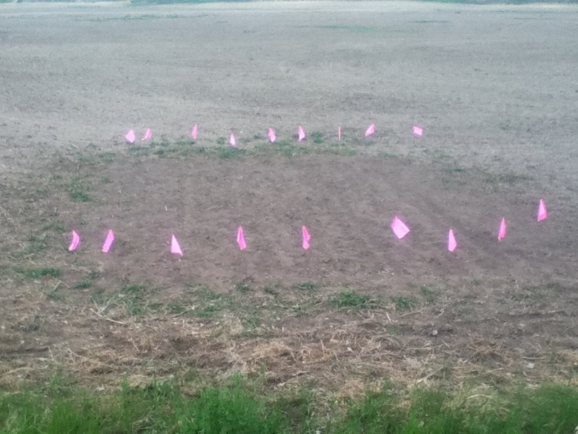
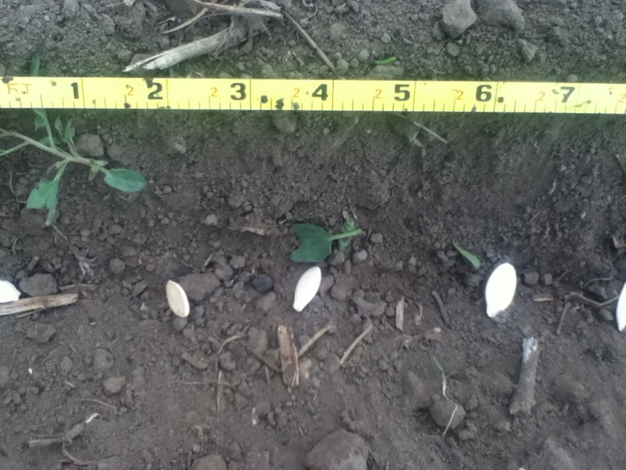

1 seed per 2"
Finished Product

7/8/14
The pumpkins had a slight yellow color, they were taller than the other plots. The ground was very packed and had many other weeds, other than bind weed.
Howden's Field Pumpkin-5.5"
Connecticut Field Pumpkin-7.5"
Golden Hubbard Winter Squash Heirloom-6"
Weed Density- Uncountable

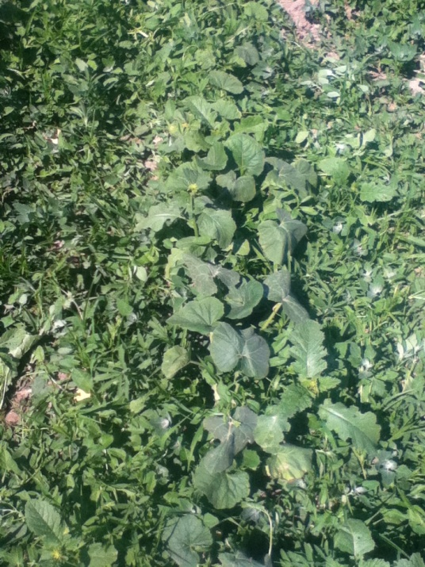
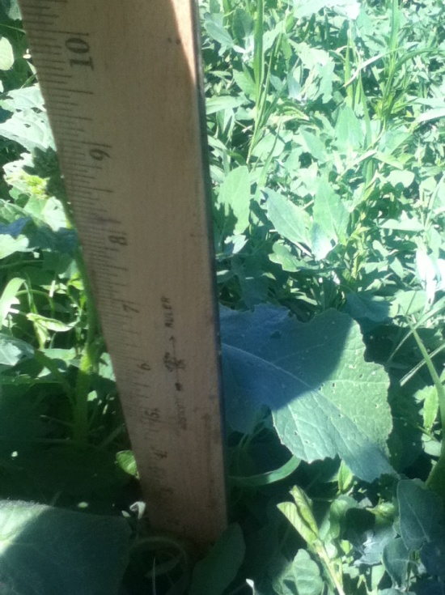

Squash

7/14/14
Got hit by hail and many of the pumpkins suffered. I measured the tallest and healthy looking pumpkin left. There is very little bind weed present, but part of that might be the hail.
Howden's Field Pumpkin-5"
Connecticut Field Pumpkin-6"
Golden Hubbard Winter Squash Heirloom-6"
Weed Density- Bind weed dead, but other weeds still standing. Compared to the other plots, this plot had more plants which protected the pumpkins from the hail.
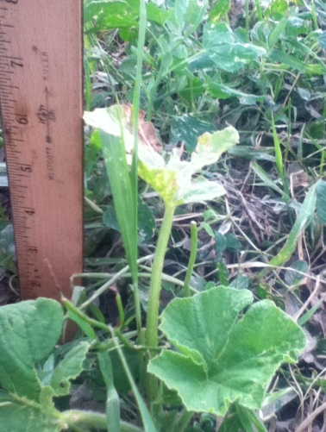
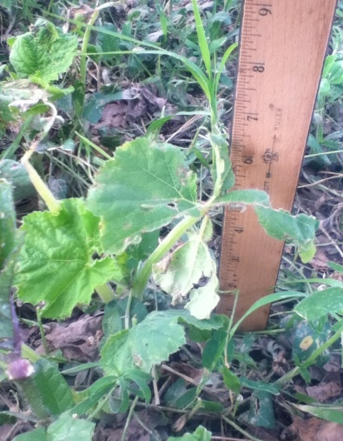
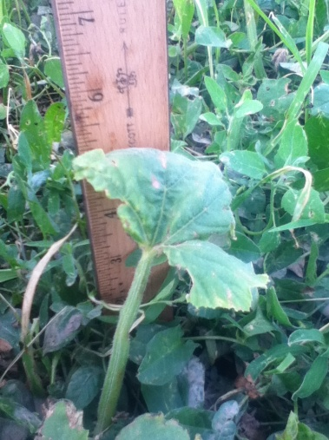

Howden's Field Pumpkin Connecticut Field Pumpkin Golden Hubbard Squash
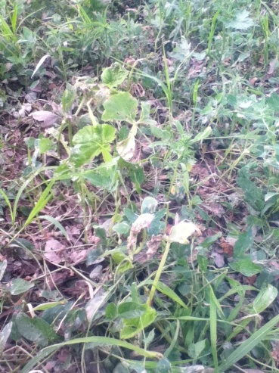
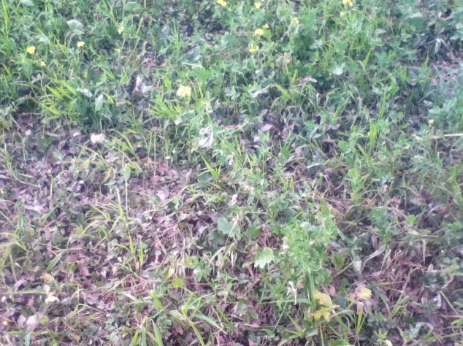

Damage from hail Damage from hail

7/30/14
Many of the pumpkins made a recovery and are continuing to grow.
Howden's Field Pumpkin-10"
Connecticut Field Pumpkin-11"
Golden Hubbard Winter Squash Heirloom- Close to 9"
Lots of other foliage, but little bind weed.

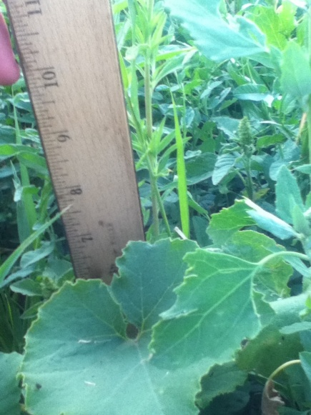
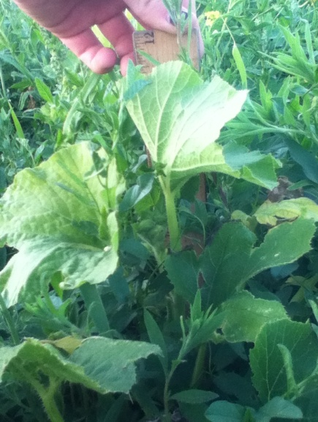
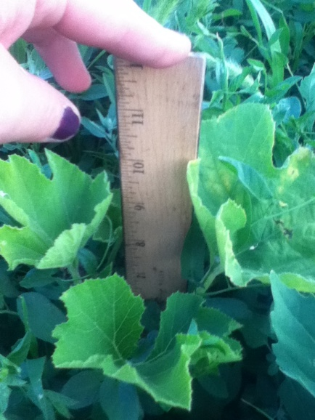

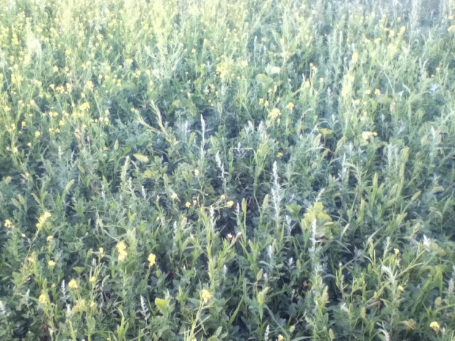
Howden's Field Pumpkin Connecticut Field Pumpkin Golden Hubbard Squash
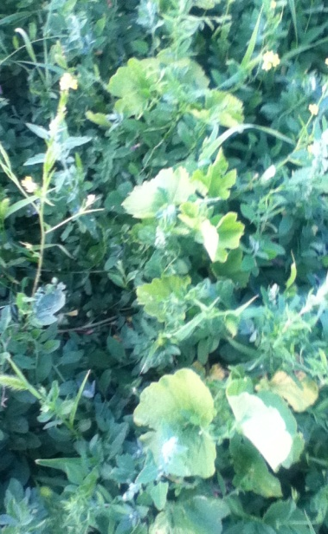

Other foliage

8/11/14
The weather has been extremely hot and dry.
Howden's Field Pumpkin-14"
Connecticut Field Pumpkin-18"
Golden Hubbard Winter Squash Heirloom- 9"
Bind weed has appeared

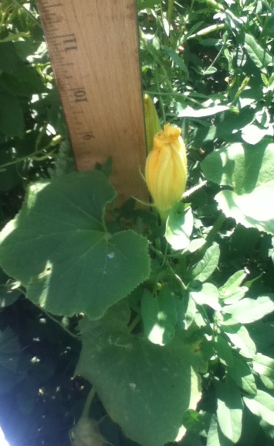
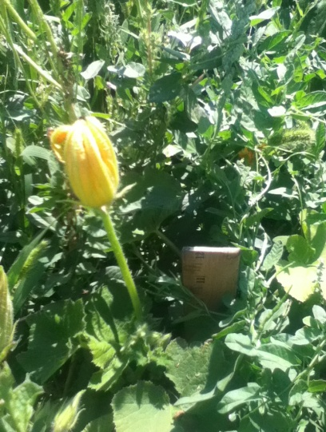
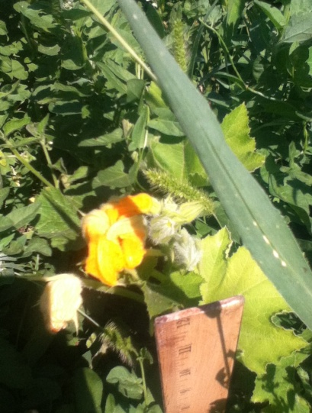

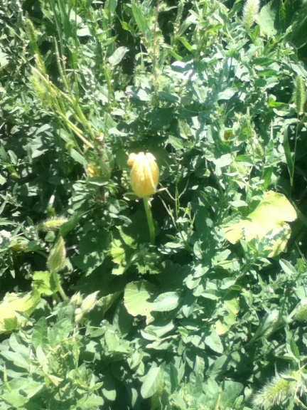
Howden's Field Pumpkin Connecticut Field Pumpkin Golden Hubbard Winter Squash

9/13/14
The last week of August we received close to 6" of rain. Then we received frost around September 10th and it stay for about 3 days, most all of the pumpkins died.
Howden's Field Pumpkin-18"
Connecticut Field Pumpkin-12"
Golden Hubbard Winter Squash Heirloom-10"
Weed Density- The frost killed off the bind weed, it turn black like the pumpkins.
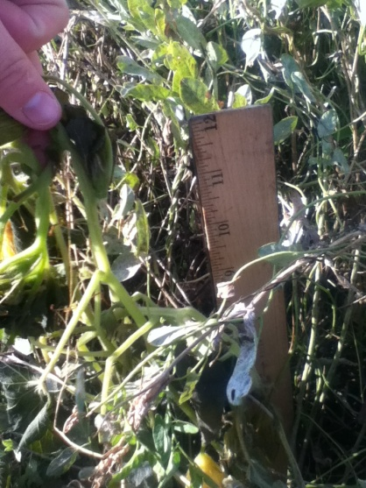
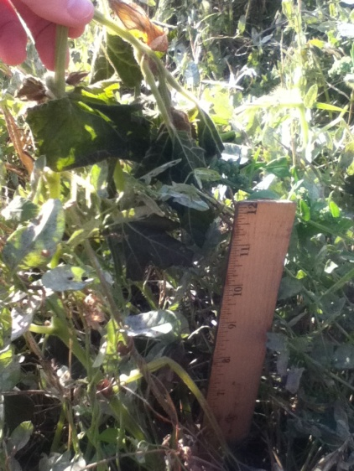
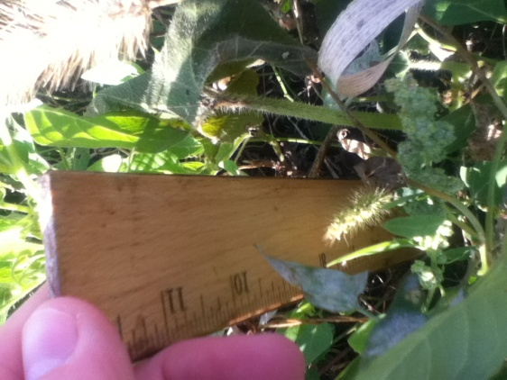

How den's Field Pumpkins Connecticut Field Pumpkins Golden Hubbard Squash
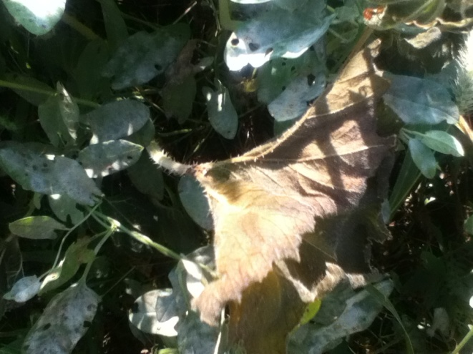
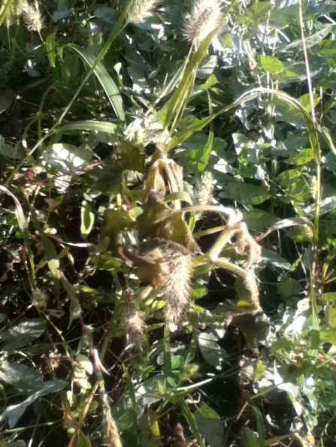

Plot 2
6/11/14
Spaced- 1 seed per 6"
Soil Type- loam clay
Soil Temp- 65 F
Soil Moisture- 1.8
Weed Density (2' by 2' plot) - 11 plants
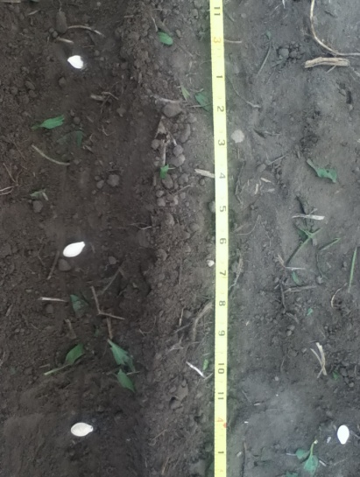
Weather Conditions- Nice day

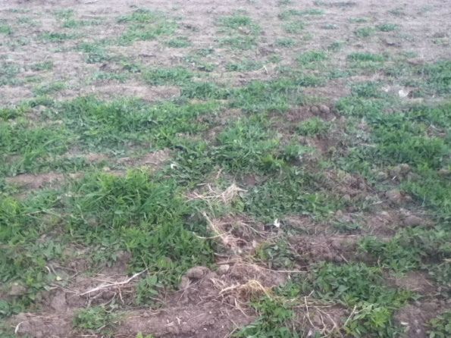

Before using a rototiller Spaced 6" apart
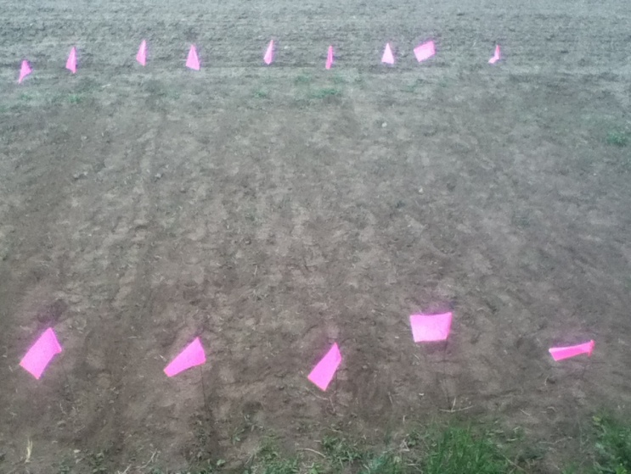

7/8/14
Doing well, they have some other foliage but not as much as plot 1.
Howden's Field Pumpkin-6"
Connecticut Field Pumpkin-5"
Golden Hubbard Winter Squash Heirloom-5.5"
Weed Density- Very few bind weed plants, no new sprouts.

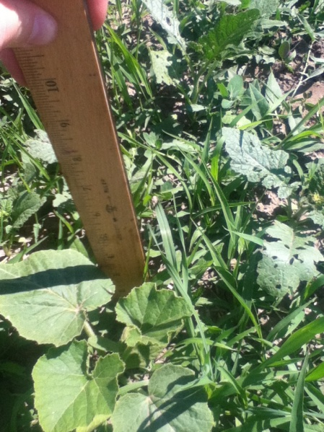
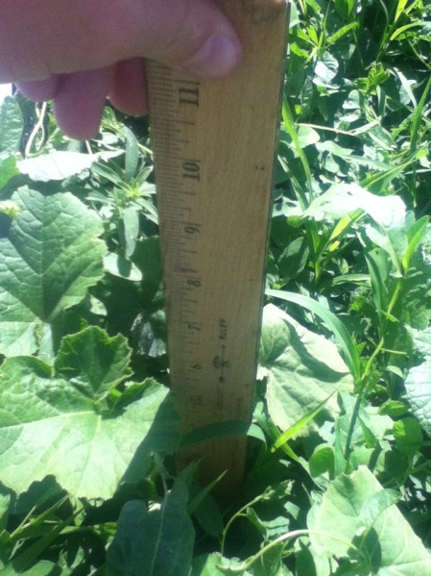
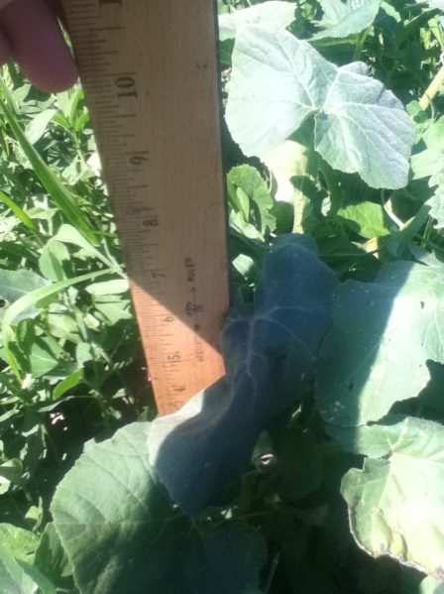

Howden's Field Pumpkins Connecticut Field Pumpkin Golden Hubbard Squash
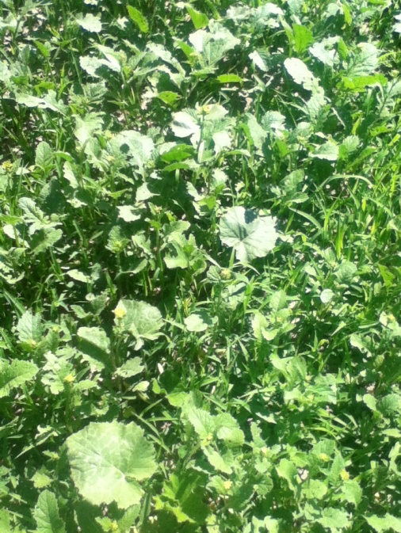

7/14/14
Got hit by hail and many of the pumpkins suffered. Not many pumpkins remained, although the little bit of foliage help protect it. There is very little bind weed present, but part of that might be the hail.
Howden's Field Pumpkin-5"
Connecticut Field Pumpkin-6"
Golden Hubbard Winter Squash Heirloom-7.5"
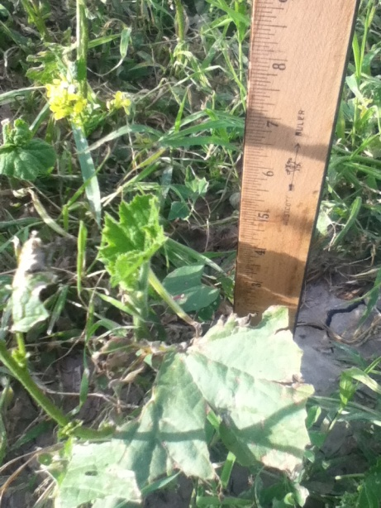
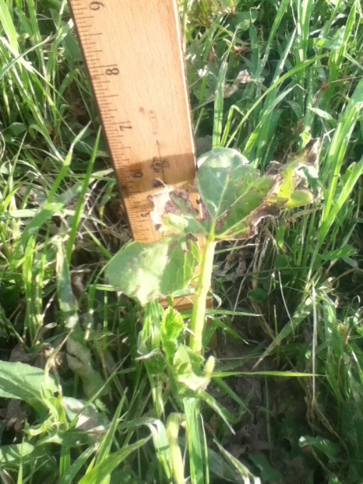
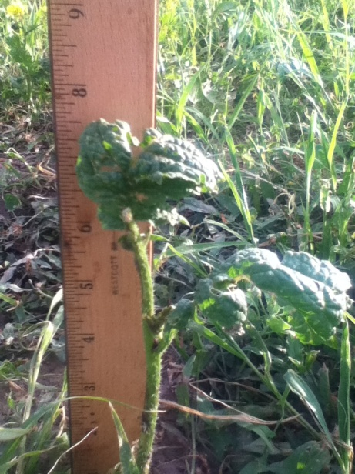
Weed Density- Very little bind weed can be seen.

Howden's Field Pumpkins Connecticut Field Pumpkin Golden Hubbard Squash
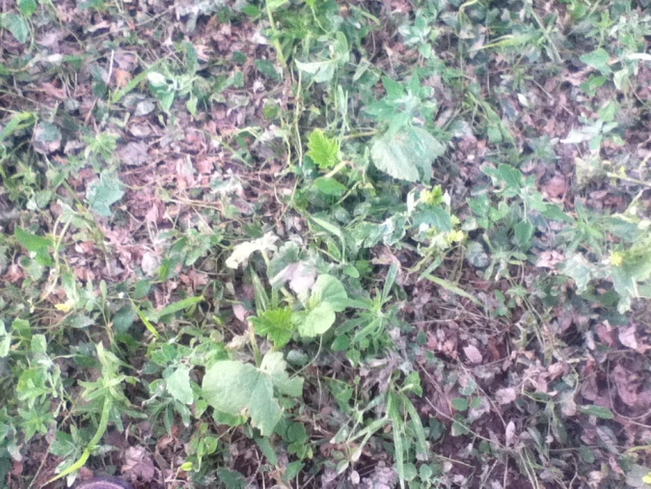
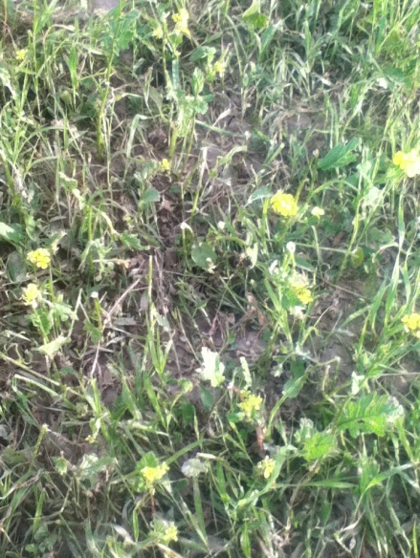

7/30/14
Many of the pumpkins made a recovery and are continuing to grow.
Howden's Field Pumpkin-Almost 7"
Connecticut Field Pumpkin-7.5"
Golden Hubbard Winter Squash Heirloom- 5"
Other foliage, but little bind weed.
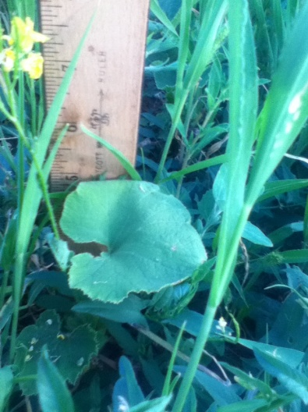
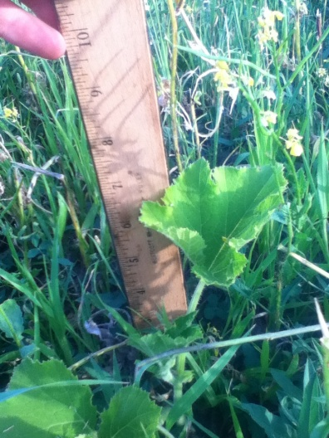
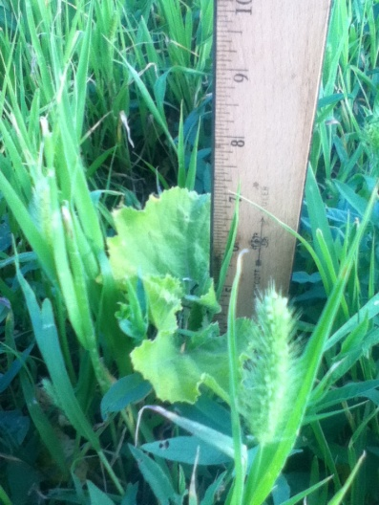

Howden's Field Pumpkin Connecticut Field Pumpkin Golden Hubbard Squash

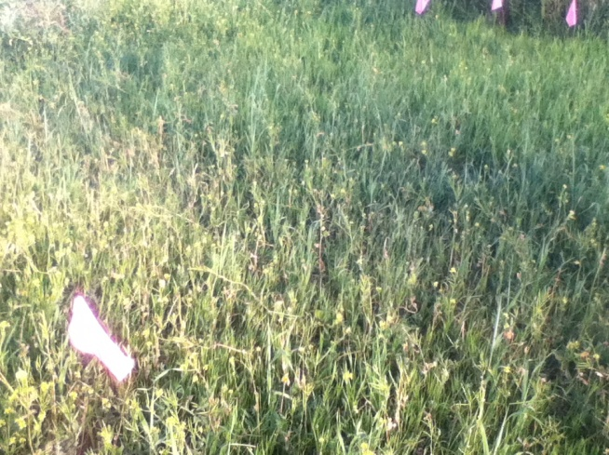

8/11/14
The weather has been extremely hot and dry.
Howden's Field Pumpkin-8"
Connecticut Field Pumpkin-7.5"
Golden Hubbard Winter Squash Heirloom- 5"
Bind weed has appeared with white flowers .Part of the time there was a horse in the field and it walk on Plot 2.
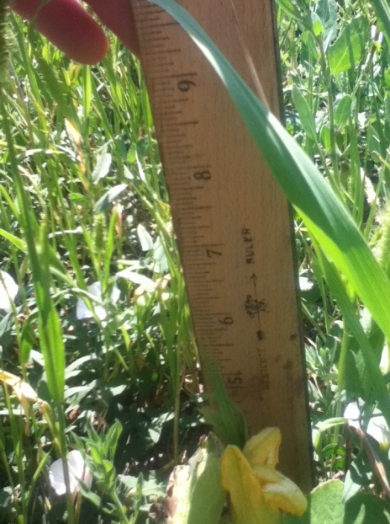
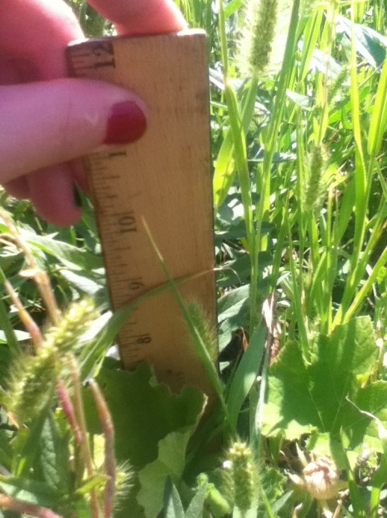
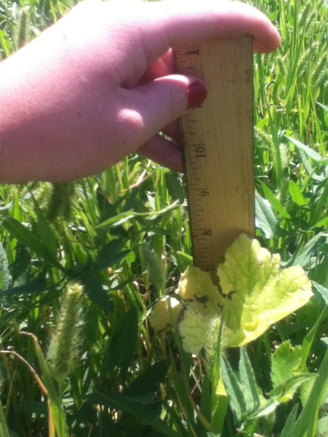

Howden's Field Pumpkin Connecticut Field Pumpkin Golden Hubbard Squash
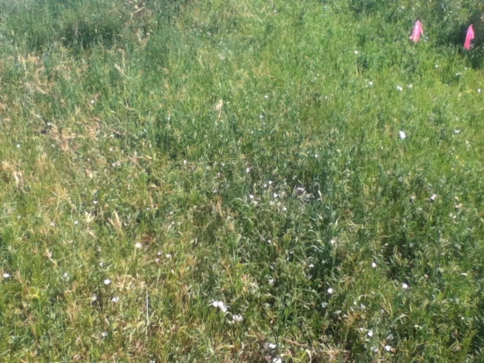
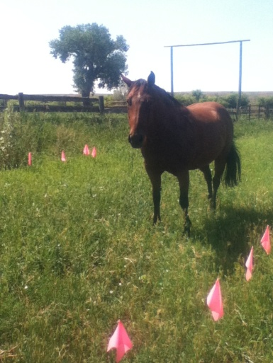

9/13/14
The last week of August we received close to 5.5" of rain. Then we received frost around September 10th and it stay for about 3 days, most all of the pumpkins died.
Howden's Field Pumpkin-7"
Connecticut Field Pumpkin-7"
Golden Hubbard Winter Squash Heirloom- Couldn't find any Squash.
Weed Density- The frost killed off the bind weed, it turn black like the pumpkins.
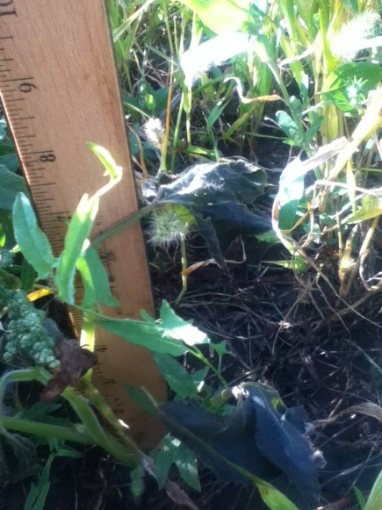
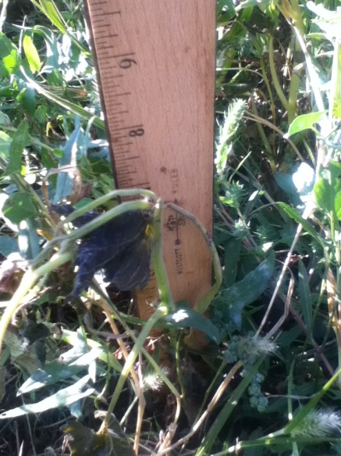

Howden's Field Pumpkin Connecticut Field Pumpkin
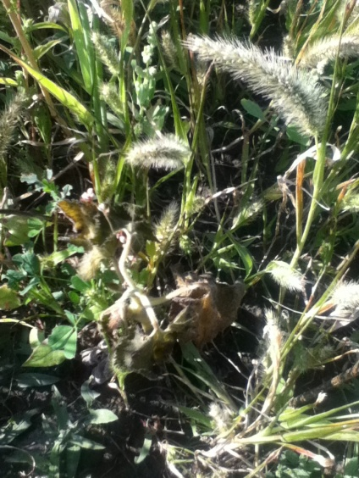

Plot 3
6/12/14
Spaced- 1 seed per 1'
Soil Type- loam clay
Soil Temp- 58 F
Soil Moisture- 1.6
Weed Density (2' by 2' plot) - 25 plants
Weather Conditions- Cloudy, started sprinkling and rain for 2 days.
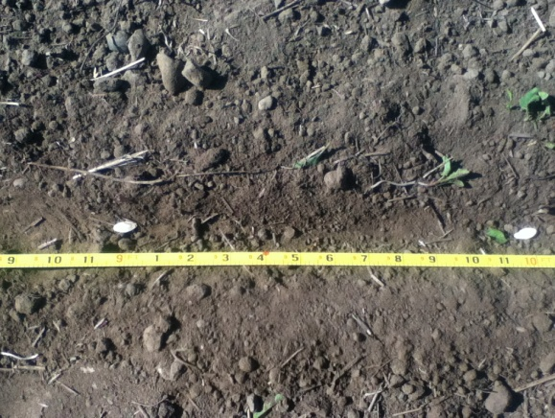
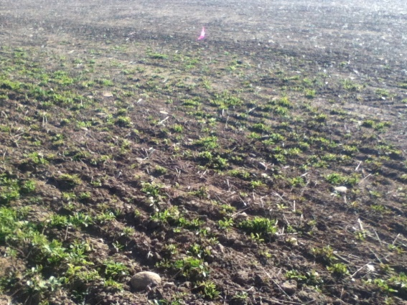

Before being rototilled 1 seed per 1'

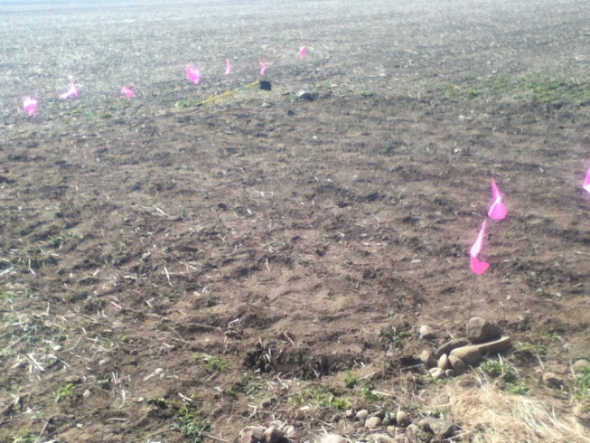

7/8/14
No extra foliage like plot 1 and plot 2. On this plot the pumpkins were much smaller.
Howden's Field Pumpkin-4.5"
Connecticut Field Pumpkin-4.5"
Golden Hubbard Winter Squash Heirloom-3.5"
Weed Density- 12
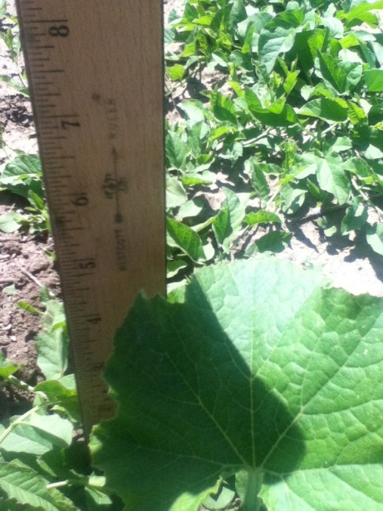
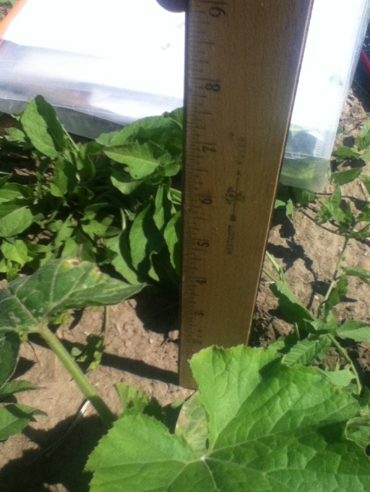
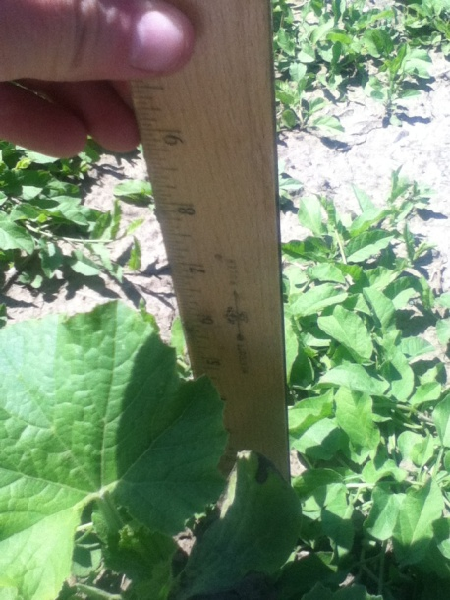

Howden's Field Pumpkins Connecticut Field Pumpkin Golden Hubbard Squash
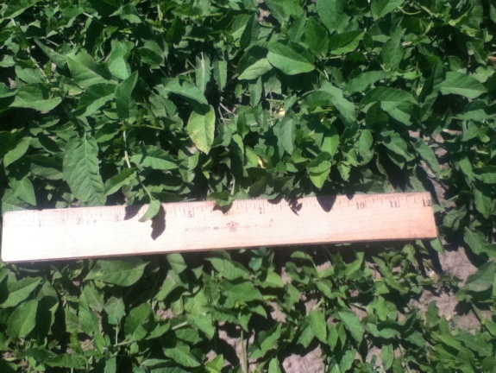

7/14/14
Got hit by hail and many of the pumpkins suffered. Plot 3 really got hurt because there was no foliage to protect it. The bind weed also got knocked out with the hail.
Howden's Field Pumpkin-4"
Connecticut Field Pumpkin-5"
Golden Hubbard Winter Squash Heirloom-3"
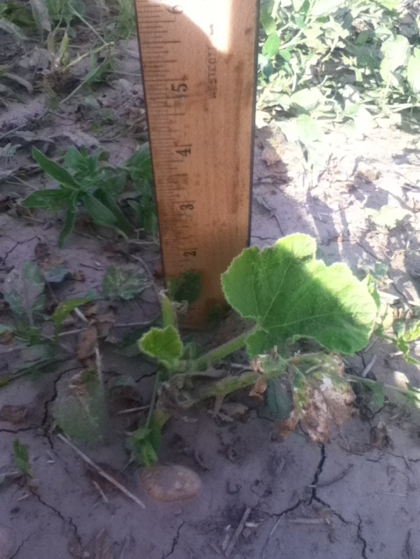
Weed Density- 7
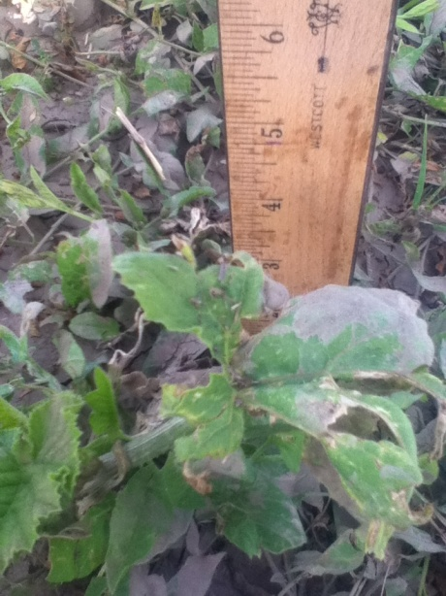
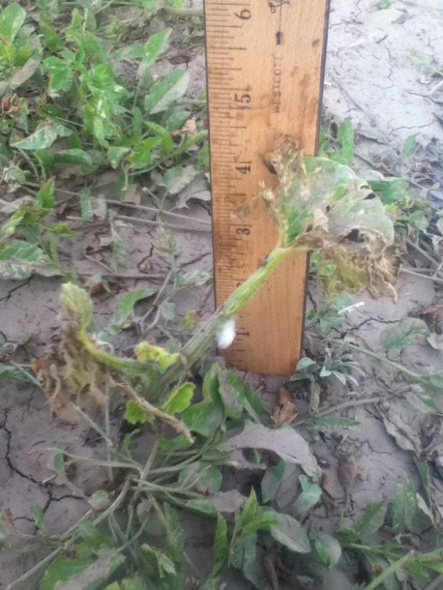

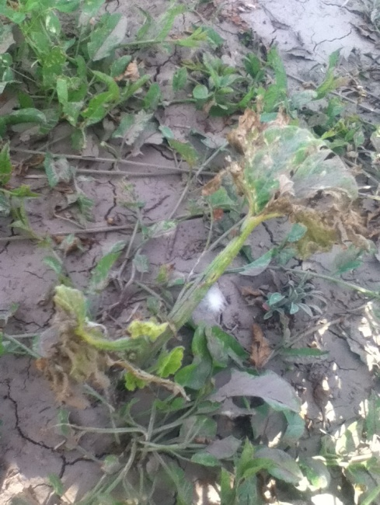
Howden's Field Pumpkins Connecticut Field Pumpkin Golden Hubbard Squash

7/30/14
Have not made much of a recovery, there are only 3 squash plants left.
Howden's Field Pumpkin-6"
Connecticut Field Pumpkin-8" most are smaller
Golden Hubbard Winter Squash Heirloom- 5"
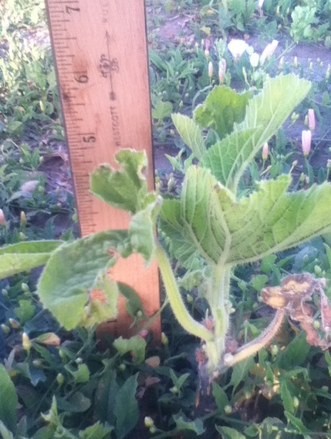
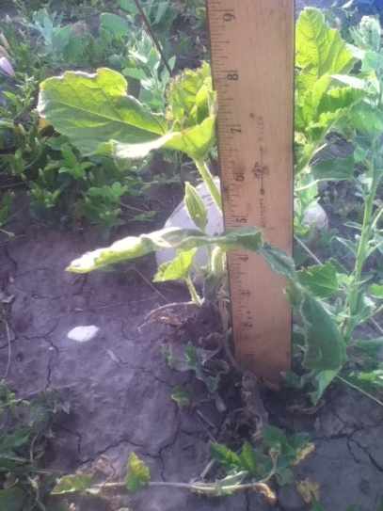
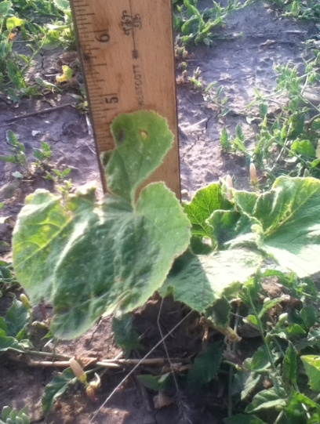
Weed Density- 13, white flowers have emerged.

Howden's Field Pumpkin Connecticut Field Pumpkin Golden Hubbard Squash
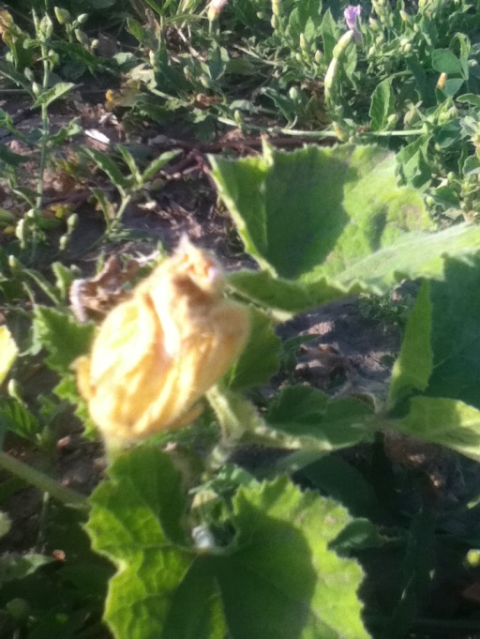
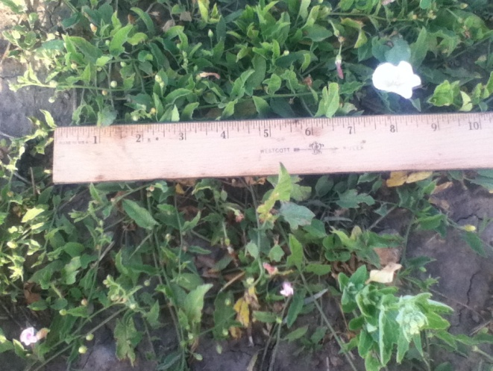

8/11/14
The weather has been extremely hot and dry.
Howden's Field Pumpkin-7"
Connecticut Field Pumpkin-9"
Golden Hubbard Winter Squash Heirloom- 4"
Weed Density- 13
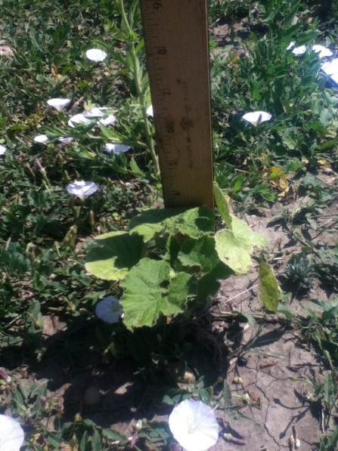
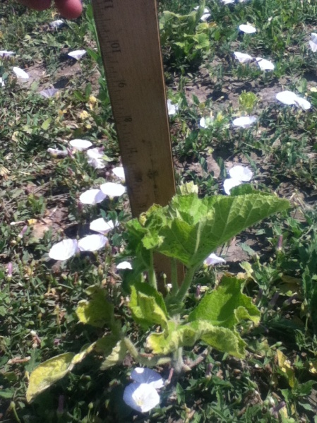
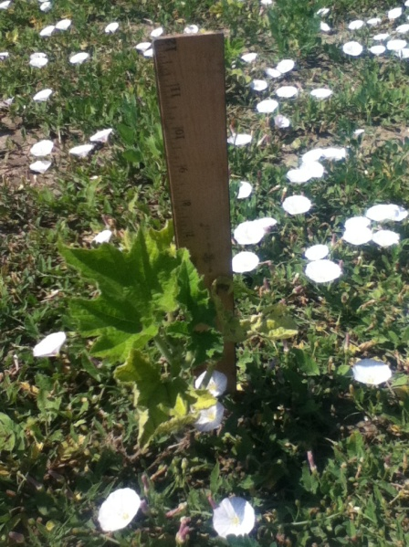

Howden's Field Pumpkin Connecticut Field Pumpkin Golden Hubbard Squash
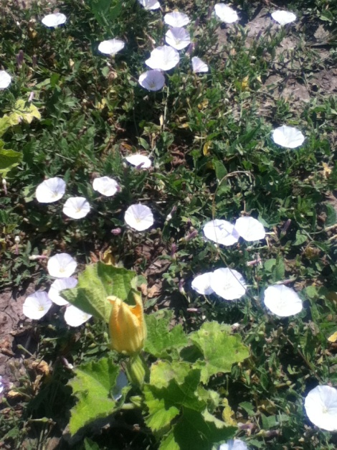
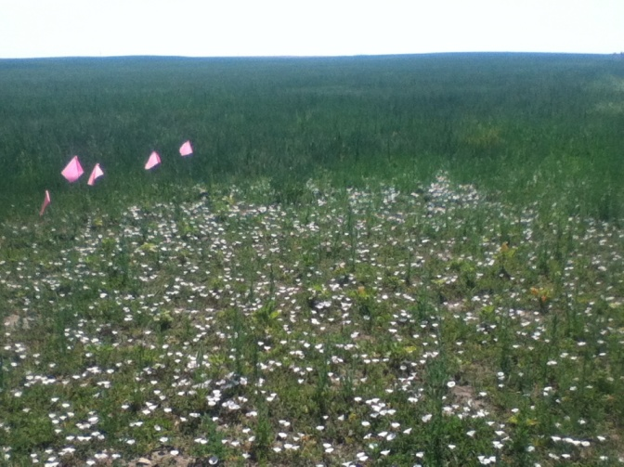

9/13/14
The last week of August we received close to 5.5" of rain. Then we received frost around September 10th and it stay for about 3 days, most all of the pumpkins died.
Howden's Field Pumpkin-8"
Connecticut Field Pumpkin-12"
Golden Hubbard Winter Squash Heirloom- 3.5"
Weed Density- The frost killed off the bind weed, it turn black like the pumpkins.
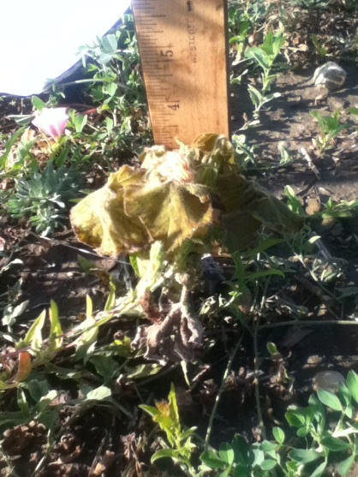
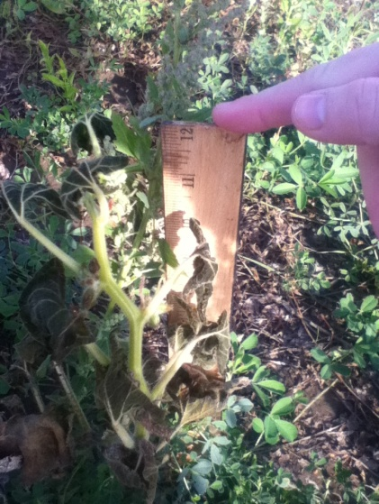
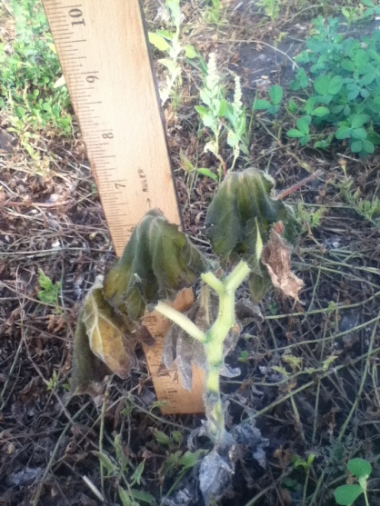

Howden's Field Pumpkins Connecticut Field Pumpkins Golden Hubbard Squash
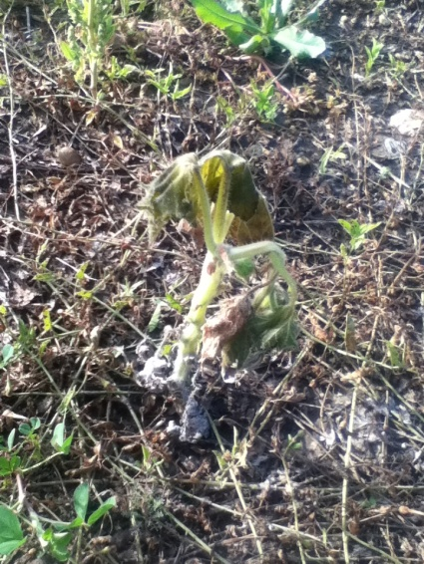

Control Plot

6/10/14
Soil Type- Clay
Soil Temperature- 70 F
Soil Moisture-1.8
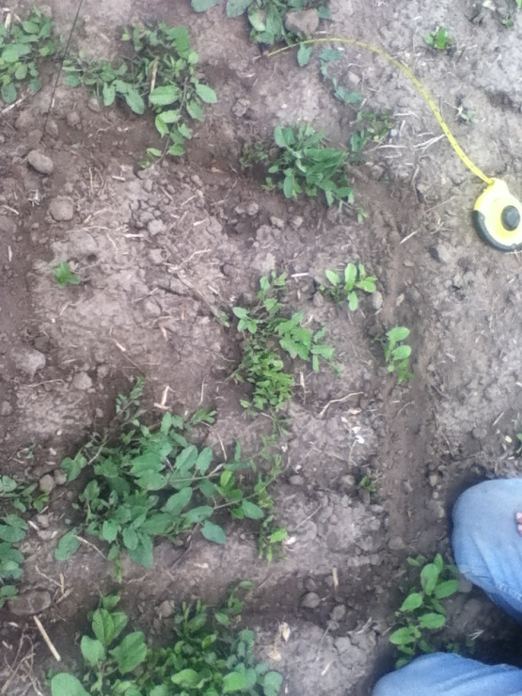
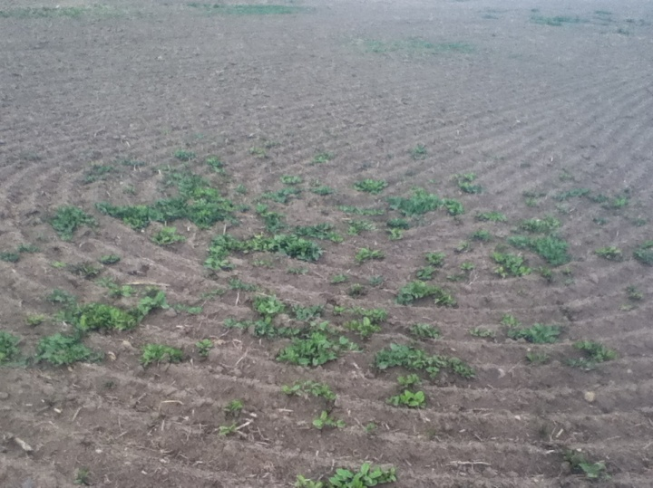
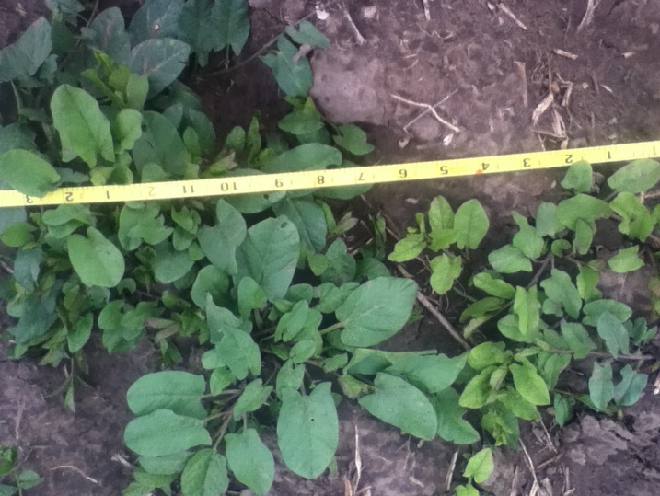
Weed Density-16

7/8/14
Weed Density-30

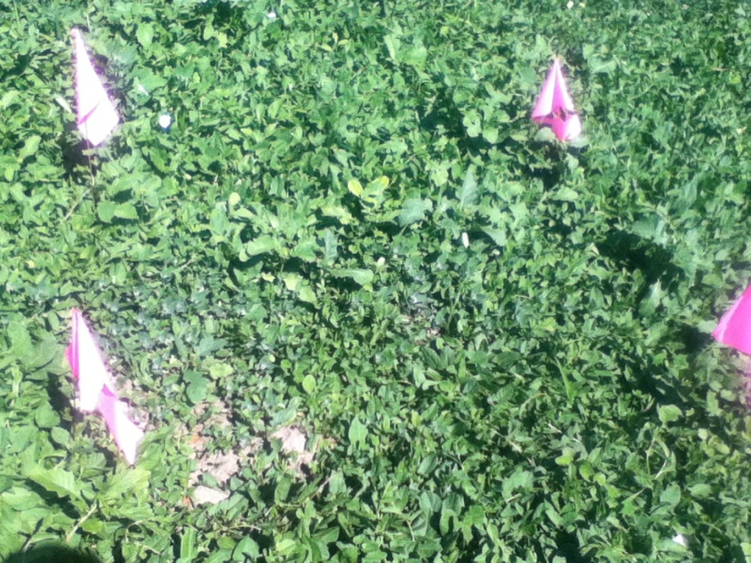

7/14/14
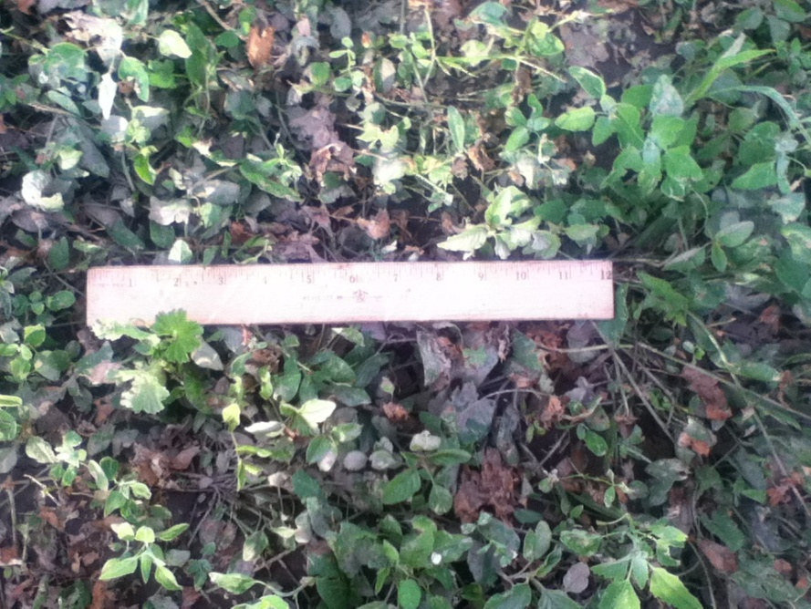
Weed Density- Square is completely covered, the bind weed intertwined around each other.

7/30/14
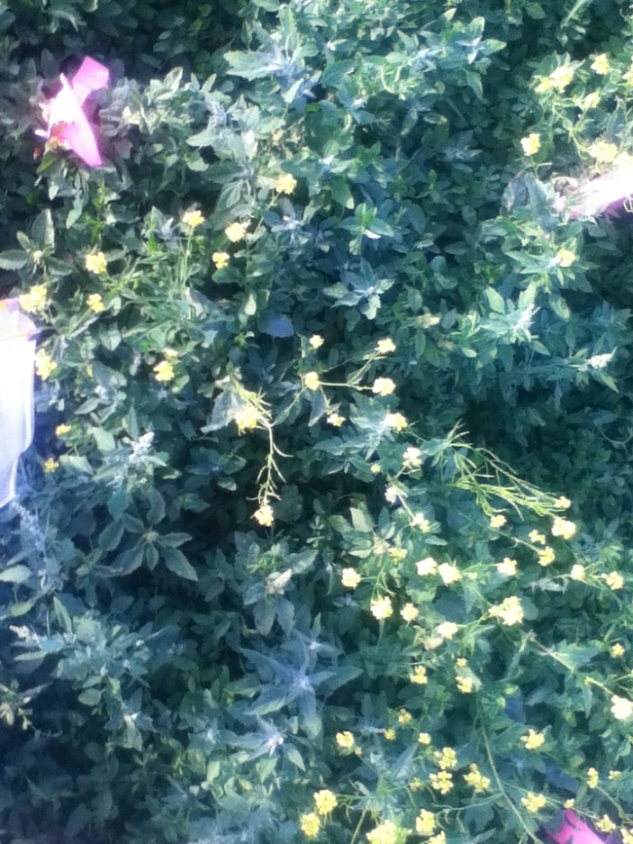
Weed Density- Completely overgrown. Some other weeds aso have grown in with the bind weed.

8/11/14
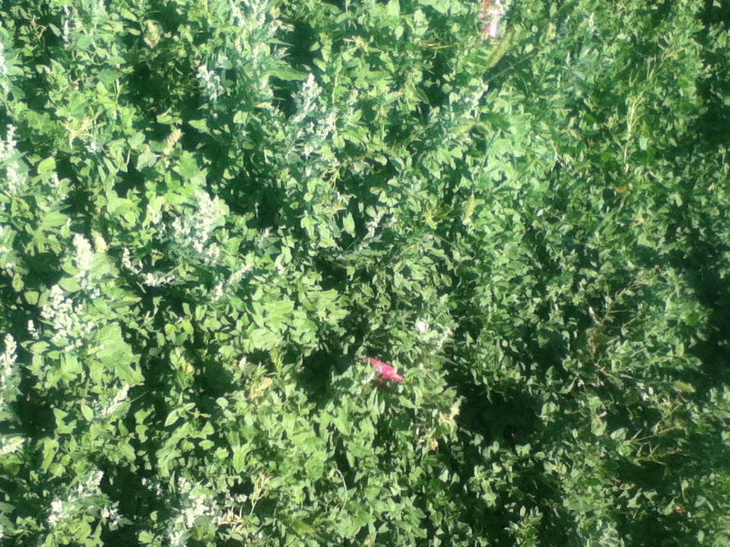
Weed Density- The weeds keep becoming thicker.

9/13/14
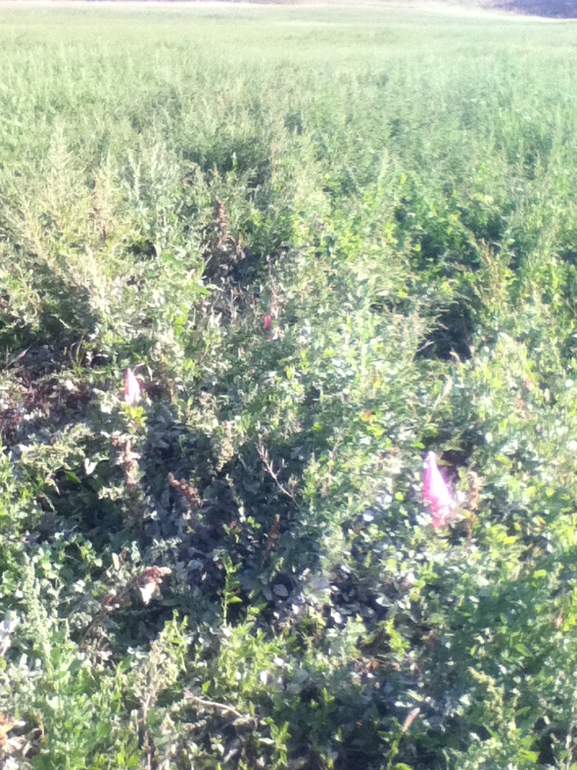
Weed Density- Still overgrown, but is black from the frost.

