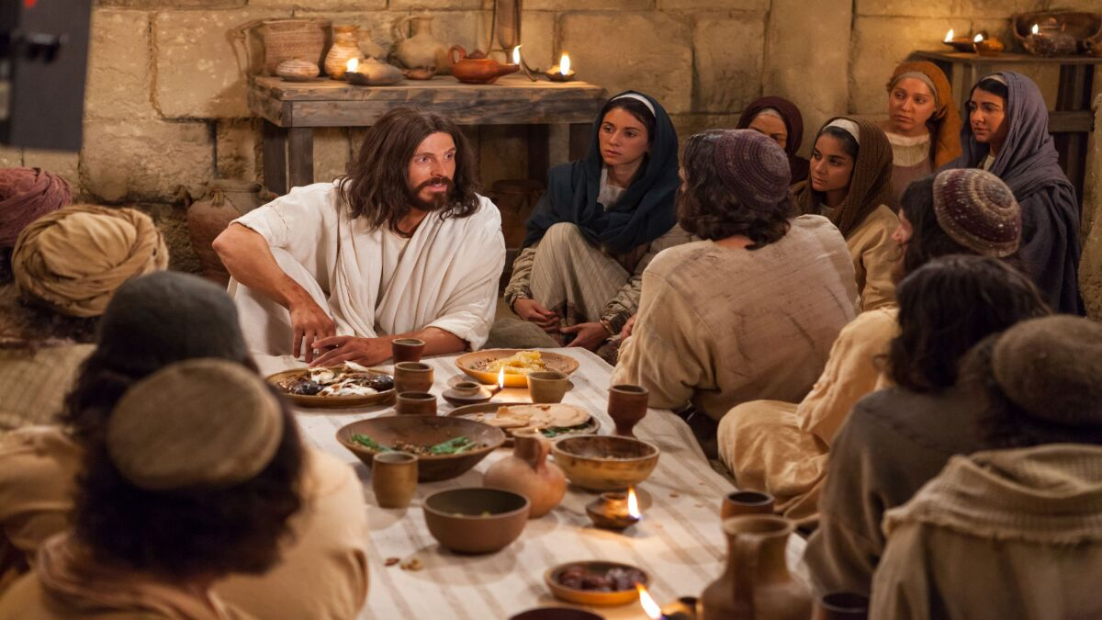

May 15, 2022

5th Sunday of Easter

Carson City United Methodist Church

10:30 am

Greeting/Announcements

Call to Worship

L: Lord, our Lord, how majestic is your name in all the earth!
P: You have set your glory in the heavens.
L: Through the praise of children and infants you have established a stronghold against your enemies, to silence your foes.
P: When we consider your heavens, the work of your fingers, the moon, and the stars, which you have set in place,
L: what is mankind that you are mindful of them,
human beings that you care for them?
P: You have made us a little lower than the angels
and crowned us with glory and honor. Lord, our Lord, how majestic is your name in all the earth!

*Hymn: This is the Day UMH 657 (2 times)

Opening Prayer: (unison)
Jesus, we come before you this morning to say, thank you for the gift of salvation. A blessing we possess in the present moment and not something we hope for in a distant future. We come before you to say, thank you for reaching out to us with your love. AMEN.

Contemporary Song: Listen to Our Hearts (Casting Crowns)

Offering

Doxology UMH 95

Offertory Prayer

Sharing of our Joys and Concerns

Call to Prayer: He is Lord UMH 177

Pastoral Prayer

Gospel Reading: JOHN 14:23-27

Old Testament: ISAIAH 5:20-21
Epistle Lesson: 1 CORINTHIANS 3:18-20
Celebration Sunday: Million Reasons

Children’s Church

Contemporary Song: Goodness of God

MESSAGE

*Hymn: Jesus Loves Me UMH 191

Benediction

CCUMC – Announcements & Upcoming Events:
==========================================
As a courtesy to others please silence
or shut off cellphones
==========================================
United Women of Faith (UWF, formerly UMW): Salad Potluck, Mon, May 9th, 5:30 pm. Everyone is welcome to come learn about the Lutheran Quilt Project and what UWF is all about. Bring own table service and a salad to share. Drinks provided. For questions, call WalthaGaye at 989-640-0238.
==========================================
VBS Decorating Work Bee: Thur, May 19 @ 6:00 pm.
Supplies needed: white flat sheets, cylindrical oatmeal boxes, tissue paper, pool noodles, boxes, brown packing paper. Please place in tub under the Monumental table.
T-shirts for Monumental VBS – Preorder from on table in lobby.
Thank you for your support.
==========================================
Frontier Days Picnic Lunch: Mark your calendar for
Sat, June 4th 11:00 am to 1:00 pm. More details coming soon.
==========================================
LAST DAY REMINDERS BEFORE FOR SUMMER
Cool Hour & Children’s Church:
Last day for these two is Sun, May 15th,
which will also be Celebration Sunday.

ARK:
Last meeting is Wed, May 18th

Euchre:
Last meeting is Sat, May 21st

Women’s Group:
Last meeting is Sun, May 29th
====================================

Serving & Supporting Sunday Worship
Audio/Video: Pat Monroe
Children’s Ministry Audio/Video: Colin Fitzpatrick

Joys, Concerns & Prayer Request
For those battling cancers:
Jim Dunlap, Carolyn Nykerk, Ray Seaman, Dillan Abell, Andrew Hogan, Amorena Newman-Wojciakowski

For those who need support, guidance or have health concerns: Mike Decker, Gordon Augustine

Monthly Giving
5/1 $4306.02 5/8 $3382.68

Nursery Schedule
5/15 Chris Benjamin
5/22 Jenna Benjamin 5/29 Alex Krantz

Lighting of Candles

Passing of Collections Plate

Children’s Church

Our Church in Ministry This Week
Sun: Women’s Group 6:30-8 pm
Mon: PT Class 6:30-8 pm
Tue & Thu: COA Meal @ Noon
Wed: A.R.K. 6:30-8 pm

Coloring Page

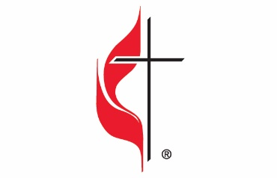

Carson City United Methodist Church
Location: 119 East Elm St., Carson City, MI
Mail: PO Box 298, Carson City, MI 48811
Phone: 989-584-3797 Email: carsoncityumc@gmail.com
Website: carsoncityumc.com
Sunday Worship Service: 10:30 am
Office Hours: Monday-Thursday, 9:00 am-12:00 pm
After hours by appointment
Pastor: Ian McDonald 906-322-5318
Secretary: Bonnie Seaman 989-763-1674

Weekly Sunday Bulletin now available on our website
@ www.carsoncityumc.com

“Thank You, heavenly Father, that You can be known through Your creation. I pray for those who don’t see You. Please draw them to You”

