**THE covid-19 pandemic WILL LEAD TO**

**THE DIVINE PLAN**

**by**

**Marguerite dar Boggia**

[](https://getpocket.com/explore/item/is-gravity-quantum) Why must it take extreme pain for us to adhere to the just Laws of the Cosmic? Out of the world Covid-19 pandemic the Spiritual Hierarchy of our planet will create the situation for Unity and Harmony among all countries and its peoples. We were told that we are a One Humanity. How can the left arm compete with and stab the right arm of humanity again and again? When will we realize that we are Brothers, regardless of color, race, religion and beliefs. Hindu and Zoroastrian Sages of the past have foretold our future. We are destined to live in the Golden Age1. How will it become manifest?

The Global Elite,2 aka the Cabal seeks to create one world through force, blackmail and/or assassination. This is the method of the forces of Negativity. They cannot win.

"In industrialized economies, where roughly 70% of the workforce is in services, countless businesses in myriad industries will fail in a rolling financial collapse that will eclipse the Great Depression. That spans the whole spectrum of possibly 47 million US workers soon to be laid off -- with the unemployment rate skyrocketing to 32% - all the way to Oxfam's warning that by the time the pandemic is over half of the world's population of 7.8 billion people could be living in poverty."3

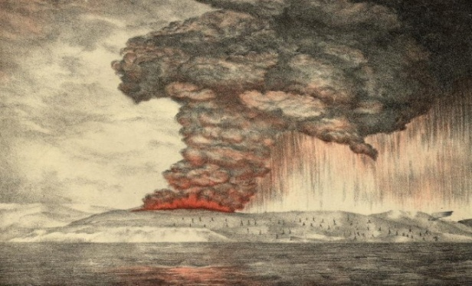 In addition the total global system will see a huge world bank failure and depression in late September or early October, 20204. The people of the US will elect Joe Biden of the Democratic party. He will start a war with Russia and Iran in 2023, believing that wars always help the economy. A greater disaster will occur which disaster will exacerbate the economies and life of the people of the Middle East. This was seen in the maps of the spiritual Hierarchy. For more details see page 430 of the book *The Rays and the Initiations,* by Alice A. Bailey. which book was written many years ago. We have no idea of what form the disaster will take. The sea and land might be so nuclear toxic that people will try to escape in ships to other countries. This also was seen by psychics.

The Sages have foretold of a messanic figure who will destroy the evil forces and bring light to humanity. Most religions are awaiting the reappearance of the Messiah. His personal name is known to the Buddhists as Maitreya, whom the Christians call the "Christ."5 He is 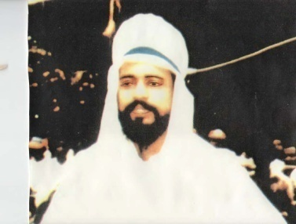known as the World Teacher to esoteric students. He is at the head of the Spiritual Hierarchy of our planet.  When this event occurs, which could be in July, 20376, the Lord Maitreya will bring with him all of the Masters of the Spiritual Hierarchy and great Devas who will teach us how to obtain food from the ethers, etc.7 Great changes will occur including a new economic system. Peace will be based on justice, freedom and goodwill. For more information on the Christ see my article: *The  Forthcoming Golden Age and also The Next War is Inevitable* under Articles in my website: [www.FreePythagorasTeachings.com](http://www.FreePythagorasTeachings.com). This photo is of the Lord Maitreya as he appeared before a healing gathering in Nairobi Kenya in June, 1988. See Share-International org for more information.

The new economic system will be based on SHARING the resources of the Earth. This economic system is already prepared. It just requires the nations of the world to accept it. A computer will be set up into which each nation will place a list of what it requires and what products it can give. Judges will be from the members of the Spiritual Hierarchy. They will see to it that each country will receive equitably what it needs.

These events tie into information from our Military Industrial Complex about **the** "**high energy cloud" our solar system is moving into.8**  Spacecraft had been sent out to view the cloud and study its energetic properties. It is expected to trigger a dramatic evolutionary event on Earth, including an epic solar energy release of some kind. This information coincides with the information from the Hindu and Zoroastrian sages, to the effect that we will enter into a Golden Age in the Age of Aquarius and the appearance of the messianic figure.

Eventually the French motto and maxim, Liberty, Equality and Fraternity will become a reality, when all the workers receive the same amount of pay. There will be no money, no unemployment.9 Other nations will follow suit of the US and eventually all nations will be part of the One New Order under the direction of the Spiritual Hierarchy of our planet. This will last for a thousand years, when the forces of negativity will assume more control. Why? There will always be two forces working against each other. This is the will of the Great Gods. We must struggle to attain complete freedom and to become one with our Real Self, the Divine within us. Eventually we will return to our source, the Lord of our solar system.

∆ ∆ ∆

*Marguerite dar Boggia* is the former Secretary, Membership Secretary and Director for ISAR, the International Society for Astrological Research. She is  the former Publisher of Kosmos, the ISAR journal. She is a co-founder of UAC and its past Secretary and Director. Her goal is to serve humanity and the spiritual Hierarchy of our planet.  To that end, she offers **FREE, online**, **three pages weekly** of the Ageless Wisdom Teachings as was known by **Pythagoras**. These teachings include information that **Albert Einstein** received. To receive these studies, she can be contacted through her website [**www.FreePythagorasTeachings.com**](http://www.FreePythagorasTeachings.com), which website, she created at the age of 90. These teachings prepare us for discipleship.

References:

1Dar Boggia, Marguerite*, The Forthcoming Golden Age* www.FreePythagorasTeachings.com under articles.

2[World Bank Whistleblower Reveals How The Global Elite ...](https://www.google.com/url?sa=t&rct=j&q=&esrc=s&source=web&cd=1&cad=rja&uact=8&ved=0CB4QFjAAahUKEwjIopzBn7bHAhVIW4gKHa71B_Q&url=http%3A%2F%2Fwww.globalresearch.ca%2Fworld-bank-whistleblower-reveals-how-the-global-elite-rule-the-world%2F5353130&ei=BQrVVYiMEci2oQSu65-gDw&usg=AFQjCNFWFWycs-tAjp9xAZy1b0TE8Uzhfg)

### [3](https://www.google.com/url?sa=t&rct=j&q=&esrc=s&source=web&cd=1&cad=rja&uact=8&ved=2ahUKEwipurLWiO7oAhU0Ln0KHR1hDq4QFjAAegQIARAB&url=http%3A%2F%2Fwww.informationclearinghouse.info%2F55050.htm&usg=AOvVaw1nRYCZ47ziQERAzY2DeEtc)[Total System Failure Will Give Rise to New Economy - Information ...](https://www.google.com/url?sa=t&rct=j&q=&esrc=s&source=web&cd=1&cad=rja&uact=8&ved=2ahUKEwipurLWiO7oAhU0Ln0KHR1hDq4QFjAAegQIARAB&url=http%3A%2F%2Fwww.informationclearinghouse.info%2F55050.htm&usg=AOvVaw1nRYCZ47ziQERAzY2DeEtc)

### 4Dar Boggia, Marguerite *The 2020 Stock Market Crash* www.FreePythagorasTeachings.com under articles

5Bailey, Alice A. *A Treatise on Cosmic Fire*, Lucis Publishing Co. 1925, pg. 211, footnote...the World Teacher. *.."The Buddha held office prior to the present World Teacher, and upon His illumination, the Lord Maitreya, took His place. The Occidentals call him the Christ".*

6Dar Boggia, Marguerite The *Forthcoming Golden Age* www.FreePythagorasTeachings.com under articles.

7Bailey, Alice A*. Esoteric Psychology I*, Lucis Publishing Co. 1936, pgs. 123, 124.

8Wilcock, David, *Ascension Mysteries* ,Penguin Random House LLC, 2016, p 317.

9Dar Boggia, Marguerite *Life in the Golden Age of the Gemini Decanate of the Aquarian Age* under Articles o*f* www.FreePythagorasTeachings.com

+