February 28, 2018 sia1912@comcast.net

htpp://www.Strathmereimprovementassociation.org/

Facelifts; Fire Commission Results; Taxes; FL Happy Hour; Upcoming Dates

Face lifts at Several Beach Entrances:
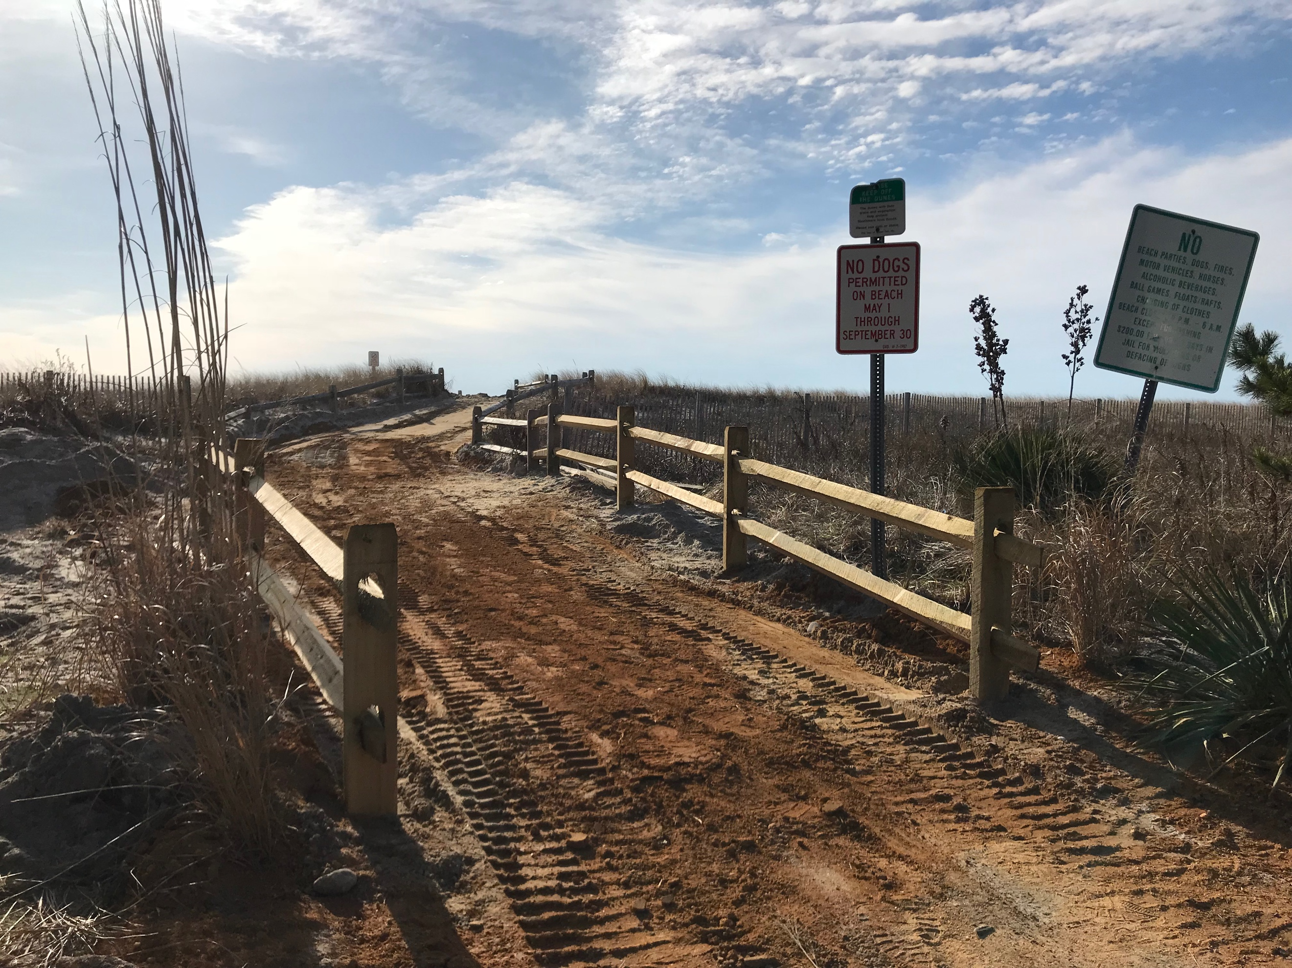
Tecumseh work underway. Note new fencing toward beach.

Set for completion by March 15, several beach entrances will be sporting new looks. Stairs have been replaced by ramps, and a new snow fencing configuration is intended to keep sand from creating drifts along the paths. Streets updated: Tecumseh, Vincent, Webster, Whittier, Randolph, and Sumner. Work on streets south of Randolph require permitting from NJDEP and will be addressed in the future. The Township is also inspecting and repairing treads and risers on crossover stairs on other streets.

Fire Commission Election Results:
Donna Diefenderfer and Steve Nickelsberg were re-elected to the Strathmere Fire Commission at the recent February election. Additionally, a 2% budget increase was approved, largely necessitated by the need to purchase new radios that support the 700-800 megahertz frequency Ocean City will be converting to. Strathmere Fire Company will join with OC for discounted purchasing power. Fire Commission President Karen Mitchell said, “As we have a contracted relationship with Ocean City for fire and ambulance services, the Fire Co must make the change.” The UT Beach Patrol is also changing for the 2018 season. Eventually all of Cape May County, including Upper Twp. fire companies, will be changing. The 2018 budget was approved for $88,152. (2017 was $ 84,834.)

Township Budget Workshops Completed:

Two February budget workshops were held to preview proposed spending by Upper Township for the coming fiscal year. The final budget will be presented at the next Township Committee Meeting, March 12, 7:30 pm, Township Hall.
As of the February 27 meeting, there is a projected increase of $322,000 from last year’s budget. That would mean an increase of 1.75 cents per homeowner. In addition, $75,000 must be added to the Capital Improvement Fund (4/10 of a cent), bringing the increase to 2.15 cents. Another $40,000 will be added to the Beach Replenishment Fund, raising the fund balance to @$400,000.00. The total increase for all three allocations would be 2.35 cents. The average value of an UT home is $280,000, meaning a $66.00 increase per average home. This does not include the school budget.
After the March 12 meeting, the budget will be available online for a thirty day period before coming to a vote at Township Committee.

Strathmere/Florida Happy Hour!
Karen and Dave Townsend hosted a "Strathmere Happy Hour in Florida" at their home in Hobe Sound, FL, recently. Here’s the “happy” group.

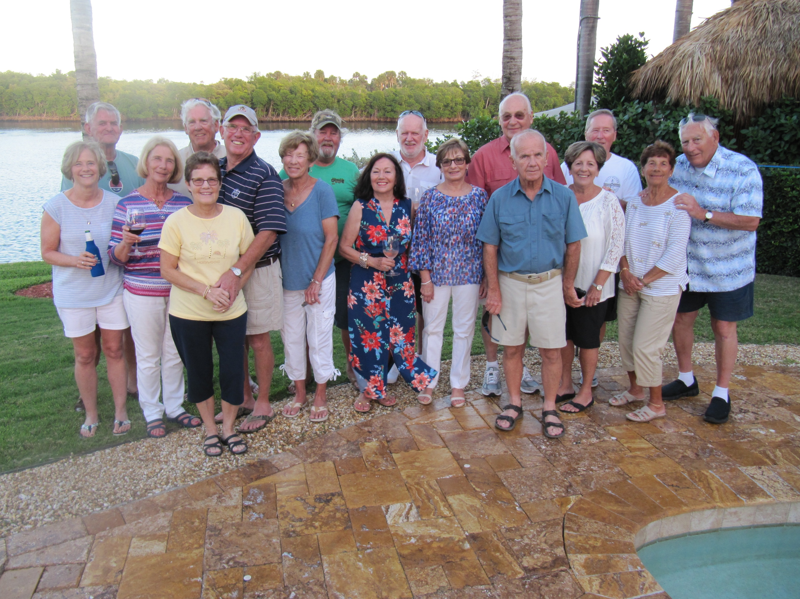
L-R
Karen Townsend, Dick Omrod, Candy Jankowski, Kath Lyon, Dave Ferguson, Bud Lyon, Carol Ferguson, Jimmy Callahan, Mary Reole, Jim Mummans, Grace Steenland, Pete Steenland, John Latwinis, Carol Bonsall, Jerry Bonsall, Jackie Cunningham & Paul. Two Strathmere lifeguards arrived later: Rod Tice and Jimmy Gibbons. The group also toasted Mary Ann Omrod and Marian Latwinis.

Sure Sign of Spring
Karen Mitchell has begun her spring planting around town-first stop, the Firehouse. Thanks for your generosity Karen, and hurry up spring!

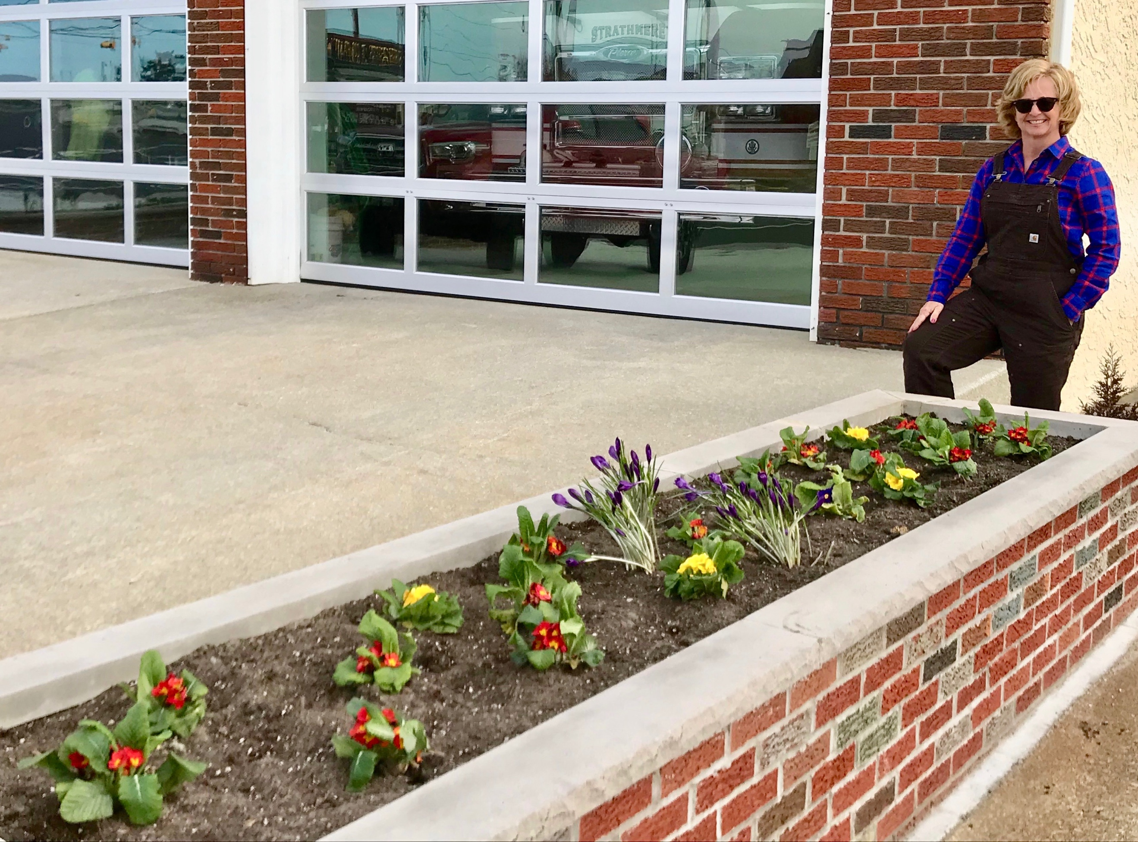

Playground Ready for Memorial Day:
Bulkhead complete, ready for more! New surfacing, fun equipment, benches and even some native plants are being installed.

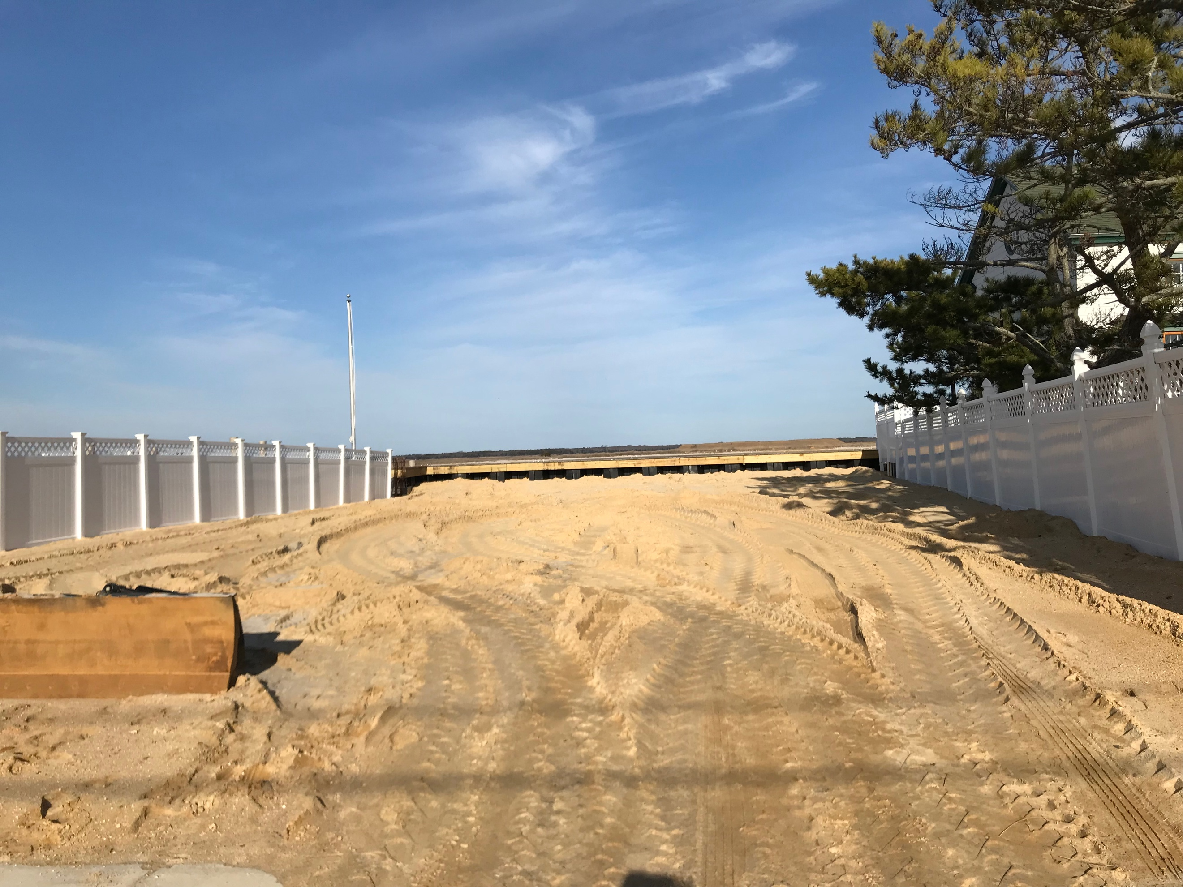

Upcoming Activities:

March 24: Egg Hunt-Amanda’s Field, 1-4 pm
March 29: Blood Drive, UT Community Ctr, 1-6 pm
April 1: Easter Sunrise Mass, Williams Ave

