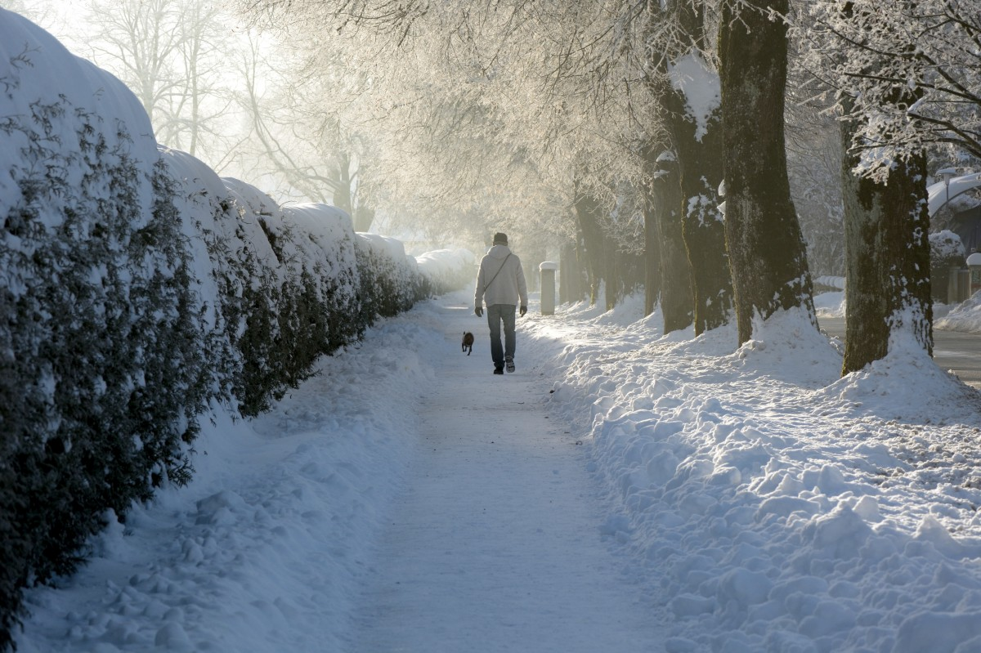

Day 13. Slow Down
Thich Nhat Hanh, the Zen monk, has stated: “Live is so short, we should all move slowly.” Winter affords us the opportunity to physically slow down. It is hard to walk through snow and when we are walking on ice, we must watch our steps carefully. Take a meditative walk down the block where you live and be thankful for winter and the chance to move slowly through the world.

