S.E.P.A.g.
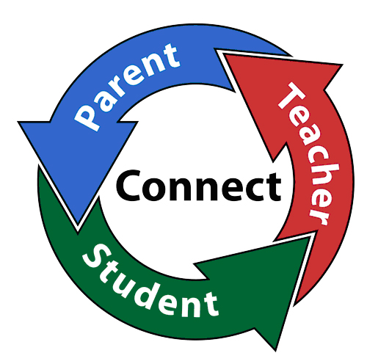
Special Education Parent Advisory Group
Come join our Special Education Parent Advisory Group and be a part of solving issues in special education. Be the voice for all students with special needs in Camden.

Upcoming Meeting Dates & Topics:

“Understanding Your

Child’s IEP”

October 17, 2016

“Parental Rights Under

the IDEA”

November 21, 2016

“Special Education-

A through Z”

December 19, 2016

All meetings will be held at 9:30am at the District Parent Center
800 Erie Street
Trailer #8
Camden, NJ 08102

CAMDEN CITY SCHOOL DISTRICT
201 N. FRONT ST, CAMDEN, NEW JERSEY 08102
856-966-2000 ● 856-966-2138
www.camden.k12.nj.us

Paymon Rouhanifard
Superintendent

SPECIAL eDUCATION pARENT aDVISORY Group (SEPAg)
Parental Feedback Survey
Back to School Night- September 2016

Programs/Workshops
- Which of the following special education workshops would you be interested in attending? (Check all that apply)

- Parent’s Rights and Responsibilities
- Homework Strategies
- Effective Communication
- Conflict Resolution

- All About IEPs (Individualized Education Programs)
- Inclusion/LRE (Least Restrictive Environment)
- Please list additional topics that are not listed above: ____________________________________________________________________________

Participation
- When is the best time for you to attend SEPAG meetings?
- 9:30am (Monday-Friday)
- 3:30pm (Monday-Friday)
- Preferred day/time: _______________________

Communication
- What is the best way for us to get important information to you? (Check all that apply)
- Phone call/Text
- Email

Language
- What is the primary language spoken in your home?

__________________________________________

Contact Information

Parent/Guardian Name: __________________________________________________________________
Phone number: ________________________________________________________________________
Email Address: ________________________________________________________________________
School Child Attends: __________________________________________________________________

