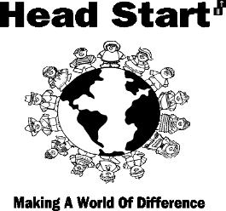
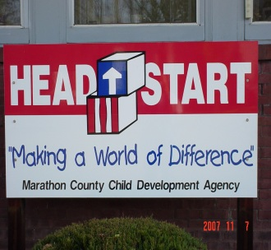

2020-21

ANNUAL

REPORT

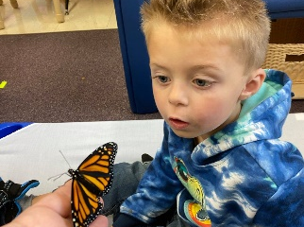

MARATHON COUNTY CHILD DEVELOPMENT AGENCY, INC.
616 Grant Street • Wausau, WI 54403 • 715-845-2947 • www.mccdahs.org

OUR MISSION:
To make a positive difference in the lives of the children and families we serve.
In striving to achieve our mission, we will:
- Provide a safe, secure, and nurturing learning environment
- Create partnerships with families and community resource agencies
- Recruit, develop and maintain a staff that is dedicated to promoting excellence

BOARD OF DIRECTORS:
Officers & Directors
President • Mike Zahrt
Vice President • Kevin Yang, MD
Treasurer • Alicia Richmond
Secretary• Kristen Lonergan Peter Rotter Anne LaChapelle
Susan Cornish Kara Rakowski Aaron Dieckman Lexy Bautch, DC Kate Kipp

POLICY COUNCIL
President • Shawnah Campbell
Vice President • Kailyn Alexander
Secretary • Lynn Chaignot
Treasurer • Ashley Griffin
Lauretta Wagner, Shari Steppert

EXECUTIVE DIRECTOR
Catherine E. Howe Thwaits, Ph.D.

HEAD START PROGRAM CENTERS:

Barrington Center
616 Grant Street • Wausau • 715-848-2947
Center Director • Nicole Guthrie
Stoddard Center
6615 County Rd J • Schofield • 715-573-3698
Center Director • Debbie Weber
Kathleen M Czech Center
607 13th Street • Mosinee • 715-693-4003 Center Director • Heidi Ernst
PROGRAM INFORMATION
Marathon County Child Development Agency Inc. Head Start (MCCDA) is a state and federally funded program in operation since 1966. MCCDA’s purpose has always been to recruit low income children and their families who are at significant risk of later problems in school and in life and to ensure that these children go to school ready to learn, and have a high likelihood of success in life and school. The Board of Directors and staff are committed to helping low-income preschool aged children, their families, and communities overcome the effects of poverty. Our center-based model provides each child with an appropriate learning environment led by licensed preschool teachers. The centers expose children to varied experiences which stimulate each child’s social, intellectual, physical, and emotional growth and development. In addition to providing educational services to children and their parents, MCCDA Head Start also strives to strengthen families and the communities they reside within by providing or linking families to local resources. These include resources for health, dental and nutritional services, social services, mental health services, services for children with disabilities, and opportunities for parent governance and involvement.

AGENCY SERVICES EFFECTED BY COVID-19 PANDEMIC
Head Start closed its doors at all three Centers by stopping to provide in-person services on March 13, 2020 as a result of the world-wide COVID-19 pandemic. The State of Wisconsin mandated all schools closed and the program quickly changed their services to being virtually provided by staff members who worked remotely from their homes.
Our agency re-opened for a four week pilot summer session in July and for full services September of 2020 offering all children enrolled a full day/full week classroom experience at all three of our Centers. Staff and children wore masks and all cleaning measures were stepped up to meet and exceed all CDC guidelines and recommendations. We were successful in that only one child and five staff members ever tested positive during this program year and no cases were serious or spread on site at our agency. As staffing patterns allowed in the Spring of 2021, we opened a virtual classroom for 11 children whose parents did not wish to have their children attending in person. We served a total of 110 children this year rather than our full enrollment of 179 children due to the pandemic.

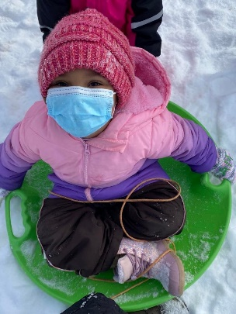
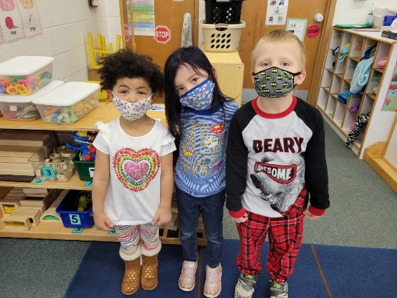
FINANCIAL REPORTS
April 1, 2020 through March 31, 2021

We received funding during this fiscal year from the federal government to serve 179 Head Start children from April 1, 2020 through March 31, 2021. Federal USDA funds, through the State of Wisconsin Department of Public Instruction, provided funding for our child nutrition program providing healthy breakfast, lunch, and snacks. The State of Wisconsin funded eight additional Head Start children with a Head Start Supplemental Funding grant from DPI. We also received funds through the Mosinee & DC Everest School District 4K agreements with our agency.
Expenses (**Audited)  04/01/20 – 03/31/21 |  | Budget 04/01/21 – 03/31/2022
Personnel | $1,091,257 | $1,208,579
Fringe Benefits | $422,344 | $486,505
Occupancy | $148,673 | $154,824
Travel | $969 | $6,000
Consumable Supplies | $165,846 | $142,131
Equipment | $9,432 | $0
Contractual | $164,503 | $187,473
Training | $22,400 | $22,400
Other (insurance, phone, technology, audit, advertising, dues, pandemic, etc.) | $210,077 | $129,054
In-Kind  Contributions | $332,383 | $285,570
Total Expenses | $2,567,884 | $2,622,536

Revenues (**Audited)  04/01/20—03/31/21 |  | Budget  04/01/21 – 03/31/2022
Federal Head Start Grant | $2,056,612 | $2,053,270
DC Everest &  Mosinee School District 4K Contracts | $41,485 | $44,668
USDA Child Nutrition | $55,852 | $150,395
WI State Head Start Supplemental | $50,190 | $54,233
Fed HS Training | $22,400 | $22,400
Corporate/Donations | $8,962 | $12,000
In-Kind Contributions | $332,383 | $285,570
Total Revenues | $2,567,884 | $2,622,536
**Figures in the above charts are audited totals from Hawkins, Ash CPAs, LLP; Certified Public Accountants

Results of Outside Review and Audits:
This fiscal year’s audit, by Hawkins, Ash CPAs, LLP indicated:
• Agency managed federal, state, local, private funds well.
• The results of tests disclosed no material weakness or instance of noncompliance material to financial statements
• Marathon County Child Development Agency, Inc. complied, in all material respects, with the requirements applicable to financial audits contained in Government Auditing Standards; Title 2 U.S. Code of Federal Regulations (CFR) Part 200, Uniform Administrative Requirements, cost Principles, and Audit Requirements for Federal Awards (Uniform Guidance) and State Single Audit Guidelines issued by the Wisconsin Department of Administration and applicable to its major federal and state programs for the year ended March 31, 2021.

Our most recent federal onsite monitoring review was conducted in April of 2020 under the auspice of the Department of Health & Human Services, Office of Head Start. Our Head Start program meets both Federal DHHS Standards and State of WI Child Care Licensing Regulations and thus has a high level of accountability and integrity. The program has regularly scheduled federal monitoring reviews, a state licensing review every year and self-assesses every year. The program is dedicated to continue to evaluate and improve programming and delivery of services to ensure a dynamic and high quality approach to meeting the needs of the most at-risk of Marathon County’s preschool children.
Head Start 2020-21
Program Enrollment by the Numbers:

Total Enrollment: 110 Total Funded: 179 Average Monthly Enrollment: 48.2%
Average Daily Attendance: 86.3
Of the Children Enrolled:

Enrollment with Disability:
• 23% enrolled with IEP
• 40% IEP for Developmental Delay
• 52% IEP for Speech/language • 8% IEP for Autism/Emotional Delay

Enrollment by Ethnicity:
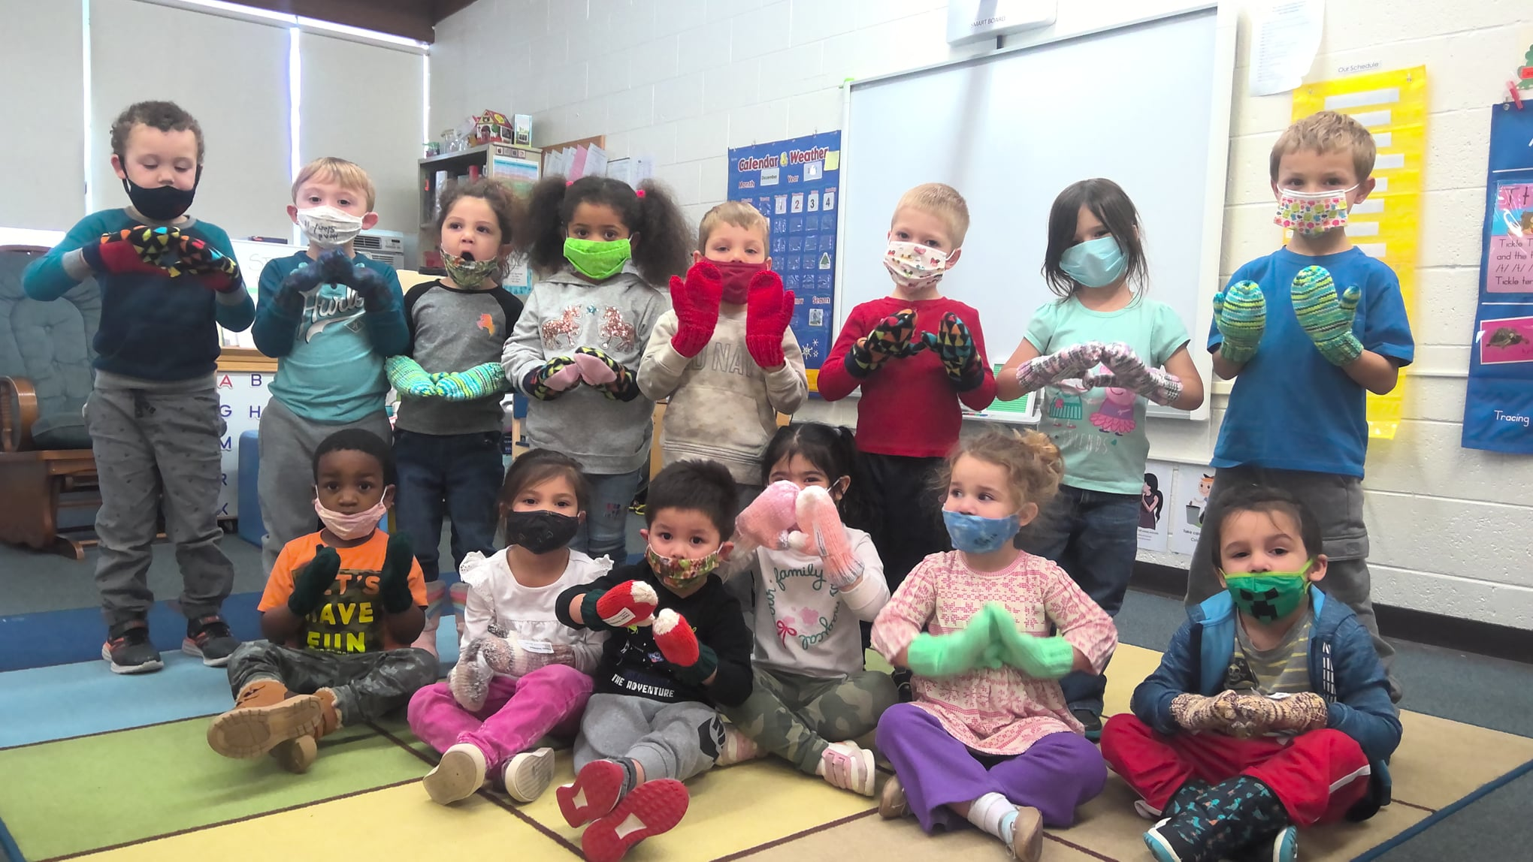
• 85% Non-Hispanic origin
• 15% Hispanic origin
Enrollment by Primary Language:
• 90% English; 12% have 2nd Language
• 6% Hmong
• 4% Spanish

Percentage of Potential Eligible
Children in Community Served:
• Wausau School District – approx.82% served
• DCE School District – approx. 52% served
• Mosinee School District – approx. 75% served

Of the Children Enrolled:
• 100% had health insurance (at enrollment)
• 75% had a medical home (at enrollment)
• 95% were up-to-date with immunizations
• 69% were up-to-date with health services
• 67% had a dental home
• 83% had a dental exam in the last year
• 32% needed professional dental treatment
• 26% received needed dental treatment
• 28% had behavioral/mental health concerns
• 14% needed mental health referral
• 10% received needed mental health services

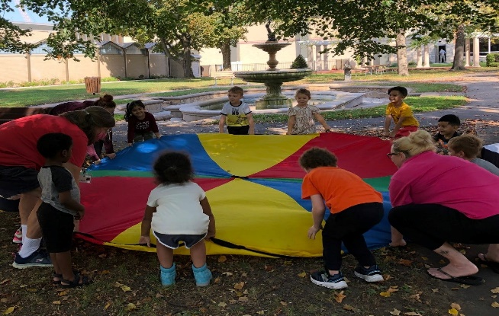

Total enrollment of families: 98 Family structure
• 59% are single-parent families
• 41% are two-parent families

Services
• 96% needed emergency/crisis intervention
• 100% received at least 1 referral or received family services (i.e. housing, food resources, medical referral, parenting education)
• 66% received parenting education
• 20% received mental health services
• 10% received asset building services
• 100% received transition support services
• 2% assistance to incarcerated individuals • 6% experienced homelessness during year
• 90 current or former parents volunteered services
Unfortunately we could not serve all who requested programming!
Children are admitted based on need on a prioritized scale. We reduced the numbers of children served in each classroom due to COVID-19 pandemic concerns.

PROGRAM HIGHLIGHTS FOR 2020-21

Staff Professional Development

At the end of the 2020-21 program year, 2 additional Teacher Assistants completed their Associate Degree in Early Childhood Education. This brings our totals to date: 85% Completed AA Degree in ECE; 5% Actively enrolled in coursework to complete AA Degree in ECE; and 10% Completed Child Development Associate Certificate. 100% of our Teachers have their Bachelor’s Degree in Early Childhood Education. Our Director of Educational Services and Mentor/Coach have Master’s Degrees in Educational Leadership and ECE.

School Readiness Goals

The Federal Improving Head Start for School Readiness Act requires Head Start programs to establish school readiness goals. Using the Creative Curriculum as our curriculum guide and Creative Curriculum GOLD as our assessment tool, MCCDA Head Start has developed goals that align with the Head Start Child Development and Early Learning Framework, The Wisconsin Model Early Learning Standards, and the benchmarks set for 4K at both the Mosinee and DC Everest School Districts.
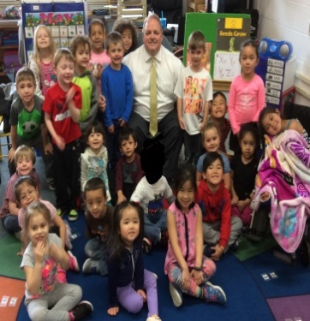
Due to the COVID-19 pandemic which closed down our in-person services mid-March 2020, we re-opened for in-person services for 4 year olds ONLY (most returning for their 2nd year of Head Start) and a few 3 year old siblings. We enrolled a few more 3 year olds in Spring 2021 as it was The teachers continued to make specific mention of the SLO indicators in their lesson plans. All children displayed growth and development over the year with the greatest gains in growth being made by the 4 year old children.

Key to Table: BLUE = 3 to 4 year olds RED = 4 to 5 year olds GREEN = Children with IEPs PURPLE = Early Language Learners YELLOW = Full Program/All Children

Congratulations!!!
to our Staff Members on Achieving these Anniversary Milestones in 2020-21:

5 Years of Service
Belinda Yang
Tammy Smith
Rhonda Siikarla
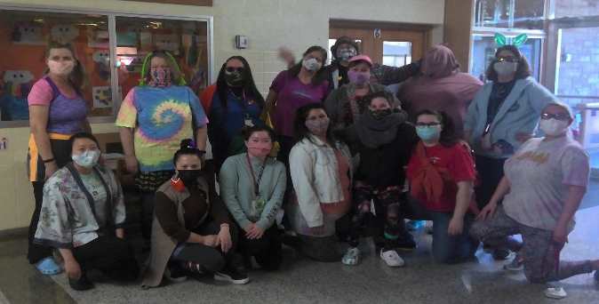
15 Year of Service
Karla Edelburg
Lou Alvarez
20 Year of Service

10 Years of Service Heidi Ernst
Nicole Guthrie Kao Her

