TREASURE MAP 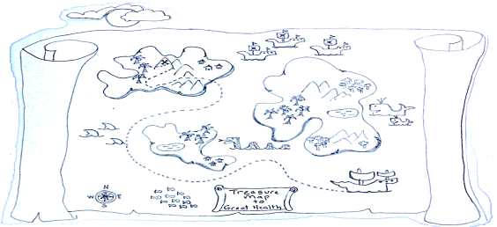 TO…
GREAT HEALTH
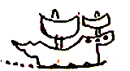START. Wherever you are. Make your ship as seaworthy as you can. Life on the sea. Let the adventure begin. You have a destination. It’s a journey toward Great Health. You have a 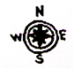compass and a map. You are part of a crew. There may be 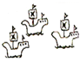pirates bearing potato chips, Key Lime Pie, and Oreos. They may want to steal your dream. There will be unexpected 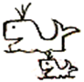 delights. And unexpected frights 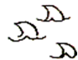 that might make you want to pack up your sails and go home. There will be life giving 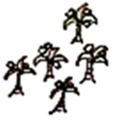coconut trees everywhere. They provide water, food and shelter. All you have to do is choose them. There will befair weather and storms. There will be  tall peaks that need to be crossed.
There will be 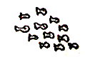 schools of fish. Which school will you join? There will be  fresh water - a God send when surrounded by a salty sea. There will be imagined 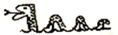dangers. There will be people that want to help you.
And there will be an END and a VICTORY - on a mountain top. You are where you want to be. Always moving toward your treasure of Great Health. And you never,
never, never give up.
What is working? | What still needs a little work?
