CHELMSFORD & DISTRICT BOWLING ASSOCIATION

Associate Member of the English B.A
Associate Member of the Essex County B.A

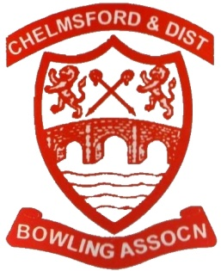

President's Tour 2025

President, Mrs Andrea Garbutt, is taking her tour to Weymouth staying at the
Prince Regent Hotel Weymouth.

The tour next year goes on Saturday 5th July returning on Sunday 13th July.

During the eight days we will be playing six games with one day off, to do as
you please.
Andrea, Angela and myself have visited the hotel.

The Hotel will be half board.

Mornings are free to spend at your leisure.

With entertainment every evening.

The cost of the tour will be. £670per person. (No more)

Single rooms will be £665 or £ 650!! I will explain, per person. (No more)

Please get you tour deposit in as soon as you can to secure a room.

Coach pickups to be advised.

Further information can be obtained by ringing Alby on 01621778487 / 07768522540.

or Mavis on. 01621772514. Alby’s email is. albert.evans44@gmail.com

Regards Alby (Hon Tour Secretary)

