SPECIAL MEETING
JANUARY 2, 2020

A Special Meeting of the Town Board of the Town of Hampton, County of Washington and the State of New York was held at the Town Hall, 2629 State Route 22A, Hampton, New York on the 2nd day of January 2020.

PRESENT: David K. O’Brien------------Supervisor
Tamme Taran----------------Councilwoman
Donald Sady-----------------Councilman
Andrea Sweeney------------Councilwoman
Michael Pietryka----------- Councilman
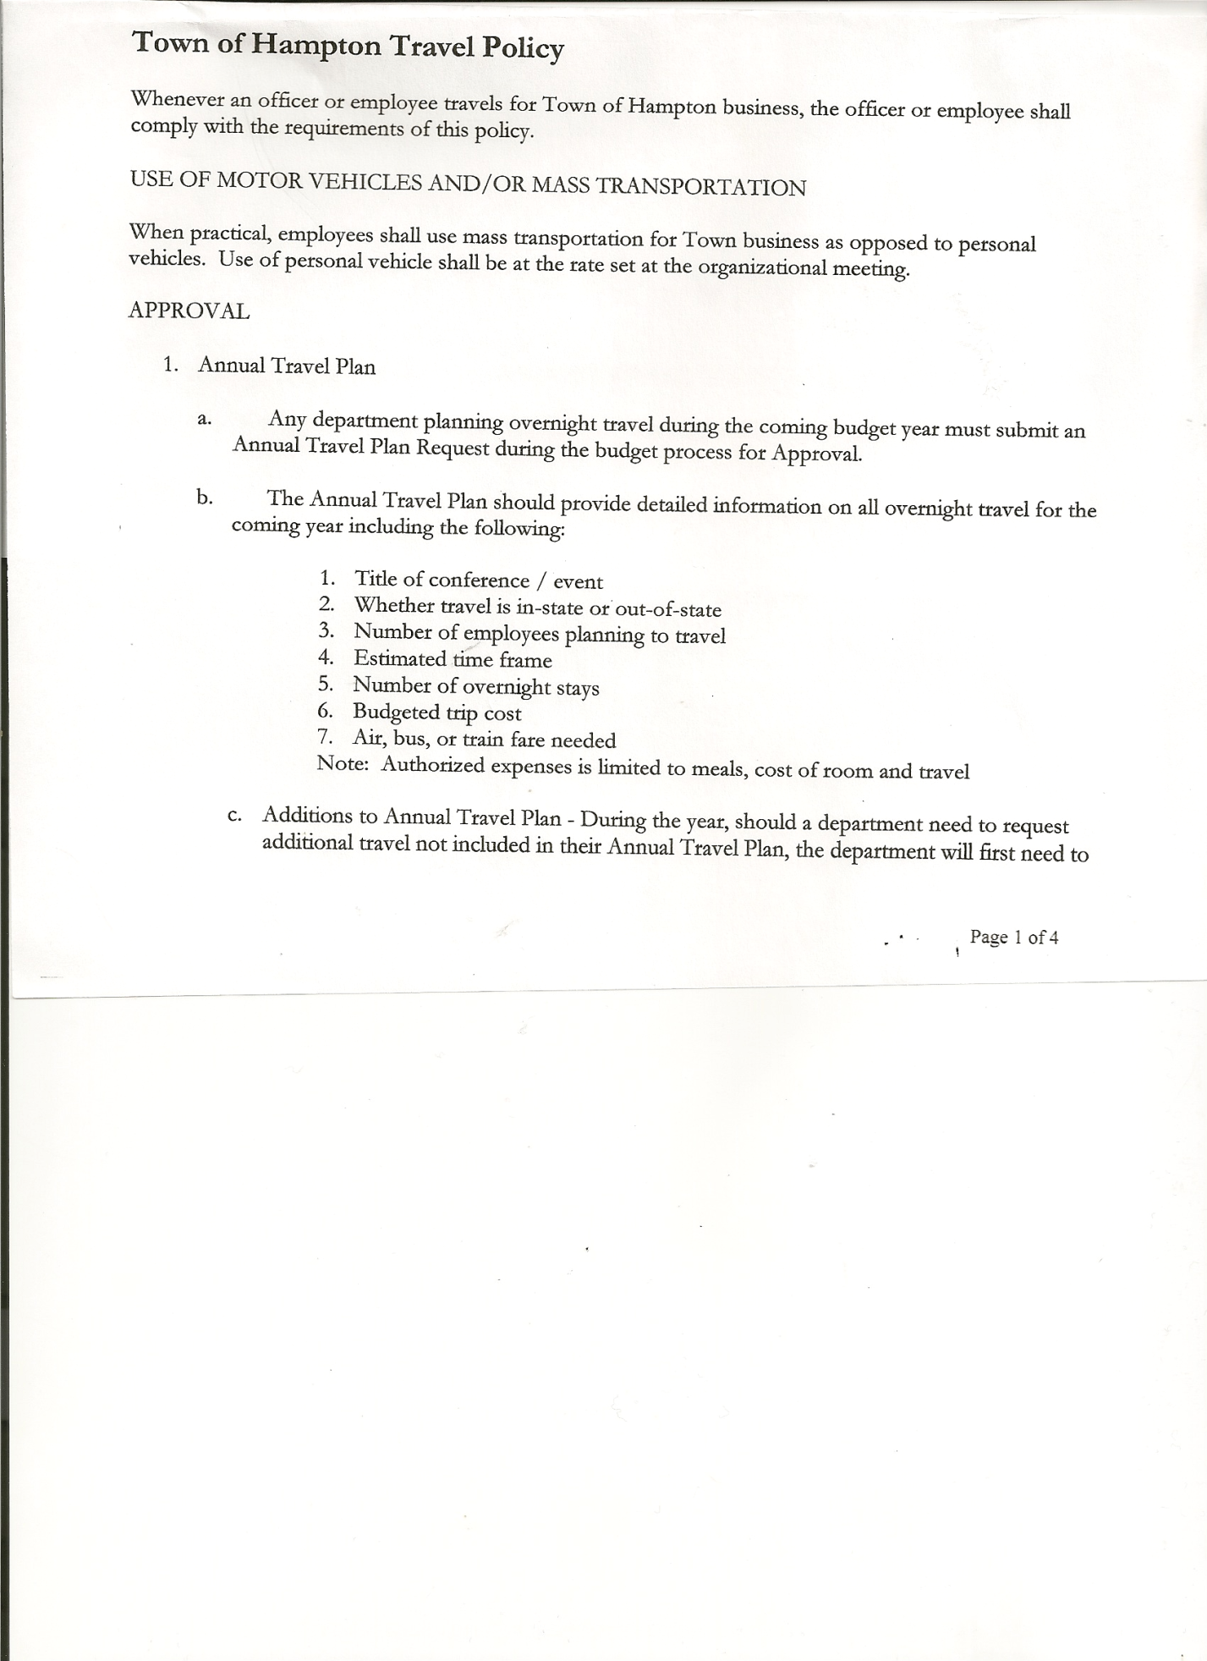
Rebecca Jones---------------Town Clerk
Camilla Shaw----------------Tax Collector/Deputy Town Clerk-absent
Herbert Sady, Jr.-------------Highway Superintendent

Planning Board Members: Matthew Pratt

Also present: Artie Pratt

The Special Meeting was called to order by Supervisor O’Brien at 7:00pm, followed by the Pledge of Allegiance. Location of Fire Exits were given. Quorum of board members present.

OATH OF OFFICE
The Oath of Office was administered to the Elected Officials present:
- David O’Brien – Town Supervisor (Oath was actually administered on Wednesday, January 1st, 2020 so that Supervisor O’Brien could participate in Committee meetings at the County on January 2nd,2020)
- Tamme Taran - Town Councilwoman
- Michael Pietryka – Town Councilman
The Oath of Office was also administered to the Appointed Officials present:
- David O’Brien-Local Compliance Officer; Point of Contact for NIMS and Association
of Towns Voting Delegate
- Donald Sady-Deputy Town Supervisor
- Tamme Taran-Health Officer
- Andrea Sweeney – Member of the Ethics Board
- Matthew Pratt-Member of Planning Board & Ethics Board
Judge Sady administered the Oath of Office to Rebecca Jones as Registrar of Vital Statistics; Deputy Tax Collector and Association of Towns Alternate Voting Delegate prior to the meeting.
Town Clerk Jones will administer Oath of Office to other Appointed Officials by January 31st, 2020.

Councilman Sady inquired about salary for Bookkeeper/Budget Officer. Supervisor O’Brien stated that was the amount approved in the Budget. The Board does have the authority via Local Law to change the salaries of Officials after the Budget process. Following a brief discussion, the Board opted not to do so.

TOWN BOARD MEETING
JANUARY 2, 2020 PAGE 2

RESOLUTION NO. 1-2020
HAMPTON ORGANIZATIONAL CHARTER FOR 2020
On a motion of Councilman Sady, seconded by Councilman Pietryka, the following resolution was ADOPTED: Ayes 5 O’Brien, Sady, Taran, Sweeney, Pietryka
Nays 0
RESOLVED, that upon review the Hampton’s Organizational Charter for 2020 is adopted as proposed and amended.

RESOLUTION NO. 2-2020
HAMPTON TOWN POLICIES
On a motion of Councilwoman Taran, seconded by Councilwoman Sweeney, the following resolution was ADOPTED: Ayes 5 O’Brien, Sady, Taran, Sweeney, Pietryka
Nays 0
RESOLVED, that upon review the following Policies:
- Travel Policy
- Investment Policy
- Cell Phone Policy
- Sexual Harassment Policy
- Workplace Violence Policy
- Procurement Policy
- Credit Card Policy
- On-line Banking Policy
- Ethics Policy
- Computer Usage Policy
- Record Storage Policy
- Employee Handbook
- Drug/Alcohol Testing Policy
- Town Hall Use
- Road Side Tree Policy
- Cyber Security Policy
Of the Town of Hampton are approved.

RESOLUTION NO. 3-2020
PROCUREMENT POLICY 2020
On a motion of Councilwoman Taran, seconded by Councilman Sady, the following resolution was ADOPTED: Ayes 5 O’Brien, Sady, Taran, Sweeney, Pietryka
Nays 0
RESOLVED, to accept the Procurement Policy for 2020 (copy is attached)

RESOLUTION NO. 4-2020
On a motion of Councilman Sady, seconded by Councilwoman Sweeney, the following resolution was ADOPTED: Ayes 4 Sady, Taran, Sweeney, Pietryka
Nays 0
Abstain 1 O’Brien
RESOLVED, to accept David O’Brien’s three (3) months Record of Activities for Retirement purposes.

TOWN BOARD MEETING
JANUARY 2, 2020 PAGE 3

Yearly Audits….Town Justice, Town Clerk, Tax Collector and Bookkeeper to be done on Thursday, January 16th, 2020.
Quarterly Audits also need to be scheduled.

PUBLIC COMMENTS/COUNCIL COMMENTS
Resident Matthew Pratt inquired about the Bookkeeper/Budget Officer position. Town Supervisor indicated that the current bookkeeper/budget officer, Kim Perry, may not be resigning.

On a motion of Councilwoman Taran, seconded by Councilman Sady, the meeting adjourned at 7:28pm. All in favor Aye.

Respectfully submitted,

Rebecca S. Jones, RMC
Town Clerk

