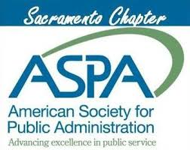 | Application for the ASPA Sacramento Chapter Scholarship  Award for the Pursuit of Public Service | 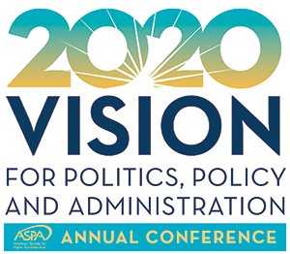

The Sacramento Chapter of ASPA is pleased to offer a scholarship (monetary award) to support a Sacramento region public administration professional/student! The objective of this award is to promote interest in public service as a career. The scholarship includes:
- Membership in ASPA (if not already a member),
- Financial support for participation in the 2020 ASPA National Conference in Anaheim, CA on April 3-7, 2020, and
- Ticket to the 2020 Sacramento Chapter Awards Dinner on May 6, 2020.

Desirable Qualifications:
- Applicant is pursuing an advanced degree (Master’s or Doctoral level).
- Applicant is currently working in a public service position or internship.

Minimum Qualifications:
- Applicant must be a current student pursuing a college-level degree (BA, BS, Master’s or Doctoral level).

Application Instructions:
- Complete the application in total, incomplete applications may lead to disqualification.
  - Application form
  - Current or most recent transcript (unofficial copies accepted)
  - Resume (no page limit)
  - Personal statement (2 page limit)
- Submit the following documents as a PDF to the Dropbox link on the Sacramento Chapter website: http://www.sacramento-aspa.info

Deadline to submit: Friday, December 20, 2019

For questions on the application process, please contact sacramentoASPA@gmail.com

For information on the ASPA National Conference, visit: https://www.aspanet.org/ASPA/Events/Annual-Conference/Annual-Conference.aspx

Please note that the conference is fully accessible, and we encourage people of all abilities to participate.

During the Conference:
Fellow ASPA members from the Sacramento Chapter will meet with the scholarship recipient and introduce them to other ASPA members. This scholarship presents an opportunity to network and interact with ASPA’s diverse practitioner and academic community. The scholarship recipient should be ready and willing to participate in functions throughout the conference. Ideally, the recipient will share their conference experience via social media including Sacramento ASPA’s Twitter and Facebook feeds.

After the Conference:
One of the Sacramento Chapter Board members will request a follow-up interview with the scholarship recipient after the conference to hear about impressions of the conference – interview responses will be published in the Chapter newsletter and on the Chapter website.

APPLICATION FORM

- Full Name:
- Mailing Address:
- Email Address:
- Phone Number:
- Education
  - School:
  - Degree:
  - Completion Date (or anticipated date):
- Current Employer/ Internship:

Personal Statement: provide a response to both questions and limit to 2 pages.
- What makes you passionate about public service?
- How will you benefit from attending the ASPA National Conference?

