REGULAR MEETING
MAY 16, 2019

A Regular Meeting of the Town Board of the Town of Hampton, County of Washington and the State of New York was held at the Town Hall, 2629 State Route 22A, Hampton, New York on the 16th day of May 2019.

PRESENT: David K. O’Brien------------Supervisor
Tamme Taran----------------Councilwoman
Donald Sady-----------------Councilman
Andrea Sweeney------------Councilwoman - absent
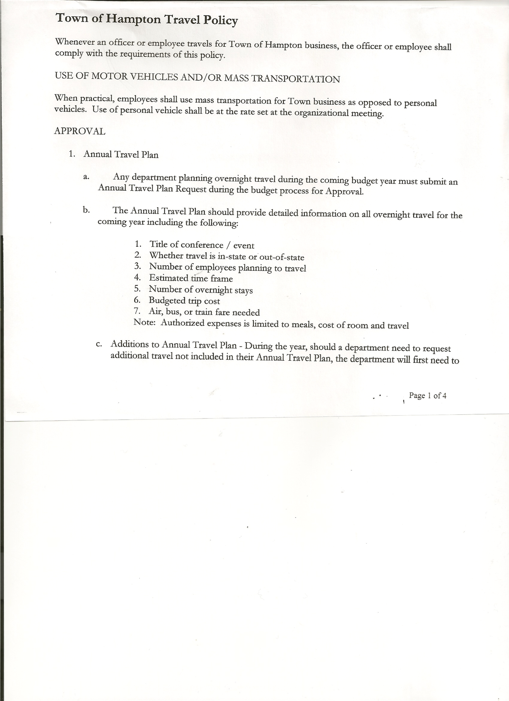
Roger Weeden---------------Councilman
Rebecca Jones---------------Town Clerk
Camilla Shaw----------------Tax Collector/Deputy Town Clerk
Herbert Sady, Jr.-------------Highway Superintendent

Planning Board Member(s): Bonnie Hawley, Chair and Matthew Pratt

Also present: see attached list

The Regular Meeting was called to order by Supervisor O’Brien at 7:30pm, followed by the Pledge of Allegiance. Location of Fire Exits were given. Quorum of board members present.

Supervisor O’Brien asked for a moment of silence in memory of Leo Dewey and Phil Lussier.

RESOLUTION NO. 51-2019
APPROVAL OF THE MINUTES
On a motion of Councilman Sady, seconded by Councilman Weeden, the following resolution was ADOPTED: Ayes 4 O’Brien, Taran, Sady, Weeden
Nays 0
Absent 1 Sweeney
RESOLVED, that the Regular Town Board Minutes for April 18th, 2019 are approved.

Camilla Shaw, Tax Collector- Zero balance. Submitted a Bank Statement to the Board for review and signatures.

Larry Carman, Dog Control Officer…submitted his report, which was read by Supervisor O’Brien, copy of report is attached for 4/15/19 - 5/13/19.

Planning Board Report…
- Planning Board Members have completed the required Workplace Violence/Sexual Harassment Training
- Next meeting will be June 13th, 2019 @ 7:00pm at the Town Hall
(Thursday instead of Wednesday for June)

Herbert Sady, Jr., Highway Superintendent submitted his report, copy of which, is attached.
Replacing four (4) culverts on Roberts Lane, one (1) on Rainbow Way, which may come from the County at no charge, otherwise the Residents of Rainbow Way will need to pay for.
Further discussed weight limits on dirt roads. Board opted not to put a weight limit on them at this time.
Uniforms…prices have gone up, the fellas are discussing buying their own pants and shirts.
TOWN BOARD MEETING
MAY 16, 2019 PAGE 2

Five Year projection for Highway Department…Councilman Roger Weeden and Highway Superintendent Herb Sady will be working on this.
Discussed progress on Grant for new Highway Truck, still in process.
Following the discussion, the following resolution was introduced.

RESOLUTION NO. 52-2019
BOND ANTICIPATION NOTE
On a motion of Councilman Sady, seconded by Councilman Weeden, the following resolution was ADOPTED:
By Roll Call Vote: Supervisor O’Brien AYE
Councilman Sady AYE
Councilman Weeden AYE
Councilwoman Taran NAY
Councilwoman Sweeney ABSENT
RESOLVED, to authorize Supervisor O’Brien to sign the necessary Bond Paperwork.

RESOLUTION NO. 53-2019
MOWING CONTRACT
On a motion of Councilwoman Taran, seconded by Councilman Weeden, the following resolution was ADOPTED: Ayes 4 O’Brien, Taran, Sady, Weeden
Nays 0
Absent 1 Sweeney
RESOLVED, that Herb Sady, Highway Superintendent, be authorized to sign the Washington County Mowing Contract for 2019.

RESOLUTION NO. 54-2019
APPROVAL OF SUPERVISOR’S MONTHLY REPORT
On a motion of Councilwoman Taran, seconded by Councilman Sady, the following resolution was ADOPTED: Ayes 4 O’Brien, Taran, Sady, Weeden
Nays 0
Absent 1 Sweeney
RESOLVED that, the Supervisor’s Monthly report be accepted as submitted for APRIL
3/31/19 04/30/19
ACCOUNT BALANCE RECEIPTS DISBURSEMENTS BALANCE
General Fund $ 68,646.95 $ 4,330.15 $ 7,312.58 $ 65,664.52
Highway Fund $169,278.21 $ 6.76 $ 17,559.68 $151,725.29
Equipment Reserve $123,667.24 $ 5.08 $ 0.00 $123,672.32
Fire #1 $ 41,616.00 $ 0.00 $ 0.00 $ 41,616.00
Fire #2 $ 7,756.00 $ 0.00 $ 0.00 $ 7,756.00
Cemetery $ 1,713.60 $ 2.10 $ 0.00 $ 1,715.70
Totals $412,678.00 $ 4,344.09 $ 24,872.26 $392,149.83
All Board Members present signed Supervisor’s Report.

OLD BUSINESS
Hampton Fire Co. has agreed to a signage board on the building. Matt Pratt will get something in writing.
TOWN BOARD MEETING
MAY 16, 2019 PAGE 3

The Town Clerk’s report for April 2019 was submitted to the Board. The Town Clerk had Board Members review and sign bank reconciliation statements for the Town Clerk Account and Special Town Clerk Account dated April 30th, 2019.

PUBLIC COMMENTS/COUNCIL COMMENTS
Tax Assessment Revaluation….will need to discuss with Town Assessor
Bonnie Hawley asked about procedure for Grievances….Grievance Day is May 30th.

Hannah Jones, daughter of Town Clerk Rebecca Jones & David Jones will be graduating Magna Cum Laude this Sunday, May 20th, 2019 from St. Lawrence University with her Bachelor Degree in Biology. She is then headed to the University of Maine, Portland to Graduate School for her Doctorate in Physical Therapy.

RESOLUTION NO. 55-2019

AUDIT OF CLAIMS
On a motion of Councilwoman Taran, seconded by Councilman Sady, the following resolution was ADOPTED: Ayes 4 O’Brien, Taran, Sady , Weeden
Nays 0
Absent 1 Sweeney
RESOLVED that the bills have been reviewed by the Town Board and are authorized for payment in the following amounts.
General Fund No. 72 through No. 87 $ 4,560.57
Highway Fund No. 41 through No. 52 $10,873.98
Total both funds $15,434.55

On a motion of Councilwoman Taran, seconded by Councilman Sady, the meeting adjourned at 8:23pm. All in favor Aye.

Respectfully submitted,

Rebecca S. Jones, RMC
Town Clerk

