Sea Dragon’s JULY 2024
SUNDAY |  |  | MONDAY | TUESDAY | WEDNESDAY | THURSDAY | FRIDAY | SATURDAY
 |  | 30 | 1 | 2 | 3 | 4 | 5 | 6
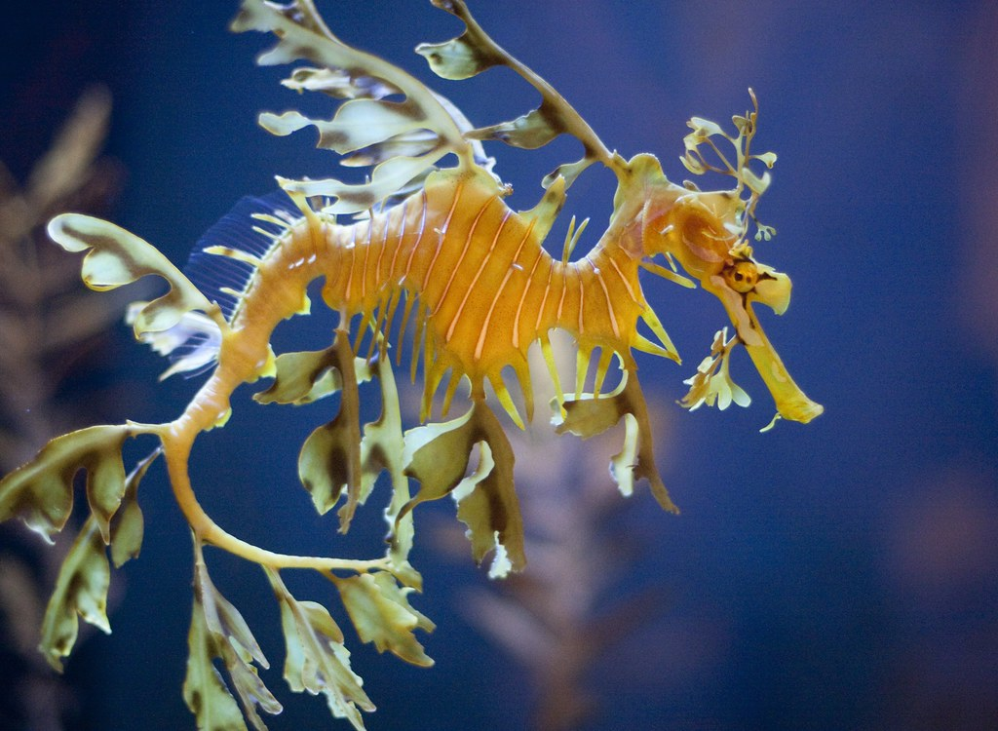  This Photo by Unknown Author is licensed under CC BY-NC-ND |  |  | Closed  Canada Day | Esquimalt Lagoon | Langford Water Park | Royal Bay Beach | Glen lake Water Park
 | 7 |  | 8 | 9 | 10 | 11 | 12 | 13
 |  |  | Witty’s Lagoon | Bamberton Beach | Central Saanich Park  Crazy Hair Day | Esquimalt Water Park | Aylard  Farm | 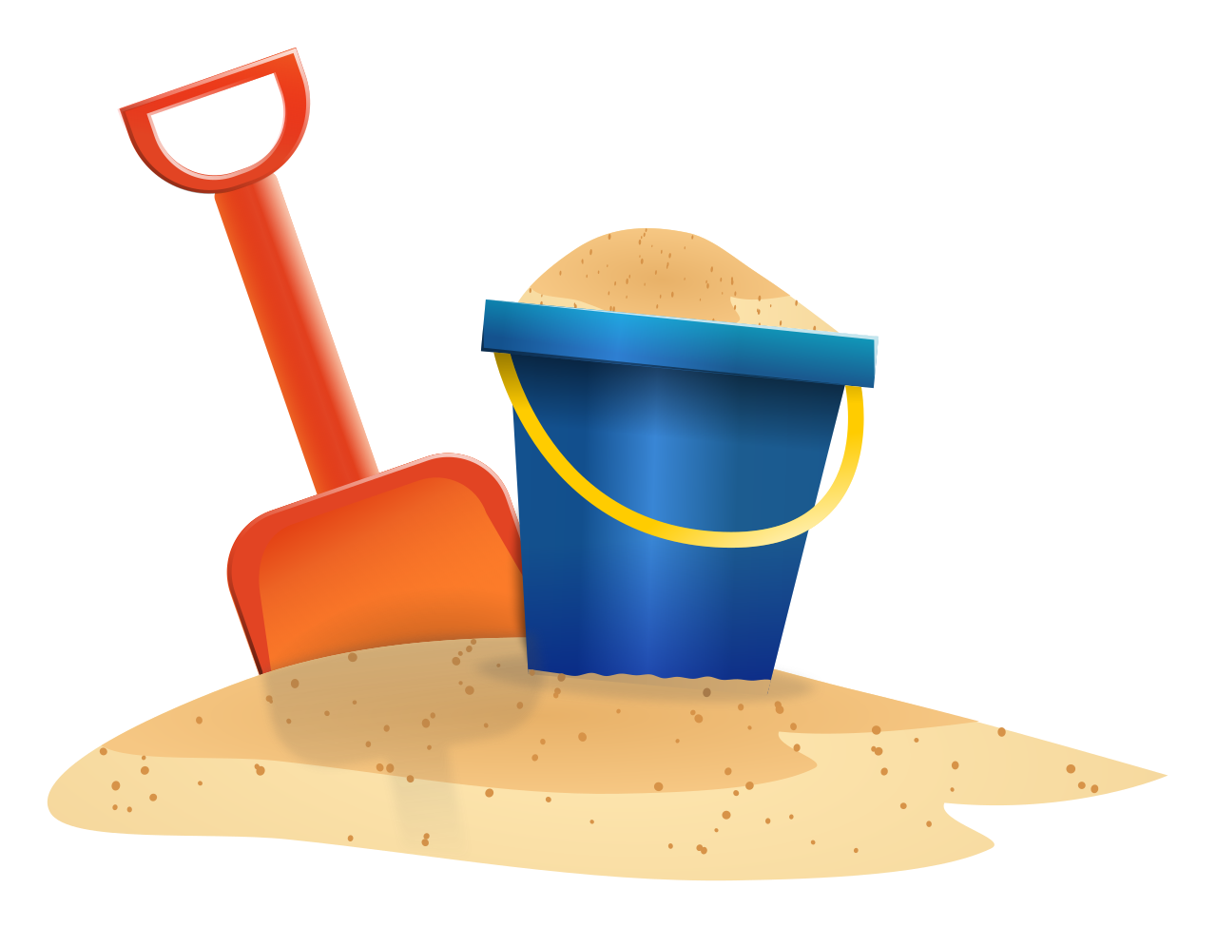  This Photo by Unknown Author is licensed under CC BY-SA
 | 14 |  | 15 | 16 | 17 | 18 | 19 | 20
 |  |  | Gyro  Park | Peter Pan Water Park | Island View Beach | Devonian Beach Trail | Sydney Water Park
 | 21 |  | 22 | 23 | 24 | 25 | 26 | 27
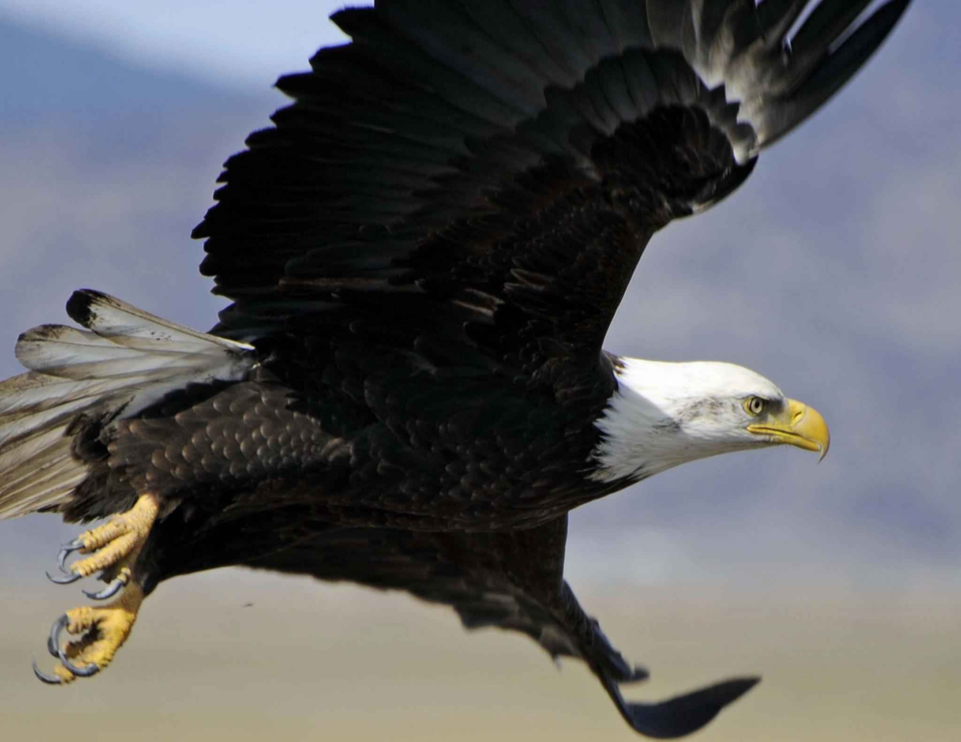 |  |  | Beckwith Water Park | Beacon Hill Water Park | Raptor’s  $13.50 | Whiffin  Spit | Central Saanich Park
 | 28 |  | 29 | 30 | 31 | 1 | 2 | 3
 |  |  | Mt Doug  Tinker Town | Sooke Water Park | Cloverdale Water Park |  | 

