REGULAR MEETING

JANUARY 16, 2025

The Regular Meeting of the Town Board of the Town of Hampton, County of Washington and the State of New York was held at the Town Hall, 2629 State Route 22A, Hampton, New York, on the 16th day of January 2025.

PRESENT: David K. O’Brien------------Supervisor

Donald Sady----------------- Councilman

Tamme Taran----------------Councilwoman

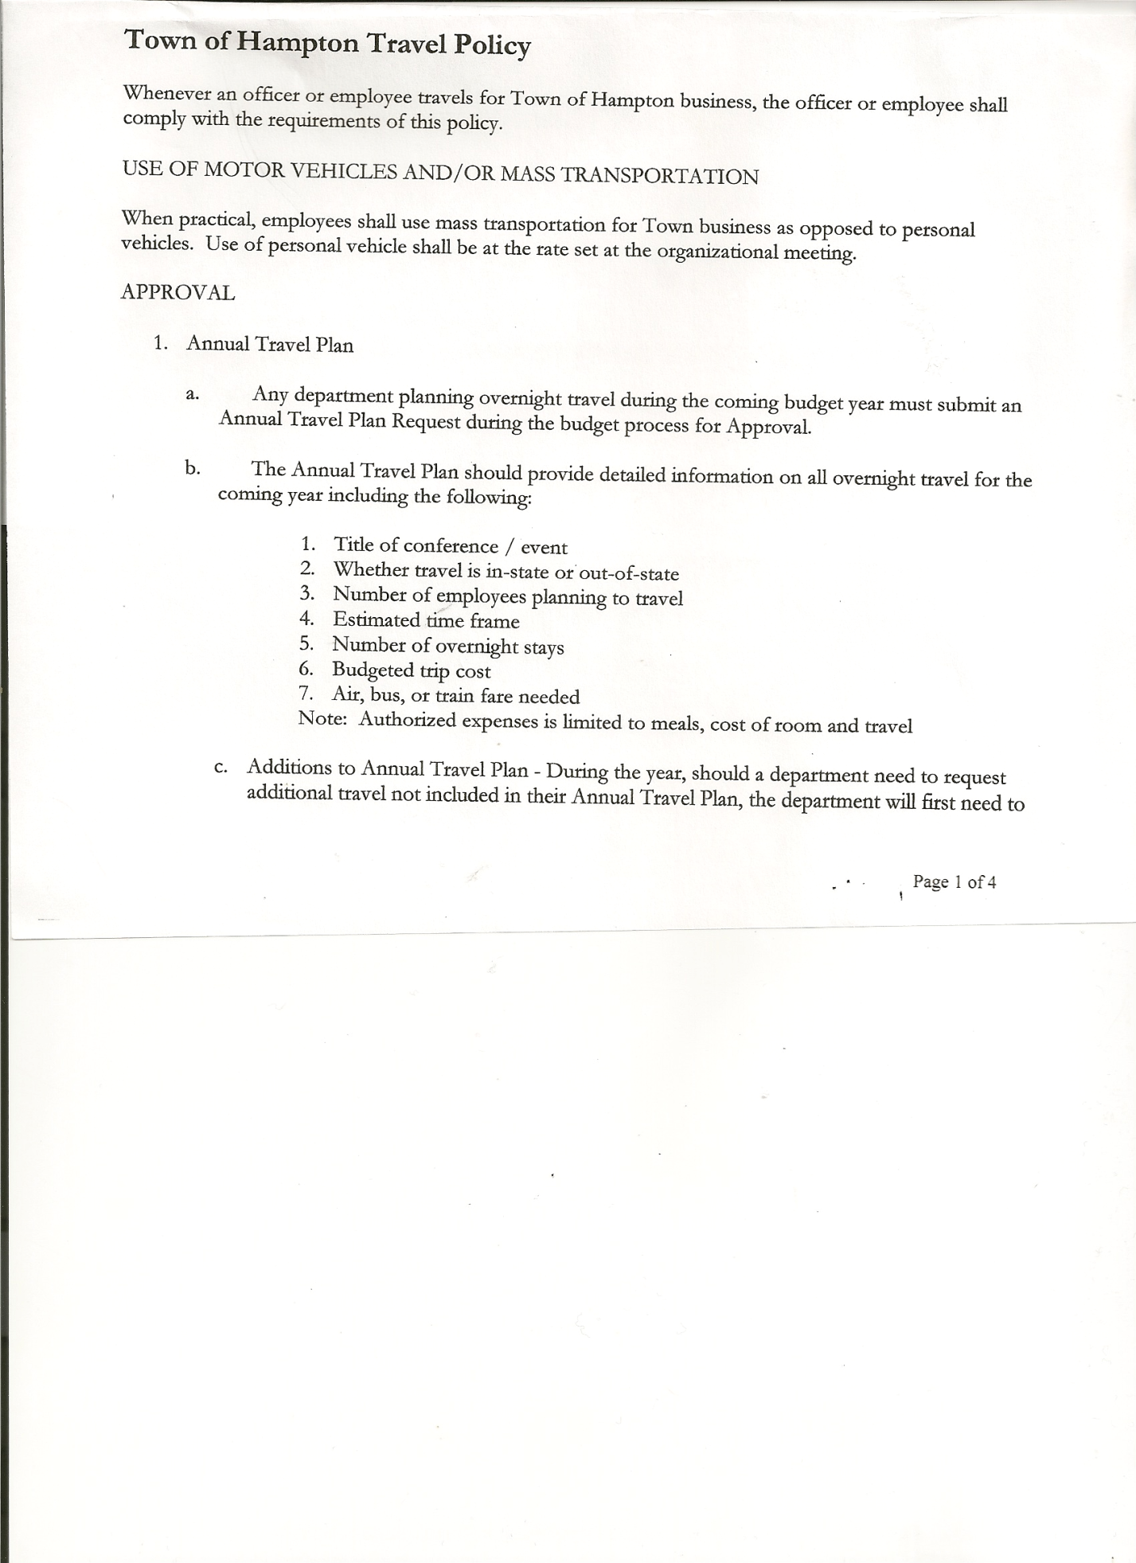 Michael Pietryka------------Councilman

Andrea Kugler---------------Councilwoman

Rebecca Jones---------------Town Clerk

Camilla Shaw----------------Deputy Town Clerk - absent

Tyler McClure---------------Highway Superintendent

Planning Board Member (s):… Bonnie Hawley, Chair and Rene Rountree

Others present at the Town Hall: EJ Conzola (NYVT Media Reporter) and Artie Pratt

The Regular Meeting was called to order by Supervisor O’Brien at 7:30pm, followed by the Pledge of Allegiance. Location of Fire Exits were given. Quorum of board members present.

**RESOLUTION NO. 9-2025**

**APPROVAL OF THE MINUTES**

On a motion of Councilman Sady, seconded by Councilwoman Taran, the following resolution was ADOPTED: AYES 5 O’Brien, Sady, Pietryka, Taran, Kugler

NAYS 0

RESOLVED, that the Regular Town Board Meeting Minutes for December 19th, 2024 and the Special Town Board Meeting Minutes (Organizational Meeting of 2025) for January 2, 2025 are approved.

Dog Control Officer….no report

Tax Collector Report….Tax bills were sent out at the end of December 2024. As of January 14th, amount collected was $242,451.28. The Town Clerk/Collector had Board Members review and sign bank reconciliation statements for the Tax Collector Account dated December 31st, 2024.

Bonnie Hawley, Chair Planning Board….Planning Board Meeting was held January 8th 2025, copy of the minutes is attached. Next meeting will be February 12, 2025 @7:00 at the Town Hall.

Supervisor O’Brien has spoken with John Mead regarding the Town Historian position. John has indicated he would like to remain as the Town Historian.

TOWN BOARD MEETING

JANUARY 16, 2025 PAGE 2

HIGHWAY – BID for the 2012 Dodge 3500 1-ton.

One bid was received from Dean Mullen, 10 Washington St., Cambridge, NY for $2500.00.

Following a discussion between the Highway Superintendent and Town Board, the following resolution was made:

**RESOLUTION NO. 10-2025**

**HIGHWAY – BID**

On a motion of Councilman Sady, seconded by Councilwoman Taran, the following resolution was ADOPTED: AYES 5 O’Brien, Sady, Pietryka, Taran, Kugler

NAYS 0

RESOLVED, to reject the bid received and to put out to bid again.

Tyler McClure, Highway Superintendent…submitted his report, copy of which is attached.

As indicated in his Highway report, Tyler received two (2) quotes on bit systems for the Grader.

One is from Chemung Supply for $2930.00 for Wolverine stinger blade, Tyler has spoken with other Highway Superintendents, none of which use this type.

The second one is from Kay Kenneally for $4390.00 for Heavy Duty Carbide Bits.

**SUPERVISOR’S REPORT/COUNTY UPDATES/COMMUNICATIONS**

**RESOLUTION NO. 11-2025**

**BUDGET AMENDMENTS-GENERAL FUND**

On a motion of Councilwoman Taran, seconded by Councilman Pietryka, the following resolution was ADOPTED:

By Roll Call Vote: Supervisor O’Brien AYE

Councilman Sady AYE

Councilwoman Taran AYE

Councilman Pietryka AYE

Councilwoman Kugler AYE

RESOLVED that, the following Budget Amendments to the General Fund are approved:

EXPENSES:

Increase Justice CE Account A1110 in the amount of $3,296.00

Increase Town Clerk PS Account A1410.1 in the amount of $261.33

Increase Unallocated Insurance Account A1910.1 in the amount of $386.80

Increase Municipal Association Dues Account A1910.2 in the amount of $75.00

Increase Central Printing & Mailing CE Account A1670.4 in the amount of $3,745.07

Increase Payment to Treasurer Account A1972.4 in the amount of $1,140.00

Increase Payroll Expenses Account A6560 in the amount of $47.68

Increase Planning Board CE Account A 8020.4 in the amount of $500.20

Increase Employee Training Account A91489.8 in the amount of $15.40

**TOTAL $9,467.48**

TOWN BOARD MEETING

JANUARY 16, 2025 PAGE 3

**RESOLUTION NO. 12-2025**

**BUDGET AMENDMENTS-GENERAL FUND**

On a motion of Councilman Sady, seconded by Councilwoman Kugler, the following resolution was ADOPTED:

By Roll Call Vote: Supervisor O’Brien AYE

Councilman Sady AYE

Councilwoman Taran AYE

Councilman Pietryka AYE

Councilwoman Kugler AYE

RESOLVED that, the following Budget Amendments to the General Fund are approved:

Decrease Contingent Fund Account A1990.4 in the amount of $3,371.00

Decrease Town Clerk CE Account A1410.4 in the amount of $261.33

Decrease Buildings CE Account A1620.4 in the amount of $386.80

Decrease Control of Dogs PS Account A3510.1 in the amount of $945.07

Decrease Garage CE Account A5132.4 in the amount of $1,140.00

Decrease Ambulance CE Account A4540.4 in the amount of $2,800.00

Decrease Historian PS Account A7510.1 in the amount of $47.68

Decrease State Retirement Account A9010.8 in the amount of $500.20

Decrease Cemeteries CE Account A8810.4 in the amount of $15.40

**TOTAL $9,467.48**

**RESOLUTION NO. 13-2025**

**BUDGET AMENDMENTS-HIGHWAY FUND**

On a motion of Councilman Sady, seconded by Councilwoman Taran, the following resolution was ADOPTED:

By Roll Call Vote: Supervisor O’Brien AYE

Councilman Sady AYE

Councilwoman Taran AYE

Councilman Pietryka AYE

Councilwoman Kugler AYE

RESOLVED that, the following Budget Amendments to the Highway Fund are approved:

EXPENSES:

Increase Uniforms Account DA9089.8 in the amount of $228.47

Increase Machinery Equipment Account DA5130.2 in the amount of $87,085.00

Increase Capital Reserve Account DA230 in the amount of $87,085.00

Decrease Medical Insurance Account DA9060.8 in the amount of $228.47

**RESOLUTION NO. 14-2025**

**BUDGET ADJUSTMENT- GENERAL FUND**

On a motion of Councilman Sady, seconded by Councilwoman Taran, the following resolution was ADOPTED:

AYES 5 O’Brien, Sady, Pietryka, Taran, Kugler

NAYS 0

RESOLVED to move the amount of $16,200.00 in the 2025 Town Budget from Personnel Personal Service Account# A1430.1 to Supervisor Contractual Expense Account #A1220.4.

TOWN BOARD MEETING

JANUARY 16, 2025 PAGE 4

**RESOLUTION NO. 15-2025**

**APPROVAL OF SUPERVISOR’S MONTHLY REPORT**

On a motion of Councilman Sady, seconded by Councilwoman Taran, the following resolution was ADOPTED: AYES 5 O’Brien, Sady, Pietryka, Taran, Kugler

NAYS 0

RESOLVED that, the Supervisor’s Monthlyreport be accepted as submitted for **DECEMBER**

ACCOUNT 12/01/24 Receipts Disbursed 12/31/24

Citizens Cemetery $ 3,028.71 $ .13 $ .00 $ 3,028.84

Citizens Total $ 3,028.71 $ .13 $ .00 $ 3,028.84

GFNB Fire, Trust & Agency $ 1,418.04 $ $ 0.00 $ 1,418.04

GFNB Fire, Trust & Agency ICS $ 33,805.00 $ $ 33,195.50 $ 609.50

GFNB Health Insurance $ 2,591.23 $ $ $ 2,591.23

GFNB Trust & Agency $ 7,725.90 $ 4,319.81 $ 4,332.88 $ 7,712.83

GFNB General Fund $ 11,970.30 $44,099.89 $ 49,941.07 $ 6,129.12

GFNB General Fund ICS $ 48,105.06 $ 215.71 $ 2,000.00 $ 46,320.77

GFNB Total $105,615.53 $48,635.41 $ 89,469.45 $ 64,781.49

GFNB Highway Fund $ 16,027.48 $ 29,923.83 $ 31,491.34 $ 14,459.97

GFNB Highway Fund ICS $ 99,022.67 $ 355.68 $ 22,000.00 $ 77,378.35

GFNB Capital Reserve $ 88,090.02 $ $ 87,085.00 $ 1,005.02

GFNB Capital Reserve ICS $ 66,383.39 $ 306.55 $ $ 66,689.94

GFNB Total $ 269,523.56 $ 30,586.06 $ 140,576.34 $159,533.28

TOTALS $378,167.80 $ 79,221.60 $ 230,045.79 $227,343.61

All Board Members present signed Supervisor’s Report.

**OLD BUSINESS**

Highway Department Personal Time Off Policy and John Mead as the Town Historian.

**RESOLUTION NO. 16-2025**

**ORGANIZATIONAL CHARTER FOR 2025 – ADDITIONS**

On a motion of Councilman Sady, seconded by Councilwoman Taran, the following resolution was ADOPTED: AYES 5 O’Brien, Sady, Pietryka, Taran, Kugler

NAYS 0

RESOLVED to add the new Highway Department Personal Time Off schedule and to add John Mead as the Town Historian.

**NEW BUSINESS**

**RESOLUTION NO. 17-2025**

**END OF YEAR AUDIT FOR CHIEF FISCAL OFFICER**

On a motion of Councilman Sady, seconded by Councilwoman Kugler, the following resolution was ADOPTED: AYES 5 O’Brien, Sady, Pietryka, Taran, Kugler

NAYS 0

RESOLVED, to accept the Chief Fiscal Officer (Bookkeeper) Audit for 2024.

TOWN BOARD MEETING

JANUARY 16, 2025 PAGE 5

**RESOLUTION NO. 18-2025**

**END OF YEAR AUDIT FOR TOWN CLERK and TAX COLLECTOR**

On a motion of Councilman Pietryka, seconded by Councilman Sady, the following resolution was ADOPTED: AYES 5 O’Brien, Sady, Pietryka, Taran, Kugler

NAYS 0

RESOLVED, to accept the Town Clerk and Tax Collector Audits for 2024.

**PUBLIC COMMENTS/COUNCIL COMMENTS**

* On-line version thru Quickbooks is changing
* Inquiry about speed limit signs on Ballard Rd and County Route 11- Ballard Rd is a dirt road, can not post speed limits on dirt roads; County Route 11 is a County Route, need to contact the County and State.
* Judge report
* Flag on a resident’s lawn, with an inappropriate word – Supervisor will ask the resident to kindly remove the flag.

**RESOLUTION NO. 19-2025**

**AUDIT OF CLAIMS**

On a motion of Councilman Pietryka, seconded by Councilwoman Taran the following resolution was ADOPTED:

AYES 5 O’Brien, Sady, Pietryka, Taran, Kugler

NAYS 0

RESOLVED that the bills have been reviewed by the Town Board and are authorized for payment in the following amounts.

General Fund No. 1 through No 12 $ 2,679.58

Highway Fund No. 1 through No.12 $ 7,884.45

Total both funds $ 10,564.03

The Town Clerk’s report for December 2024 was submitted to the Board. The Town Clerk had Board Members review and sign bank reconciliation statements for the Town Clerk Account and Special Town Clerk Account dated December 31st, 2024.

**RESOLUTION NO. 20-2025**

**MEETING ADJOURNED**

On a motion of Councilman Pietryka, seconded by Councilwoman Taran the following resolution was ADOPTED:

AYES 5 O’Brien, Sady, Pietryka, Taran, Kugler

NAYS 0

RESOLVED that the meeting adjourned at 8:39pm.

Respectfully submitted,

Rebecca S. Jones, RMC

Town Clerk