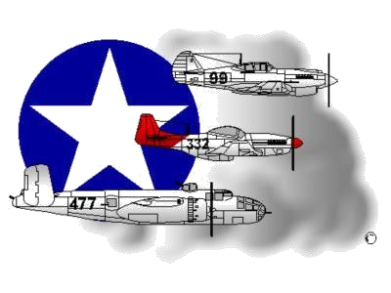 **BIOGRAPHY**

**__________________________________________________________**

**A DOCUMENTED ORIGINAL TUSKEGEE AIRMAN**

**Tuskegee Airmen Inc. Public Relations, P.O. Box 830060**

**Tuskegee, AL 36083**

# William R. White, Sr.



Mr. William R. White was born in Isle of Wight County, Virginia on November 13, 1926. He attended Middle School at Isle of Wight Training School (later known as West Side Training School and now called Isle of Wight West Side Middle School). Mr. White never got the opportunity to attend High School as his Father died and his Mother became ill forcing him to drop out of school after the 8th grade to work at an Isle of Wight farm and later, the Gwaltney Meat Packing Company.

Mr. White was drafted by the Army in April 1945 and boarded a train to Ft. Devens, Massachusetts for “boot camp” training school. While at Ft. Devens, Private (PVT) White did interact with German and Japanese prisoners of war (POW). The German POWs were cooks while Japanese POWs were ground keepers. One unforgettable interaction with a German POW was that PVT White was extra hungry one morning and requested a 2-pancake serving instead of the maximum 1-pancake serving. The German POW used foul language in addressing him and did not give him an extra pancake. After successfully completing boot camp 4-months later, Private First Class (PFC) White requested to be reassigned to the Army Air Corps at Ft. Meade, Maryland. PFC White’s request was denied because he was drafted into the Army and was not a volunteer. He was instructed to make his request again after successfully completing Supply training at his next assignment in Wichita Falls, Texas. In Wichita Falls, TX, PFC White received Supply Training at Sheppard Air Force Base. Following successful completion of all his Supply School examinations, PFC White requested and received reassignment orders to the Army Air Corps. He was reassigned to Lockbourne Army Airfield to work in Supply Warehouse Operations for the 477th Bombard-ment (Medium) Group (BMG).

While assigned to the 477th BMG in Lockbourne, OH, PFC White observed some racial tension that spilled over from the Godman Field, KY period. However, the tension was significantly minimized when Colonel Benjamin O. Davis, Jr. became Commander of the 477th BMG and moved from Godman Field, KY to Lockbourne, OH. On a personal note, PFC White said he found Col Davis to be a kind, firm and fair man. In 1945, WWII ended following the dropping of the Atomic Bomb. The dropping of the A-Bomb, coupled with delay tactics aimed at the combat ready 477th BMG, prevented the unit from entering any combat. After attaining the rank of Corporal (CPL), CPL White was honorably discharged in December 1946. He received a Good Conduct Medal and a congratulatory letter from President Harry S Truman.

CPL White returned to Isle of Wight County and resumed working for the Gwaltney Meat Packing Company. He never spoke publicly about his Tuskegee Airmen service as he did not think he did anything special. He married his wife (Elsie), raised their 6-children (2-deceased) and after 27-years, he resigned from the Gwaltney Meat Packing Company and went to work for Norfolk’s Naval Supply Center (NNSC) in 1973. He retired from the NNSC in 1993. Mr. White’s few awards included a 20-year Civil Service retirement pin and receipt of a replica Congressional Gold Medal in May 2013 (originally presented the Tuskegee Airmen as a unit in March 2007). On the same day, the Tidewater Chapter, in coordination with the Smithfield City School Superintendent, arranged for Mr. White to receive an honorary and official High School Diploma. CPL White was very active in his Church and Tidewater Chapter until he joined the Lonely Eagle Chapter on 24 July 2015. For more information on CPL White, please visit the Tidewater Chapter’s Website at [www.TAI-TidewaterChapter.Com](http://www.tai-tidewaterchapter.com/).

