ConneX Says “YES” to $1,100,000 CRE Loan for a Customer
with a Prior Felony Conviction

Sometimes big mistakes in life can close a lot of doors. Getting one’s life back on track is hard enough; sometimes all that’s needed is a break.
This customer not only had this as a challenge; their cash flow was alright but not stellar. Additionally, they wanted to save $80,000 in the construction process by being their own General Contractor, but had scant background therein.
Let’s face it – this was a crossfire!
We provided the ConneXion to “Yes” and at a great rate – in the low 5s with a 25 year amortization.
Once this project is finished and expected profits are produced, a second takedown of $700,000 will commence that will produce even greater profits.
From equipment financing to factoring, ABL, working capital loans and multi-million dollar CRE loans, ConneX is here to be your backstop and help clients realize their dreams.
What can we do you for?
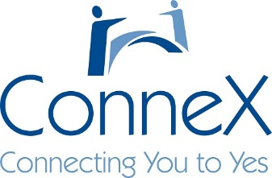

(425)210-3352 ralph@connexweb.com www.connexweb.com

