Pleasant Township Board of Trustees Meeting Highlights
Date _December 12, 2023 Next Resolution No._ _58---12-12-2023_ _

- Call to Order -- The meeting tonight will also be on WebEx.
- Please stand for moment of silence. --Pledge of Allegiance-----Roll Call
- Visitors –
- Hanna Poling with the Southwest Messenger via WebEx.
- Swearing-in for elected officials Trustee Sheets and Fiscal Officer Wilkins for the term 2024 through 2027
- Minutes to approve- No minutes
- Financial Reports – Motion to pay expenditures.
- Department Reports
- Franklin County Sheriff’s Report- Community Liaison, Deputy Adkins
11-12-2023 through 12-12-2023
- Total Calls for Service/Self-Initiated Runs: 272
- Total Reports Taken: 28
- Total Arrests/Citations: 15
- Burglaries: 1 (2900 Block of Norton Rd)
- Traffic Crashes: 17
- Medic Runs: 38
- Thefts:3
- Missing Persons:0
- Stolen Vehicles: 0
- Suspicious Persons/Vehicles:17
- Overdose: 1 (7300 Harrisburg Pike)
- Traffic Offenses:42
- Motorcycle/ATV/Bike Complaints: 2
On November 18th, Deputies responded to the 6800 Block of Darby Blvd on the report of a suspicious vehicle. Responding Deputies found the vehicle in the front yard of a residence. Upon investigation, the driver was found to be under the influence and was arrested.
On November 30th, Deputies responded to a shooting in the 5800 block of Harrisburg-Georgesville Rd. One person with injuries was located. Initial reports indicate a possible accidental shooting. The investigation is ongoing.
Also, on November 30th, Deputies responded to a burglary in the 2900 block of Norton Road. Numerous tools were taken. The investigation is ongoing.
- Road Department- Greg Geiger
- Marker flags are placed at the cemeteries for Wreaths Across America this Saturday.
- Equipment maintenance- ready for snow
- Set last minute Headstones.
- 1 burial
Unresolved items
- Any updates on the rocks/boulders in the right-of-way on Oakhurst Dr.
- Any updates on Gay Rd. about repairs due to heavy rains washing the roadway and gravel away. (meeting on 8-8-23 we said we’d keep it on the agenda till resolved in some way.)
- Trustee Sheets thanked the Road Dept. for cleaning up a mess dumped along Creamer Rd. They picked up 9 bags of trash, a bumper and had to wade in the creek to pick up more trash. Thank you Road Dept. for your dedication.
- Fire Dept. – Chief Whiting
- Need an amended motion to increase the amount for plumbing services from $4500.00 to $4600.00.
- _Ed made motion to amend the motion made on 11-14-23 to spend no more than $4,500 to do the plumbing repairs, to increase that amount to $4,600. Passed.
- Apparatus
- E-2 @ Prairie
- Tanker 231 repaired airline leaks but must go in for other issues.
- Selling the old medic to Prairie for $4, 995.
- Staffing
- Resignation-Wyatt Kistler
Resolution__58____ to accept the resignation of part-time firefighter Wyatt Kistler.
- One full-time Firefighter taking a lateral. Newly hired Adam Lake leaving in January
New Hire-Part-time
- Resolution _59____ to hire Tyler Carter as part-time firefighter
- Resolution _60____ to hire Alexander Hammond as part-time firefighter
- Training
- Paramedic School ongoing.
- Station
  - Issues with bay door Compton ordering parts.
- Community Risk Reduction
- The pancake breakfast was a success, with many positive comments from the community.
- Union
- Levy Update
- Completed paperwork deadline for submission is December 20th.
Resolution__61__ to proceed with the intent process and complete the paperwork and send it in.
- Communications (Dispatch)
- Meeting with GCC on AVL dispatching-Pete has this contract for review.
- Community
- We have had several thank you notes from the community, donations of toys and to the pancake breakfast.
- Old Business-
  - The comparison table in the email for the upcoming mosquito contract said total cost for 2023 is $9,268.61. The next table total for 2024-26 is $36,499.51. It is confirmed that is per year, each year for 3 years. An increase in one year of $27,230.90. Had a discussion, this is too much of an increase to fit the township budget. Invited residents to comment or give the trustees ideas.
- New Business –
  - We received a request to act upon a resolution to nominate a representative to serve on the Solid Waste Authority of Central Ohio (SWACO) Board of Trustees. Ron Grossman (Fiscal Officer, Jackson Township) has graciously served as the FCTA representative and is the only FCTA member who has formerly expressed an interest in serving the upcoming term. As explained at the November 16, 2023, FCTA Dinner Meeting with the Franklin County Engineer, SWACO requires two-thirds of the townships to vote and pass a resolution. Although Ron Grossman is the only candidate, voting is still required.
If you have not already, please send your township’s acted upon and recorded resolution to me by Friday, December 29, 2023. Chet J. Chaney, President Franklin County Township Association
RESOLUTION _62__ APPROVING THE NOMINATION OF _____Ron Grossman____ AS THE REPRESENTATIVE OF THE FRANKLIN COUNTY TOWNSHIPS ON THE SWACO BOARD OF TRUSTEES. (The entire resolution recommended by FCTA is attached.)
- Please see attached form that confirms that the plans will renew in 2024. The form needs to be signed and returned to me.
Thank you, Courtney Rietkerk | Senior TPA Administrator | Burnham & Flower Insurance Group
Resolution_63_ to approve the 2024 HRA & Wellness renewal with Burnham & Flowers.
- Resolution_64_ retaining Peter N. Griggs of Brosius, Johnson & Griggs, LLC and the law firm of Brosius, Johnson & Griggs, LLC, and are hereby employed on an annual basis for calendar year 2024 as the Township’s legal counsel to represent the Township and its officers, boards, and commissions in their official capacities and to advise them in connection with such matters as may be referred to said Counsel by or on behalf of the Board or its designee.
- Announcements-
  - Wreaths Across America.
The Wreaths are here and ready for placement this Saturday, December 16, 2023 at noon. Thank you to township resident and Veteran herself, Carrie Cole for organizing this project for our cemetery. There are enough wreaths to also do Ebenezer and Gundy. A big thanks to our Road Department, Robert Bausch, Greg Geiger and Rick Haag for placing the marker flags for the event and keeping a total. Everyone is welcome and encouraged to come and be a part of this ceremony. Everyone is invited to place a wreath on a veteran’s grave.
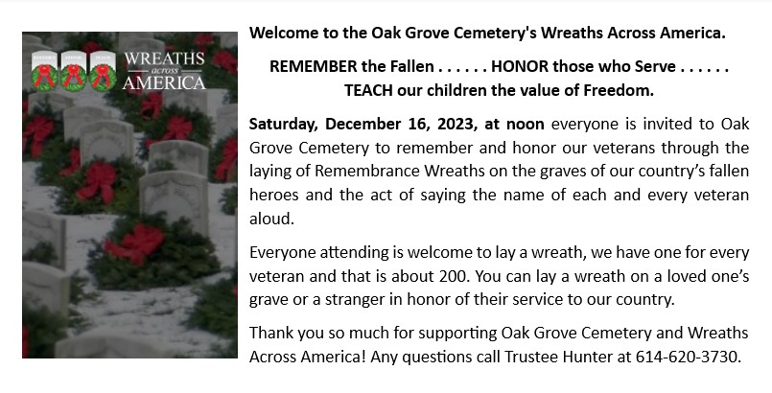

- Clerk Updates- Paula
- Miscellaneous correspondence
- Resolution__65__ to transfer $10,000 from General Fund to Medical fund
- Resolution 66 to authorize Paula to amend the appropriations and send to the county.

- Set date for reorganization meeting – Motion to hold a Special Meeting Tuesday, January 2, 2024 at 7:00 p.m. for reorganizing.
- Motion to hold a Special meeting Friday, December 15, 2023 at 10:00 a.m. for the purpose of having an executive session to meet with legal counsel and mediator.
- Executive Session –
- “I move to go into Executive Session according to Ohio Revised Code Section 121.22 (G)(1) for the purpose of __negotiations____. Do I have a second?”
ROLL CALL VOTE
Reconvene
- Under the Ohio Revised Code Section 121.22(G), I move to come out of Executive Session, do I have a second? ROLL CALL VOTE

- Adjourn-

