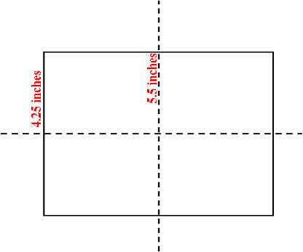
These student post cards are set up to use at the beginning of the school year. A message inviting students to your classroom is already written for you. It MUST BE CUSTOMIZED before you can print and send the postcards out. You can use the postcards throughout the year to send positive messages home to students’ parents. The postcard can be sent home with a student, or mailed. There are two versions for your convenience—male & female teachers. Use the one that best suits your needs.

If you prefer to write messages by hand, use the PDF version.

Preparation:
1. Read the message CAREFULLY (pages 3 OR 5) and customize it to suit your purpose. Be sure to change EACH message (copying and pasting is a quick way to do this). You can type the students’ addresses if you wish to do so—just double click “Name”, “Street”, and “City” and retype your information.
2. Run pages 2-3 OR 4-5 off back to back on cover stock or tag. (Check when the first page comes out of the printer to make sure you loaded the paper correctly for printing the back side!) Make enough for each student in the class.
3. Cut the postcards apart (5.5 inches and 4.25 inches on the paper cutter).

Uses:
• Invite students to your classroom a week or two before school starts.
• Send positive notes home to parents. Run a class set. Then when everyone has received a note, run another set.
• Invite parents to Back to School Night, Open House, and other special school events.
• Use for note cards on gifts for school employees or classroom volunteers.
• Communicate with staff members.
- Place at your writing center for students to write to each other.
- Invite other classes to visit for special projects or presentations.

The Artful Classroom
Student Post Cards
All Grades
Copyright © 2011 Integreat! Thematic Units. www.thematicteacher.com

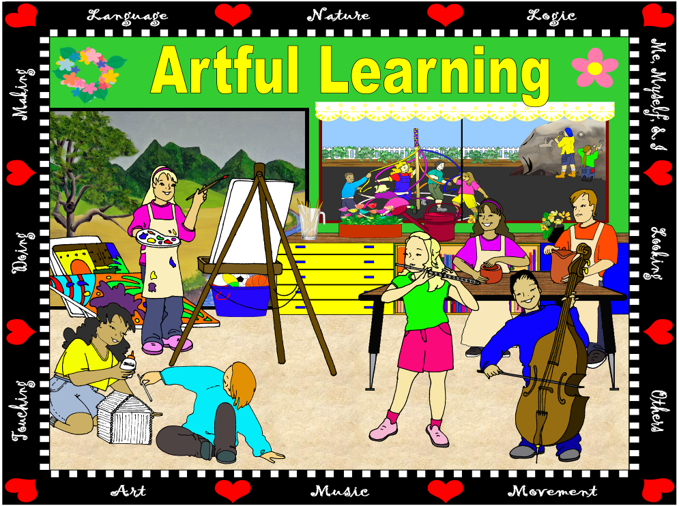
© 2011 Integreat! Thematic Units
© 2011 Integreat! Thematic Units
© 2011 Integreat! Thematic Units
© 2011 Integreat! Thematic Units

Welcome to our Artful Classroom!
Dear Student,
I am really looking forward to meeting you and working with you this new school year in our Artful Classroom found in Room Number. School will start at 8:00 AM on Tuesday, August 17. I will meet the class out on the playground. Look for the “Artful Learning” sign—it will show you where to line up. I’ll see you then!

Ms. Teacher
Welcome to our Artful Classroom!
Dear Student,
I am really looking forward to meeting you and working with you this new school year in our Artful Classroom found in Room Number. School will start at 8:00 AM on Tuesday, August 17. I will meet the class out on the playground. Look for the “Artful Learning” sign—it will show you where to line up. I’ll see you then!

Ms. Teacher
25¢
Welcome to our Artful Classroom!
Dear Student,
I am really looking forward to meeting you and working with you this new school year in our Artful Classroom found in Room Number. School will start at 8:00 AM on Tuesday, August 17. I will meet the class out on the playground. Look for the “Artful Learning” sign—it will show you where to line up. I’ll see you then!

Ms. Teacher
25¢
Welcome to our Artful Classroom!
Dear Student,
I am really looking forward to meeting you and working with you this new school year in our Artful Classroom found in Room Number. School will start at 8:00 AM on Tuesday, August 17. I will meet the class out on the playground. Look for the “Artful Learning” sign—it will show you where to line up. I’ll see you then!

Ms. Teacher
25¢
25¢
Name
Street
City
Name
Street
City

Name
Street
City

Name
Street
City

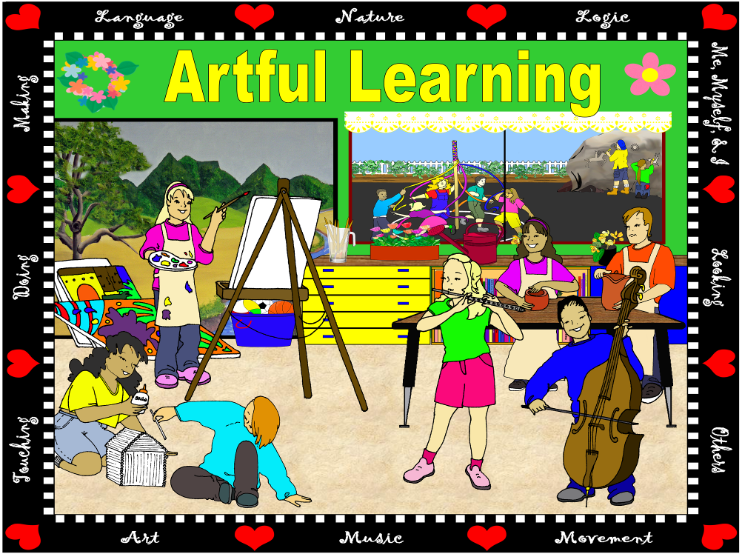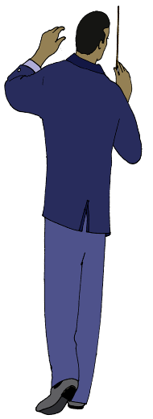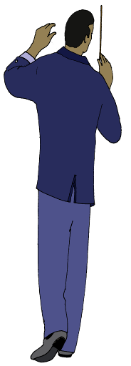
© 2011 Integreat! Thematic Units www.thematicteacher.com
© 2011 Integreat! Thematic Units www.thematicteacher.com
© 2011 Integreat! Thematic Units www.thematicteacher.com
© 2011 Integreat! Thematic Units www.thematicteacher.com
© 2011 Integreat! Thematic Units
© 2011 Integreat! Thematic Units
© 2011 Integreat! Thematic Units
© 2011 Integreat! Thematic Units

Welcome to our Artful Classroom!
Dear Student,
I am really looking forward to meeting you and working with you this new school year in our Artful Classroom found in Room Number. School will start at 8:00 AM on Tuesday, August 17. I will meet the class out on the playground. Look for the “Artful Learning” sign—it will show you where to line up. I’ll see you then!

Ms. Teacher
Welcome to our Artful Classroom!
Dear Student,
I am really looking forward to meeting you and working with you this new school year in our Artful Classroom found in Room Number. School will start at 8:00 AM on Tuesday, August 17. I will meet the class out on the playground. Look for the “Artful Learning” sign—it will show you where to line up. I’ll see you then!

Ms. Teacher
Welcome to our Artful Classroom!
Dear Student,
I am really looking forward to meeting you and working with you this new school year in our Artful Classroom found in Room Number. School will start at 8:00 AM on Tuesday, August 17. I will meet the class out on the playground. Look for the “Artful Learning” sign—it will show you where to line up. I’ll see you then!

Ms. Teacher
Welcome to our Artful Classroom!
Dear Student,
I am really looking forward to meeting you and working with you this new school year in our Artful Classroom found in Room Number. School will start at 8:00 AM on Tuesday, August 17. I will meet the class out on the playground. Look for the “Artful Learning” sign—it will show you where to line up. I’ll see you then!

Ms. Teacher
Name
Street
City
Name
Street
City
Name
Street
City
Name
Street
City
Name
Street
City

