LUNCH Cedar Hills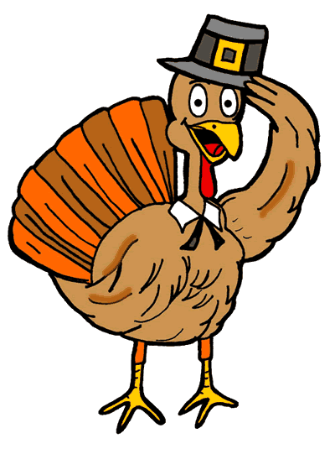
November 2018
Reduced Price .40 (Child) Full Price $2.92 (Child) Adult Price $2.92
MONDAY | TUESDAY | WEDNESDAY | THURSDAY
NSLP REQUIRMENTS:  Fruit: ½ cup daily  Veggie: ¾ cup daily. Meat/Alt: 1.75/2 oz. daily  W/Grain: 1.75/2 oz. daily  Milk: 1 cup daily | WEEKLY AVERAGE:  Calories: 600-650  Sodium: <935  Sat Fat: <10  Trans Fat: 0g. /Serving |  | Please Advise Mr. Steve 24 hrs. In advance if you would like to have breakfast or lunch with your child/ grandchild so we may plan accordingly.
1
W/G Sausage or Pepperoni Pizza w/ Cheese
Fresh Garden Salad
Fresh Mixed Berries
Milk Variety

5  Grilled Turkey Sandwich on  W/G Bread  Steamed Cauliflower  Diced Pears  Milk Variety | 6  Teriyaki Chicken  W/G Brown Rice  Pinto Beans  Fresh Apples  Milk Variety | 7  Fish Sticks  W/G Chips  Corn  Fresh Carrots  Milk Variety | 8  Sloppy Joes on W/G Bun  Peas  Diced Peaches  Milk Variety
12  Veterans Day Holiday  No School | 13  Ham & Cheese Sandwich on W/G Bread  Veggie Beans  Fruit Cocktail  Milk Variety  School Board Meeting | 14  Baked BBQ Chicken  Mashed Potatoes  Fresh Steamed Cauliflower  Applesauce Cups  Milk Variety | 15  Turkey  Mashed Potatoes w/ Gravy  Stuffing  W/G Roll  Corn  Pumpkin Pie w/ Cool Whip  Milk Variety  THANSKGIVING LUNCHEON
19  Thanksgiving Break  No School | 20  Thanksgiving Break  No School | 21  Thanksgiving Break  No School | 22 Thanksgiving Break  No School
26  Hot Dog on W/G Bun  Veggie Beans  Diced Pears  Milk Variety | 27  Taco Tuesday  Meat Taco on W/G Tortilla Shell  Spanish Rice  Fresh Mellon  Milk Variety | 28  Chicken Strips  Baked French Fries  Fresh Broccoli  Diced Peaches  Milk Variety | 29  Beef and Noodles  W/G Roll  Green Beans  Applesauce Cups  Milk Variety
This institution is an aqual opportunity provider.
Menu is subject to change without notice.
Milk Variety: Low Fat 1%, White or Non Fat Chocolate or Non Fat Strawberry
BREAKFAST Cedar Hills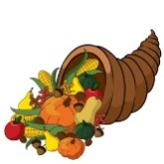
November 2018
Breakfast in Classroom Adult Price $2.92
MONDAY | TUESDAY | WEDNESDAY | THURSDAY
NSLP REQUIREMENTS:  Fruit/ Veggie 1 cup daily  Grain: 1.75/2 oz. daily  Milk: 1 cup daily  Meat/Alt. Optional | WEEKLY AVERAGE:  Calories: 400-500  Sodium: <540  Sat. Fat: <10  Trans Fat: 0g. /Serving |  | Please advise Mr. Steve 24 hrs. In advance if you would like to have breakfast or lunch with your child/grandchild so we may plan accordingly.
1
W/G Pancakes
Yogurt
Mixed Fruit
1% White Milk

5  W/G Cereal  Sausage Patty  Fresh Cantaloupe  1% White Milk | 6  Nutri Grain Bar  String Cheese  Diced Pears  1% White Milk | 7  Cheesy Scrambled Eggs  W/G Toast w/ Jelly  Fresh Apple  1% White Milk | 8  W/G Blueberry Muffin  Sausage Patty  Diced Pears  1% White Milk
12  Veterans Day Holiday  No School | 13  W/G French Toast  Sausage Link  Diced Peaches  1% White Milk  School Board Meeting | 14  Oatmeal  W/G English Muffin  w/ Peanut Butter  Fresh Blueberries  1% White Milk | 15  W/G Biscuits w/  Jelly or Butter  String Cheese  Mixed Fruit  1% White Milk
19  Thanksgiving Break  No School | 20  Thanksgiving Break  No School | 21  Thanksgiving Break  No School | 22  Thanksgiving Break  No School
26  W/G Toasted Bagel  w/ Jelly or Butter  Sausage Link  Diced Pears  1% White Milk | 27  Blueberry Fruit Smoothie  W/G Toast w/ Peanut Butter  1% White Milk | 28  Egg, Cheese, Sausage and Hash brown Bake  Fresh Pineapple  1% White Milk | 29  W/G Raisin Bread  Yogurt  Peaches  1% White Milk
This institution is an equal opportunity provider.
Menu is subject to change without notice.
Milk: Low Fat 1% White

