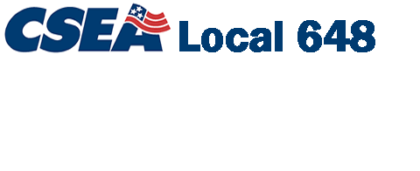

Proudly Representing the Employees of
Binghamton University
(State University of New York)

Raymond Hallett Jr, President
rhallett@csealocal648.org

LSG-407, P.O. Box 6000
Binghamton, NY 13902-6000
(607) 777-4377

NYS & CSEA PARTNERSHIP WANTS TO KNOW
Does your Break/Lunch Room need appliances?

Does it need a Coffee Pot _______________
Does it need a Refrigerator ______________
Does it need a Microwave Oven __________
Does it need a Toaster Oven _____________
Does it need a Fan______________________

How many CSEA NYS Employees would benefit from these appliances? __________
Which bargaining units are these employees with?
ASU (Administrative) _____ ISU (Institutional) ______ OSU (Operational) _______
Your Name: ___________________________________________________________
Your Department/Location: _______________________________________________
Phone where we can reach you: ____________________________________________
Actual Location of Lunch/Break Room: _____________________________________
Supervisor Approval: ____________________________________________________

ALL information above is required for all appliance requests!
When equipment is received it will need to be tagged and cannot be removed from the designated area without proper approval of CSEA Local 648 SUNY Binghamton Executive Board. All CSEA members are allowed to use appliances.

If you have any questions, please contact Dave Hektor at (607) 768-8181 or dhektor@csealocal648.org.

Return completed forms to, CSEA Office LSG407

Deadline to submit request is July 1

