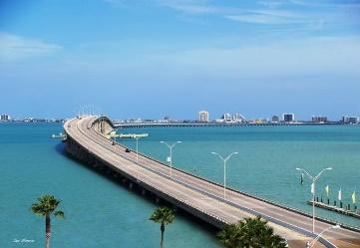 **12thAnnual**

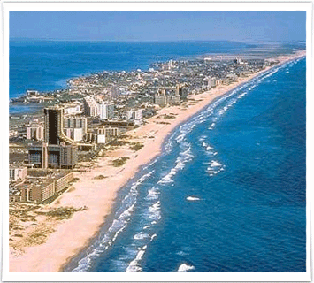

**2024 STASMO**

**Summer Conference**

MAINTENANCE & OPERATIONS

**WEDNESDAY, 7/17** **Location:** South Padre Island Convention Center

Wed. & Thur. July 17th-18th

[Host Hotel](https://www.bestwestern.com/en_US/book/hotel-rooms.44716.html?groupId=4F6UV9J1)

Best Western Beachside Inn, 4500 Padre Blvd, (956) 761-4919

Escape to the charming island of sun drenched fun and explore miles of our sparkling Gulf Coast beaches. We are moments away from treasures like the spectacular Dolphin Research & Sea life Nature Center, Sea Turtle Inc., South Padre Island Birding and Nature Center and the unique Schlitterbahn® Waterpark. We are a 5-minute walk from the beach, free hot brkfst, and free Wi-Fi.

Sign In/Register at the Convention Center **South Padre Island** [Convention Center](http://sopadre.com/meeting/meeting_venues.php), **7355 Padre Blvd**,



**Great Presentations! *Networking & Sharing***

***Trade Show***

**School Districts & Educational Organizations $49 per person**

9:00- 9:45 am **Sign In**/Registration (beverages & continental breakfast)

9:45- 10:00 am **Welcome**, Opening Remarks, Invocation, National Anthem

10:00- 10:45 am **“Paving the Way…HydroPavers”** by Flowing Innovation

11:00- 11:45 am **“Advanced Tech for Chiller Longevity”** by Mechanical

Products Texas

12:00- 1:30 pm **Lunch (on your own)**

1:45- 2:30 pm **“Problem Solving- A 6 Step Process…”** by TASBO

2:45- 3:30 pm **“Did You Know…”**, AEP Programs & Alternative to Full Blown Controls

by Pelican Wireless Sys

5:00- 7:00 pm **President’s Mixer**, Breakaway Tours, Sunset Bay Cruise, location-

33384 State Park Road 100

**THURSDAY, 7/18 Location:** South Padre Island Convention Center

7:45- 8:30 am Sign In/ Registration, (beverages & continental breakfast buffet)

8:30- 8:45 am Opening Remarks, Pledge of Allegiance, Invocation

8:45- 9:45 am **“Planning for HVAC Failures…”** by Ethos Engineering & ProTech

Mechanical

10:00-10:45 am **“Using 360 Video Capture To Improve The Maint Process…”** by

OpenSpace AI

11:00-11:45 am  **"The Happiness Advantage…Orange Frog"** by TASBO

11:45-1:00 pm **Lunch**

-**Awards & Recognition,** 12:45- 1:00 pm

* Sponsors Recognition, Diamond & Gold Sponsors Remarks
* Student Scholarships

1:00- 3:00 pm **Vendor Displays & Demonstrations**

3:00- 3:15 pm **Award Final Door Prizes** & Closing Remarks

Registration Link: [STASMO Summer Conference 2024 (zohobackstage.com)](https://stasmo.zohobackstage.com/STASMOSummerConference2024#/)