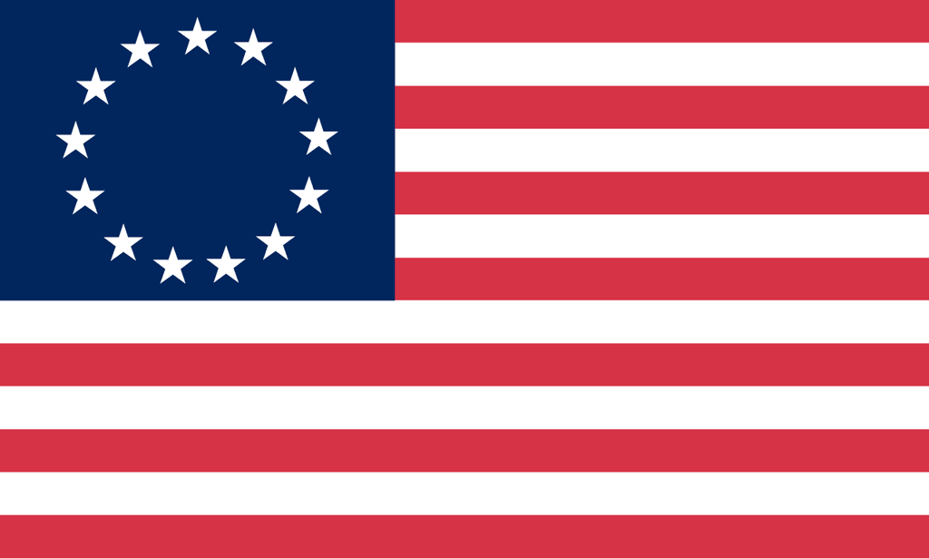U.S. History with Mr. Brown Name _______________________________ Period _____
Constitution Matching Quiz

Directions: Match the term on the right with the definition on the left.
1 Match
Dates  1) ________ Louisiana Purchase  2) ________ Declaration of Independence  3) ________ Beginning of the Civil War  4) ________ Constitution Written  ________ Mayflower Compact  5) ________ Jamestown VA established  6) ________ End of the Civil War | 1607  1620  1776  1787  1803  1861  1865
The Constitutional Convention  7) _________________________ People who supported the new Constitution  8) _________________________ People who were against the new Constitution  9) _________________________ A plan for the Constitution that was supported by large states  10) _________________________ A plan for the Constitution that was supported by small states  11) _________________________ The first ten amendments that were added to the Constitution to protect individual rights  12) _________________________ A plan that combined elements from both the VA and NJ Plans | Virginia Plan  New Jersey Plan  Great Compromise  Federalists  Anti- Federalists  Bill of Rights
7 Principles of the Constitution  13) _________________________ People in the government are not above the law  14) _________________________ How each branch can check the others to keep the power balanced  15) _________________________ Power comes from the people  16) _________________________ People elect representatives to vote for them  17) _________________________ Protections in the Bill of Rights  18) _________________________ How power is shared between the state and national governments  19) _________________________ How power is divided into the three branches of government  20) _________________________ Branch of government that makes the law  21) _________________________ Branch of government that enforces the law  22) _________________________ Branch of government that interprets the law | Popular Sovereignty  Republicanism  Federalism  Separation of Power  Checks and Balances  Limited Government  Individual Rights  Legislative Branch  Executive Branch  Judicial Branch
Branches of Government  23) _________________________ Head of the executive branch  24) _________________________ Upper house of the congress in which representation is equal  25) _________________________ Lower house of the congress in which representation is based on population  26) _________________________ Branch of government that enforces the law  27) _________________________ Branch of government that interprets the law  28) _________________________ Building that the President lives and works in  29) _________________________ Building that the Congress meets in  30) _________________________ Branch of government that makes the law  31) _________________________ Highest court in the nation  32) _________________________ Jamestown, VA (easy repeat) | Legislative Branch  House of Representatives  Senate  Executive Branch  President  Judicial Branch  Supreme Court  US Capitol Building  White House  1607

