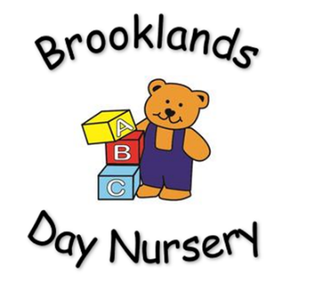
Brooklands Private Day Nursery
Under the influence Policy

Aim:
- To ensure the competency of practitioners whilst working with children.
- To ensure the safety of children at all times.
Rationale:
- All adults working with children must be aware of their responsibilities and have a duty to ensure that they are competent to do so.
Senior staff must be vigilant, and assess any potential risks to children in relation to staff, parents or carers that may be under the influence of alcohol or other substances.
Procedure:
Staff
- When working with children’s practitioners MUST NOT be under the influence of alcohol or any other substance that may affect their ability to care for children.
- Practitioners taking medication, MUST seek medical advice to determine their suitability to look after children. The decision of the medical practitioner MUST be discussed with the manager.
- Any member of staff who appears to be under the influence of any substance, will be asked to leave the setting. An explanation to which MUST be provided by the manager or senior person.
Parents/carers
- If a parent/carer arrives to collect a child from nursery and they appear to be under the influence of alcohol or another substance, they will be informed that they cannot take the child from the setting, and asked to leave the building.
- The next emergency contact for the child will be contacted and asked to collect the child from the setting.
- If there is no other suitable person to collect the child, the senior member of staff will follow Safeguarding Children Procedures. This involves contacting Child Care Services or the Police.

If a parent/carer is thought to be a drunk driver whilst the child is in the car, the senior person MUST phone 999 immediately and provide the police with the vehicle registration number.
Emergency contact numbers
Social services (MASH): 0161 770 7777 - 8.40am - 5.00pm, Monday to Friday.
Police: 999

This policy will be reviewed every 12 months by management.

