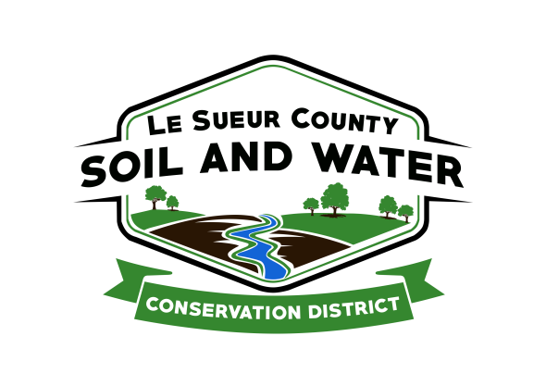

Le Sueur County Soil & Water Conservation District

Le Sueur County SWCD Tel. (507) 419-0365
181 W Minnesota St Website: www.lesueurswcd.org
Le Center, MN 56057

Minutes from February 9, 2021 regular board meeting of the Le Sueur County SWCD Board of Supervisors. Le Sueur County Justice Center, Le Center, MN.

Meeting was called to order by Chairman Struck at 9:00 am.

Members present: Chairman, Jim Struck (in person)
Vice-Chairman, Greg Entinger (virtually)
Treasurer, Cletus Gregor (in person)
PR&I, Glendon Braun (in person)

Members absent: Earle Traxler

Others present: District Manager, Mike Schultz (in person)
District Technician, Joe Jirik (in person)
Ditch Specialist, Nik Kadel (in person)
Program Specialist, Sue Prchal (in person)
Resource Technician, Karl Schmidtke (virtually)
District Conservationist, Steve Breaker (in person)
Assistant State Con for Field Operations, Rick Berscheid (virtually)

The Pledge of Allegiance was recited.

Minutes from January 12, 2021 were read and approved.

Minutes from February 1, 2021 special meeting were read and approved.

January 2021 treasurer’s report was read. Motion by Gregor, second by Braun to approve as read and to pay bills.
Affirmative: All
Opposed: None
Motion carried

Motion by Braun, second by Gregor to adopt the well sealing grant policy. Cost-share would not exceed $1000.00 per well.
Affirmative: All
Opposed: None
Motion carried

Le Sueur County will be adding a .5% sales tax beginning April 1, 2021.

Motion by Gregor, second by Entinger to amend cost-share contract #MDM-20-01. The amendment will change from John McGillen and Pam McGillen Trust to Le Sueur County Drainage Authority. Amendment #20-01.
Affirmative: All
Opposed: None
Motion carried

Schultz discussed the Jefferson/German grant reconciliation with the board. The reconciliation showed the SWCD noncompliance on a cost-share contract by not including a date that a landowner signed the contract. Motion by Gregor, second by Entinger to write a letter of response to Julie Kreb, BWSR, of the finding and the corrective measures it will take to avoid this happening in the future.
Affirmative: All
Opposed: None
Motion carried

Update on 1W1P Cannon River: A grant agreement has been executed and the grant is moving into the project phase.

Update on 1W1P Lower MN: Resolution #2021-1 to support application to BWSR for a planning grant discussed.

Legislative Day at the Capitol will be held virtually on March 18, 2021. Registration deadline is March 12, 2021. Will discuss at next month’s meeting.

The Le Sueur County Water Planner Position was discussed.

Employees are in the process of completing their 2021 goals.

USDA lease expires 7/31/21. USDA would like to extend the current lease for 3 years, expiring 7/31/2024. The board will discuss further in upcoming meetings.

Kadel will be attending Le Sueur County Commissioner meetings 2 times per month to update them on county ditches. Nik will also present the SWCD board with monthly ditch updates. He discussed a tree removal program, beaver trapping and FEMA dollars coming into the county for past rain events that caused damage on county ditches.

Steve gave a NRCS report. He talked about 2021 EQIP projects, CRP (general and continuous), a new Soil Con Tech, Jeff Popken, will be starting on Tuesday, February 16, 2021.

Vouchers were reviewed and filled out.

There being no further business, meeting adjourned at 10:36 am.

_______________________ _________________________________________
Date District Secretary

