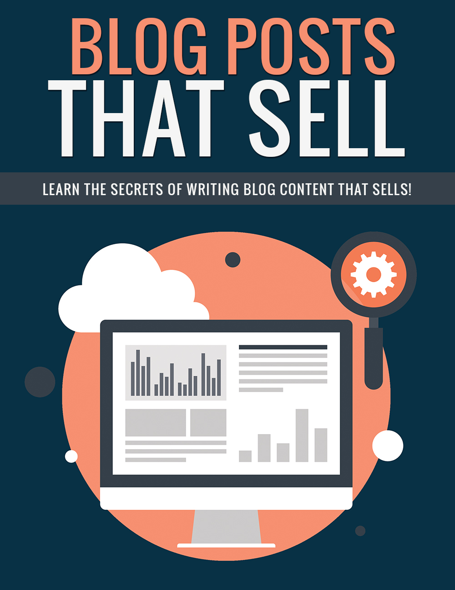

Copyright © All rights reserved worldwide.

YOUR RIGHTS: This book is restricted to your personal use only. It does not come with any other rights.

LEGAL DISCLAIMER: This book is protected by international copyright law and may not be copied, reproduced, given away, or used to create derivative works without the publisher’s expressed permission. The publisher retains full copyrights to this book.

The author has made every reasonable effort to be as accurate and complete as possible in the creation of this book and to ensure that the information provided is free from errors; however, the author/publisher/ reseller assumes no responsibility for errors, omissions, or contrary interpretation of the subject matter herein and does not warrant or represent at any time that the contents within are accurate due to the rapidly changing nature of the Internet.

Any perceived slights of specific persons, peoples, or organizations are unintentional.

The purpose of this book is to educate and there are no guarantees of income, sales or results implied. The publisher/author/reseller can therefore not be held accountable for any poor results you may attain when implementing the techniques or when following any guidelines set out for you in this book.

Any product, website, and company names mentioned in this report are the trademarks or copyright properties of their respective owners. The author/publisher/reseller are not associated or affiliated with them in any way. Nor does the referred product, website, and company names sponsor, endorse, or approve this product.

COMPENSATION DISCLOSURE: Unless otherwise expressly stated, you should assume that the links contained in this book may be affiliate links and either the author/publisher/reseller will earn commission if you click on them and buy the product/service mentioned in this book. However, the author/publisher/reseller disclaim any liability that may result from your involvement with any such websites/products. You should perform due diligence before buying mentioned products or services.

This constitutes the entire license agreement. Any disputes or terms not discussed in this agreement are at the sole discretion of the publisher.

Introduction
You may have already read a dozen guides on basic blogging, WordPress installation, theme choice and installation, maybe even customization. You might have even read some guides on SEO for WordPress or how to write great content.

The trouble is that great content is not always content that will help you achieve your objectives. Great content is not always what sells.

You can write the most helpful, interesting content in the world and make no money from it simply because you haven’t written the content in a way that makes sales.

The most productive content is always written with the bottom line objective in mind, whether that’s increasing your mailing list, finding leads, or just making money. Generally, profit is the bottom line for any organization except a non-profit.

In this guide, you’re going to learn some of the best ways to create content that is not only interesting, but helps you to achieve your business goals—whatever those goals may be.

No more spending hours writing content that isn’t going perform. Learn how to write content that sells every time.

Let’s get started.

Why Content Doesn’t Sell

Before we start talking about the ways, you can write content that does sell, let’s take a look at a few mistakes people typically make when writing content that causes that content to not sell well.

The Big Five Mistakes:

- No or weak call-to-action. When you have no call-to-action in your content, or your call-to-action is weak, you’re basically wasting your time. People can’t read your minds. They don’t know what action you want them to take.
- Off-topic content. You may be tempted to add content to your blog that isn’t related to your main topic as a way to try to draw more traffic, but this only weakens your position in the search engines and offers you little to no benefit with regards to leads or sales.
- Content that goes on too long. Sure, search engines love long content. Some people even love long content. But creating long content solely for the purpose of getting traffic isn’t going to do you any good. Especially if that content drags on so long, and is so boring, that people leave before they have a chance to see your call-to-action.
- Content that has no purpose with regards to your goals. Some people believe that any content is good content, because it’s another article that can draw traffic. But it’s a waste of your time to write content that isn’t specifically geared toward helping you achieve your business’s goals.
- Useless popups or other interruptions. Do not, absolutely do not, include popups, interstitial ads, or any other type of interrupter for anything that isn’t directly going to assist you with your main business goals. You’ll upset visitors and potentially lose them. Instead, save those interrupters for times when you are trying to achieve your goals, such as getting more email subscribers or selling a product.

Well, first-off you know some of the mistakes you might make that could cause your content to fail in its mission to help you reach the goals you have set for your business.

Now, it’s time to take a look at the best way to create content that does sell.

Brainstorming

The first thing you must do, obviously, is decide exactly what your primary and secondary goals are for your business. It might be solely to sell a particular product or service, perhaps with a secondary goal of building your email list. Maybe it’s the other way around, and you’d prefer to focus on building your email list with the secondary goal of getting sales.

Once you’ve chosen your goals, you can figure out what type of content you should create to best reach your goals.

Let’s say you want to focus on building your list as a golf professional. Each piece of content you post should specifically be geared toward building your list.

For example, let’s say you have a lead magnet called “10 Ways to Shave Strokes Off Your Golf Game”. You’d want to create content specifically that focuses on ways to improve one’s golf game so you could have a call-to-action asking people to subscribe for a free copy of your lead magnet.

Try to figure out a number of different types of content you can write specifically to relate to your lead magnet. If you create different types of content later, you might want to first create a lead magnet that matches it, especially if you think it will attract more subscribers.

For example, let’s say you’re running a weight loss blog that covers several different types of weight loss. You’ve been concentrating on the low carb diet, and your current lead magnet is a list of foods that are good for each phase of the low carb diet, and ideas for snacks and meals.

Now you’ve decided you want to focus on the raw food diet. People who practice this diet would most likely not be the least bit interested in a list of low carb foods, because those foods are most often cooked or processed in some way.

Thus, you’d need to create a brand new lead magnet that focused specifically on the raw food diet.

What if you don’t have a lead magnet for a particular topic and would rather not create one? Well, you could instead find an inexpensive paid product to promote, or just have a generic opt-in box that says something like, “Enter your name and email address for more information about the raw food diet.”

Types of Blog Posts that Sell

There are lots of types of blog posts that have the potential to get results, and some that probably won’t. In this section, we’re going to take a look at some of the most effective content types.

Always remember that you should keep your content as tightly niched as possible. You don’t want to create content that could hurt your SEO, and there’s no reason to create content that isn’t likely to help you achieve your goals.

Let’s say you’re running a blog about golf. You might think that creating a post about the top ten new luxury cars could attract golfers. While that’s not completely outside the realm of possibility since golf is a rather expensive hobby, that article is likely to attract a lot of visitors that don’t care anything about golf.

You want to create content that is the most likely to get you a new email subscriber, or buy something, or take whatever other action you wish.

Top Lists

Top lists are a very popular type of content that is perfect for a lead-in to a call-to-action. For example, you could have an article called, “The Top 5 Drivers That Can Lengthen Your Drives”.
You could then have your call-to-action at the end of the article asking people to opt in for your lead magnet called “10 Ways to Shave Strokes Off Your Golf Game”.

Interviews

Interviews with industry experts and popular figures in your market will draw a lot of attention, and they help lend a little credibility to your call-to-action.

If you’ve interviewed someone people recognize, not only will it draw in more traffic, it will also make people naturally feel your own information is more likely to be good.

Guest Posts

Like interviews, guest posts by popular people within your niche lend credibility to your own calls-to-action.

Tips & Tricks

People love articles that provide simple tips and tricks in an easy-to-digest format.

Lists of 5-10 tips and tricks on a particular topic draw a lot of readers, and make it easy to lead in to a call-to-action.

In-Depth Tutorials

In-depth tutorials always tend to be big draws, but they’re also excellent for getting people to take action.

A good in-depth tutorial will bring in a lot of traffic, and it will also give you a lot of credibility if it is well-written and interesting.

Video

Video is a type of content that has huge potential for getting people to take action, because you can actually ask them to take action in the video itself.

For example, you could say, “Visit my website your-url.com and enter your name and email address for more information about how you can lose weight with today’s most popular diets!”

People who are watching your video are much more likely to hear your call-to-action than someone who’s just read a lot of text and now need to read a call-to-action, so video can be extremely effective.

Other Types of Content

There are other types of content you can consider, too. Remember that you don’t have to stick 100% to your main goals.

Occasionally, you can have additional goals for your content.

For example, maybe you just want to raise brand awareness. You want to get a big kick of viral traffic, and you’re not as worried about your main goals.

In that case, you could create a post that was totally out there just to get traffic and help people recognize your name within your niche.

Let’s take a look at an example:

Let’s say you write an article called, “The 25 Most Bizarre Weight Loss Inventions Ever Created!”

This article is pretty generic, and it could potentially draw a lot of people who aren’t even interested in losing weight because they just want to see the strange information—BUT, it could also draw dieters who would be interested in what you are offering.

It could also increase recognition of your brand in your niche, which could benefit you down the road even if you don’t get a lot of results immediately.

Advanced Tips

Now that you know how to create good content and how to get people to take action when they read your content, it’s time to learn a few advanced tips that can increase conversions.

Segmenting

If you have a website or blog that has multiple types of content—for example an outdoor website that has sections for fishing, hunting, and camping—it’s important to use different calls-to-action for each section.

Sure, it’s easier to create one single report that covers all of the outdoor hobbies on your site, but you could be turning off people who only like one aspect of the outdoor life. For example, someone might like fishing, but not care for camping or hunting at all. If you have a free report that covers camping and hunting as well as fishing, that person probably would not subscribe.

It’s a better idea to segment and create a unique lead magnet for each topic in order to give you the best chance to get the subscriber.

You can also segment your mailing list into separate topics to be sure you aren’t later marketing hunting products to camping fans.

Of course, you could always have a generic mailing list signup box in your sidebar for people who want information about every topic.

Multiple Calls-to-Action

You don’t have to limit yourself to a single call-to-action in each article. For example, you can have your normal opt-in box at the end of the article, but you could also ask them to view another related article on your site. This would help you get more page views, and also give you another chance to get the subscriber if they didn’t subscribe after reading the first article.

You could also put your subscription box halfway through the article, and then put a call-to-action for a paid product at the end, or vice versa.

Retargeting

If you use an ad service like Facebook or YouTube, you can include a retargeting pixel on your website so you can run ads to people who have visited your site and perhaps didn’t buy anything or subscribe when they were there before.

Maybe they were not convinced the first time.

Maybe they were too busy the first time they visited your site, and meant to subscribe or buy something later.

Who knows?

But using retargeting will give you another opportunity to convert the visitor into a buyer or subscriber.

You can run ads that specifically target people who have visited your site in the past—people who have already proven they’re interested in your offerings, because they’ve visited your site before.

Learn more about retargeting here:

https://www.facebook.com/business/learn/facebook-ads-website-custom-audiences

https://support.google.com/adwords/answer/2545661?hl=en

Conclusion

Writing good content isn’t necessarily enough to get you the results you are looking for. You have to craft that content specifically to get results by creating content that naturally leads users to want to take action.

Always write your content with conversion in mind. Whether your primary goal is to sell a product, grow your mailing list, or even make money from advertising on your site, content should be written with that primary goal in mind. (You may also have a secondary goal in mind. Don’t forget you can have multiple calls-to-action in a single article.)

Remember to use multiple lead magnets if you have a variety of topics on your site to ensure you have something that will interest the audiences of each of those topics. Just because two topics are related doesn’t mean they’re similar enough that fans of one will be fans of the other.

As long as you keep your goals in mind when you’re creating your content, you’ll find your conversions growing. More people will take action, and you will get closer than ever to reaching your goals.

Good luck!

Resources

Here are links to the resources mentioned in the guide.

Facebook Retargeting:

https://www.facebook.com/business/learn/facebook-ads-website-custom-audiences

AdWords & YouTube Retargeting:

https://support.google.com/adwords/answer/2545661?hl=en

Here are few of the tools I use to work with blog post profits:

>> http://landingpagemonkey.com/

>> http://catchamonkey.com/

>> http://socialsharemonkey.com/

>> http://popupmonkey.com/

>> http://countdownmonkey.com/

>> http://attentionmonkey.com/

