REVISION

Task 5 – Budget submission & management advice 20 marks
The pass rate for this task is 27% and most of these are classified as borderline.

This is an email report with three sections, one of which relates to performance indicators. The task covers a wide range of assessment criteria.
In section 1:
• Identify the sources of data and planning assumptions used in budget proposals
• Plan and agree draft budgets with all parties involved
• Describe the impact of the external environment and any specific external costs on budgets
• Analyse critical factors affecting costs and revenues, drawing conclusions
If the question asks for approval then you must request approval.
The first section should be written factually and impartially
Take each item in turn.
- identifying the key assumptions and sources of information
- Sets out the assumptions (6% production increase, no change in material per unit, reduce wastage to 10%, price increase of 5%)
- Identify the sources of data (agreed production budget, purchasing manager and production manager

- Expand – It helps to quantify the assumptions with phrases such as ‘increasing by x%’ or ‘a price reduction of £y’.
- Summarise the cost compared with the current year.
- Make any important links eg. between material price and the benefits of improved quality.
- Relate to the question

In section 2:
• Set clear targets and performance indicators to enable the budgets to be monitored
The second section of the email is about control. Students are required to suggest performance indicators that will help managers to keep costs within budget. It should be obvious that the key variables have been identified in the scenario and already commented upon in section 1.
The indicators must be relevant to the budget being presented and each indicator must relate to a different variable element of the budget.

In section 3:
• Explain the relationship between budgetary control, product lifecycles and forecasts and planning
• Describe the purpose of income and expenditure forecasts and their link to budgets
• Inform management of any significant issues arising from budgetary control
• Present any recommendations with a clear rationale to appropriate people

The scope of this section of the task is quite broad. It always covers an aspect of forecasting but the theme can be accountability, product lifecycle or handling uncertainty. Many students are unable to understand the main thrust of the question and simply repeat their comments from section 1.

(Note: In some versions of the task the sequence of the sections is switched so that the discussion of forecasting is in section 2 and performance indicators appear in section 3. The order depends upon the flow of information in the task.)
Task 6; Revised budget assumptions 18 marks

Revised budget.

You may have to prepare a revised operating budget taking account of selling price changes and pay rises etc.
Or you may have to revise a budgeted figure.
Use a table in your workings.eg
228,800 | 104%
228,800/104*90 | 90%

From the following data, revise the forecast for energy costs.

Next year, energy costs are forecast at £228,800. This assumes a 4% increase in energy consumption and a 5% increase in gas and electricity tariffs.

However, energy saving measures are being proposed. Instead of increasing, consumption should be reduced by 10%.

The energy budget should be £______________

Select from:
- £178,200
- £198,000
- £217,800
- £220,000

Standard costing
The simple standard costing exercise that has been added to this task in AQ2013 has flummoxed many students.
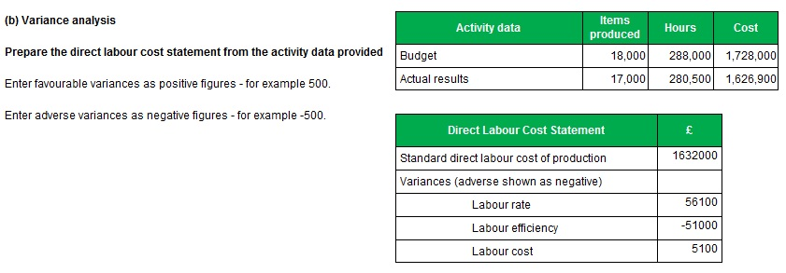

The simplest approach is start by calculating the standard cost details. • Standard labour cost per unit = £1,728,000 / 18,000 units = £96.00
• Standard labour rate = £1,728,000 / 288,000 hours = £6.00 per hour
• Standard labour efficiency = 288,000 hours / 18,000 units = 16 hours per unit
• Therefore, standard labour cost per unit = 16 hours @ £6.00 per hour = £96 per unit.

To complete the statement:
• Standard direct cost of production = 17,000 units * £96 = £1,632,000

• Labour rate variance
Should cost: (280,500 hours @ £6.00) = £1,683,000
Did cost: £1,626,900
= £56,100 favourable

• Labour efficiency variance
Should take: 17,000 units * 16 hours = 272,000 hours
Did take: 280,500 hours
= 8,500 hours adverse @ £6 per hour = £51,000 adverse

• Labour cost variance = £56,100 - £51,000 = £5,100 favourable
Or £1,632,000 - £1,626,900 = £5,100 favourable
Task 7; Operating report (flexing a budget) 16 marks
Performance continues to be impressive for this predictable task. The pass rate is 96% and many students secure full marks. Students are required to prepare an Operating Report. They have to flex the budget and calculate variances. The budget includes variable, semi-variable, stepped and fixed costs.
Predictably, the semivariable and stepped costs are a problem for weaker students.
Variable costs
Use a table in your workings.eg
 | Units | £
Budget | 70,000 | 140,000
Flexed budget | 72,000 | 140,000/70,000*72,000

Semi variable costs
Using the budget: Work out the variable element, then the fixed element.
Using the flexed budget volume: work out the variable, fixed and total cost (fixed +variable).
Stepped costs
Using the budget: work out the number of steps (round up) and cost per step.
Using the flexed volume: work out the number of steps (round up) and total cost.
Fixed costs
Keep the same as the budget.
Task 8; Explanation of variances and management advice
20 marks

Performance in this task is very poor. The pass rate is only 5%.

This task is an email report, identical in format to task 5. Like that task it has three sections which, now, always addresses standard costing. The coverage of assessment criteria is as follows.
In section 1:
• Analyse the variances explaining the impact that these will have on the organisation
• Analyse critical factors affecting costs and revenues, drawing conclusions
• Identify options and solutions to increase profitability or reduce financial losses or exposure to risk

The question is normally ‘Suggest possible reasons for the variances’.
Please read the question, it could possibly be other tasks such as ‘what action would you take’. If other questions come up it would be useful if you fed this back to me.
The most common weakness stems from confusion about budget flexing. When comparing with a flexed budget, variances can never be simply attributed to volume.
A sales revenue variance must be due to price.
A labour cost variance must be due to rate or efficiency. If increased demand causes overtime working, this is likely to create a rate variance but students who simply attribute the labour cost variance to volume do not gain marks.

First use your working papers to jot down all key points.
Read through and make sense of it.
Plan your answer so that you don’t contradict yourself.

- Take each item in turn.
- State the obvious
- Expand – use calculations (%)
- Relate to the question – try to link the variances together.

In section 2:
• Inform management of any significant issues arising from budgetary control
• Present any recommendations with a clear rationale to appropriate people
• Explain the behavioural aspects of budgeting
• Justify the uses of budgetary control for Planning, Co-ordinating, Authorising & Cost control
The second section of this report relates to behavioural issues. There is plenty of material in the scenario for students to pick over and the marking scheme allows for different approaches and responses. Marks are awarded for giving advice on target setting and control and for tailoring the advice to the scenario.

Consider motivation

Consider planning vs control

Consider different standards
- Ideal
- Historic
- Attainable
- Current

Consider budget methods
- Participative
- Imposed
Consider authorisation

Consider Accountability and control
In section 3:
• Explain the principles of standard costing within the context of a budgetary control system
In the third section students need to explain the potential relevance of standard costing to this business. Again the issues have been presented in the scenario (eg references to overtime costs, material price and material efficiency). Marks are easily won by describing the benefits of setting standard costs and reporting variances.

Advantages of standard costing
- Consistency
- Budgetary control
- Gives cost to make one item
- Can create cost budget by x production units
- Can use to create cost variances
- Helps to control and manage costs effectively

