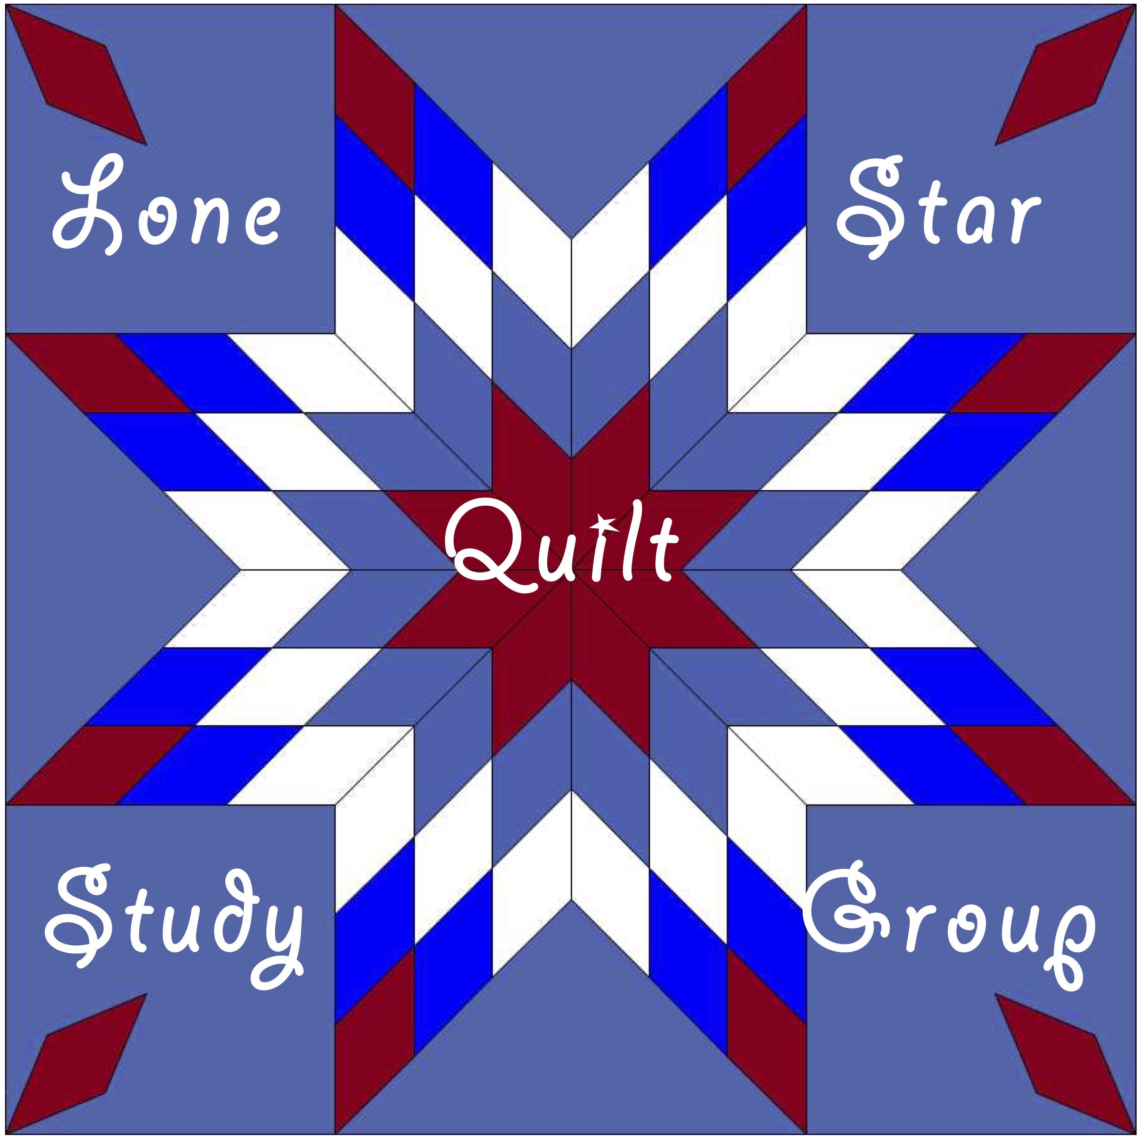
Lone Star Quilt Study Group
Study Day

Westward Ho! Nineteenth Century Homesteader Women and the Quilts They Brought from Home

Date: Saturday, August 18, 2018
Time: 10:00 a.m. to 4:00 p.m.
Cost: $40.00 per person
Location: Georgetown Public Library, 402 W. Eighth Street, Georgetown, TX 78626
.
Kathy Moore and Stephanie Grace Whitson will share the stories and quilts about which they learned during their nearly ten years of collaborative research on homesteading women in the nineteenth century. Taken from diaries, letters, and first- and second-generation memoires you will hear of the hopes, dreams and experiences of those women who came west to begin new lives in unexpected and unpredictable conditions. Their surviving quilts illustrate those experiences and expectations and represent the lives they brought from home. These quilts helped enlivened their daily lives as they struggled with new homemaking realities. You will hear in their own words what life was like and how they persevered.

Kathy Moore is a quilt historian, writer, lecturer and quilt maker living in Round Rock, Texas. Her most recent publication, “The Mystery of the Harlequin Star Quilts: Finding and Naming a Previously Unidentified Regional Design” was published in October 2017 in Uncoverings 2017, the Research Papers of the American Quilt Study Group. Additionally, she and Stephanie Grace Whitson collaborated on the research and publication of Home on the Plains: Quilts and the Sod House Experience. Stephanie is a quilt historian, lecturer and writer of both fiction and non-fiction based on her extensive research of primary and secondary sources. These presentations will include previous and recent research findings and conclusions as well as individual stories and quilts from the post-Civil War era to the late nineteenth century homesteading movement on the central plains states and Texas.

⌘⌘⌘
Attendees are invited to bring examples of relevant quilts and ephemera from their own collections to exhibit and discuss during show-and-tell at the end of our meeting.

___ ___ ___ ______ ___ ___ ___ ___ ___ ___ ___ ___ ___ ___ ___ ___ ___ ___ ___ ___ ___ ___ ___ ___ ___ ___ ___ ___ ___ ___ ___ ___ ___

Complete the form below and mail it with your check for $40 to LSQSG c/o Lisa Erlandson, 1920 County Road 150, Gainesville, TX 76240. Capacity is limited and registration is not guaranteed until confirmed. Cancellation with refund will be allowed until August 1, 2018, less $5 administrative fee. No refunds can be made after August 1, 2018. Registrations are not transferable.

To ensure adequate seating and catered lunch counts, the registration deadline is August 10, 2018.

Name E-Mail

Address City/State

Zip Code Home phone Cell phone

Lunch will consist of 2 sandwich choices, salad, and brownies served buffet style. Please circle any special need(s): Gluten-Free Vegetarian

This event is not affiliated with or sponsored by the Georgetown Public Library or the City of Georgetown

www.lonestarquiltstudygroup.org lonestarquiltstudygroup@gmail.com
LSQSG c/o Lisa Erlandson, 1920 County Road 150, Gainesville, TX 76240

