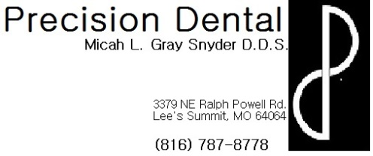
Care and expectations after Composite Restoration Placement
- If anesthetic was used during your procedure today:
  - Not only is the tooth numb, but the surrounding soft tissue structures are as well, including lip, tongue, gums, cheeks, etc. Be very careful not to bite or suck on these soft tissues while profoundly numb. Since you are so numb you will not be able to feel how hard you are biting or sucking which can result in serious soft tissue damage.
  - Your numbness can last for several hours following your procedure, on average about 3-4, however everyone reacts to local anesthetic differently. If you wake up tomorrow morning and still feel numb please contact the office for further evaluation.
  - As the numbness wears away, your soft tissues may begin to itch or tingle. This is a normal reaction and does not indicate an allergic reaction. It is very important to be careful not to scratch or itch the area because the tissues are still numb and it is possible to do soft tissue damage by scratching or itching too hard without realizing it.
  - You may want to take a pain reliever (ex: Ibuprofen, Acetaminophen, etc.) prior to the numbness wearing away because the site of the injection may be sore like a bruise. The injection site may actually bruise and some swelling is also a normal occurrence. If you are concerned about any bruising or swelling please contact the office for further evaluation.
- Some temperature sensitivity is normal following a new restoration. In fact, your tooth may be sensitive for several months every time you eat or drink something hot or cold, but it should get progressively better with time. If you notice an increase in pain or would like for us to further evaluate a sensitive tooth, please contact the office.
- If the contacts between your teeth were replaced, our goal is to achieve a tight seal which will help prevent food from impacting between them. However, this will make it more difficult to floss for the first few days, but flossing is still very important because there is remaining natural tooth structure around your new filling that is still prone to decay without proper care.
- The way your teeth bite together has been checked and seems satisfactory. However, sometimes when you are very numb you do not bite the same way you normally would, so if after the numbness wears away, your tooth feels “high” or like your other teeth do not touch the same, please contact the office. This is a condition that will not correct itself but is generally an easy fix for us here. If the tooth is biting differently and is not corrected it may cause other complications
- The larger the filling in your tooth, the less remaining tooth structure there is, resulting in a potentially weakened tooth that can be prone to fracture. Please contact the office as soon as possible if you believe that your tooth or filling has broken so that further evaluation can be conducted.
- Despite our precautions, resin (tooth colored) fillings are more prone to leakage which may necessitate more frequent replacement.
- You may notice flakes or chips on your surrounding tooth structure, this is excess bonding agent that was used during the placement of your new filling, if you are unable to brush or floss these rough areas away, contact the office for further evaluation.

