Texas History with Mr. Brown Name ____________________ Period _____
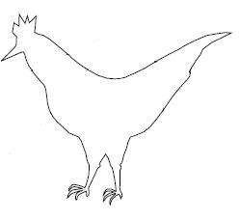
Directions: In the space below, draw your interpretation of the chicken war.

