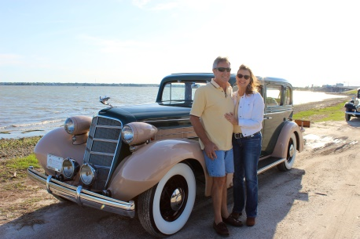
Real Restorations
By Pistorius Collectible Autos
Final assembly, and testing of your car is about to start!
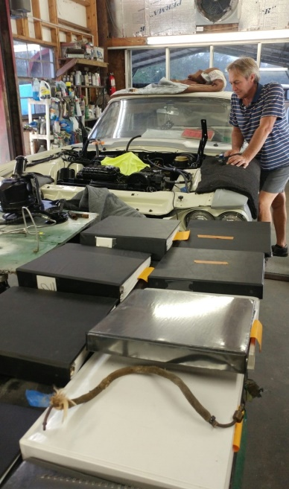
It is time to start the engine. Make sure you have filled the engine with new break-in fluid and regular oil. There are a few ways to start up the engine for the first time. I prefer to disconnect the coil wire and crank over the engine without sparkplugs. Many times you will find that oil pressure is building up. The next step is to ensure you have fuel and spark. You are ready now. Crank your engine and keep your eyes on the oil pressure gauge when it fires up. There should be pressure within seconds. If not, stop the engine. Fit a temporary mechanical press gauge and start again. With good oil pressure, keep your eyes on the temperature gauge. Keep that engine cool!
Don’t forget to bleed your brakes!
OK it is time to fit the hood and trunk lid. Mask around the edges and get help to fit both these parts. The line-up is your last item to perform, so take your time to get this right. Check tire pressures. Check all oils and lube where necessary.
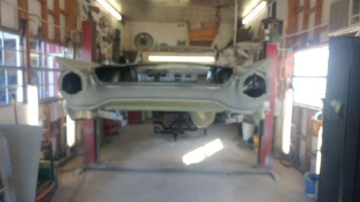
Make sure your cell phone battery is fully charged and have somebody standing by when you take your first road test. Make it short and check oil level, water temperature, and look for any leaks. You made it!
You are ready now for what I call your “shake down tour”, 50-100 miles. Fix anything that crops up during this tour. Now take your brand new cloths and good wash soap and clean your car thoroughly. This is the best way to find small imperfections and things wrong. Fix these and now you are ready to call friends to come over with champagne (and/or beers) to celebrate!
Thank you for the opportunity to give you my advice on a truly rewarding journey for most car enthusiasts. Feel free to contact me anytime if you have any questions, or just want to show off the fruits of your labor!
Brando Pistorius, Pistorius Collectible Autos, Sales & Restoration Services
813-917-9205 brando@oldwheel.com www.OldWheel.com

