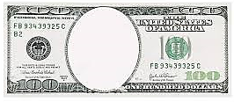
End
Of
Gold
Standard
Sears
Roebuck
General
Electric
McCormick
Reaper
Telegraph
Montgomery
Ward

