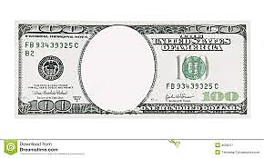

**End**

**Of**

**Gold**

**Standard**

**Sears**

**Roebuck**

**General**

**Electric**

**McCormick**

**Reaper**

**Telegraph**

**Montgomery**

**Ward**