Hot Dogs & More – Build Your Own (steamed, grilled, fried)

Hebrew© National 2.50 Vienna© Dog 3.25 Pretzel Dog 3.75
Ripper Fried Dog 2.50 Corn Dog 2.25 Italian Sausage 4.00
¼Lb Jumbo Angus Beef 4.25 Natural Casing 3.00 Polish Sausage 4.25
¼lb Stretch Fried Ripper 4.50 Bacon Wrap Dog 3.50 Veggie Soy Dog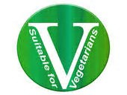 3.25
½Lb Jumbo Monster Ft lg 7.50 Turkey Dog 2.75 Veggie Sausage 4.25

Complimentary Toppings Additional Toppings
(Any toppings or sauces on the side Add .25) * (Monster toppings extra charge x2)
Sauces Dressings Veggies Cheeses
Yellow Must Blue Cheese Sauerkraut .25 Cheese Sauce. .50
Spicy Must. Ranch Sport Peppers .25 Shredded Cheddar .50
Onion Sauce Honey Must Jalapeno .25 Cream Cheese .50
House Sauce Mayo Pickle Spear .25 Mozzarella .50
BBQ Sauce Crunchies Creamy Slaw .25 Swiss Cheese .50
Sriracha Chopped Onion Tomatoes .25
Ketchup Sweet Relish Fried Onions .50 Meats
Hot Sauce Neon Relish Crispy On. or Fritos.50 Bacon Bits .50
Sesame Ginger Hot Relish Fried Peppers\on .75 Meaty Chili Sauce .75
Horseradish Lettuce Giardiniera .75 Bacon Wrap 1.00
Mad Dog 357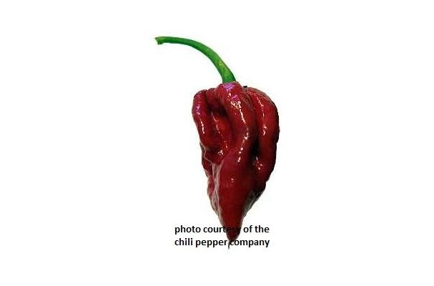 Celery Salt Guacamole .75 Roast Beef 1.00

Appetizers

American Fries 2.00 Cajun or BBQ Fries 2.25 NY Style Knish© 3.00
Cheese Fries 2.75 Corn Nuggets (8) 2.50 Creamy Slaw (12oz) 2.00
Chili Cheese Fries 3.50 Mac-n-Chz Bites (6) 3.00 Pretzel Stiks (2) 2.75
Sweet Potato Fries 3.50 Chicken Tenders (5) 3.75 Supreme Tamale© 1.75
Onion Rings 3.25 Meaty Chili Bowl(12oz) 4.00 Classic Lays Chips .50

Kids Menu (Served w/ fries & juice)
We now sell GIFT CARDS… AVAILABLE!
(12 years or younger…)
Hot Dog or Corn Dog 4.00
Chicken Tenders (2) 4.00
Corn Nuggets (5) 4.00
Mac-n-Cheez Bites (4) 4.00

Beverages & Shakes & Desserts
Coca Cola Products (20 oz. Bottle) 1.50… (12oz. Can) 1.00 * Bottled Water 1.00
Dr. Browns Specialty Sodas (12oz can) 1.50 * Root Beer Floats 2.75
Classic Milk Shakes(20 oz) 4.00 * Fruit Smoothies(20 oz) 4.50
Fresh squeezed Lemonade(20oz) 3.00 * Brewed Ice Tea(20oz) 2.00
*** Tiramisu 3.75 slice * Cannoli’s 2.50ea. * Cream Pups 1.75ea.

*See catering and retail menu on back…

Signature Hot Dogs (sub. Vienna Dog 1.00) * (sub. pretzel bun 1.25)
* (sub. Poppy bun .25) * (sub. Gluten-free bun 1.75) * (Make it a Bowl (no bun)
New Jersey Ripper- Mustard, relish on a deep fried ripper 2.50
New York- Spicy mustard, relish, onion sauce, sauerkraut 2.75
California- Lettuce, mayo, onions, tomato 2.75
Mad Dog- Jalapeno peppers and hot sauce 2.75
The Works- Mustard, ketchup, relish, onion sauce, sauerkraut 2.75
Wisconsin- Mustard and smothered in cheddar cheese sauce 3.00
Coney Island- Meaty Chili sauce, onions, mustard 3.25
Kansas City- Swiss cheese, yellow mustard, sauerkraut 3.25
Memphis- Bacon wrapped dog drizzled with BBQ Sauce 3.50
Carolina- Yellow mustard, meaty chili sauce, creamy slaw 3.50
Route ‘66’- Ranch dressing, meaty chili sauce, crushed fritos 3.75
Seattle Splitter– Cream cheese, jalapenos, fried onions, bbq sauce 3.75
Hawaiian– Teriyaki marinated pineapple, bacon bits, sesame ginger 3.75
BLT- Lettuce, bacon wrap dog, tomatoes 3.75
Cincinnati- Yellow mustard, onions, meaty chili, shredded cheddar 3.75
Chicago- Vienna© hot dog, yellow mustard, tomato, onions, neon
relish, pickle, sport peppers, and celery salt on Vienna© poppy bun 3.75
Yucatan- Guacamole, tomato, onion, shredded cheddar 4.00
European Dog- Spicy mustard, sauerkraut on a German Pretzel bun 4.00
Cobb Salad Dog- Lettuce, tomato, bacon bits, blue chz, pretzel bun 4.25
Philly Cheese Dog- Steak, cheese sauce, fried onions 4.50
John ‘B’ Splitter- ¼lb Jumbo, bacon bits, shredd cheddar, BBQ sc 5.25
Attila the ‘Hun’ster- ½ lb foot long jumbo monster, fried potatoes,
fried onions, drizzled with BBQ sauce topped with onion rings 9.50

Signature Sandwiches
Little Italy- Mild Italian sausage with peppers and onions on Italian bread 4.75
Polish Po’ Boys- Fried potato, creamy slaw, BBQ sc on Italian bread 5.25
Crispy Chicken- Lettuce, tomato, mayo, house sauce on Italian bread 5.25
The Drago - Veggie sausage, Cajun fried potato, fried onions, BBQ sc, Sriracha 5.25
Vienna© Italian Beef- Hot roast beef on French bread served wet or dry 6.75
Philly Cheese Steak- Steak, peppers & onions, cheese sc on Italian bread 7.00
Combo Sausage/Beef –Beef w/ sausage on French bread served wet/dry 8.50

