March/April 2017 At a glance
Full descriptions of activities in bulletin.

Sun | Mon | Tues | Wed | Thurs | Fri | Sat
19  Worship  11:15  Russell away - Skylight | 20  AA 7:30 pm  Meditation  7 pm | 21  Cards  9:30  TOPS  6:30  Godly Play Training  6:30 pm | 22  Lent  Service  7 pm | 23  Craft/Study  1:30 | 24 | 25  Russell away  IMCF Breakfast  9 am
26  Worship  11:15  Potluck  Cong. Care  Speaker  Russell away - Arizona | 27  AA 7:30 pm  Meditation  7 pm | 28  Cards  9:30  TOPS  6:30 | 29  Lent  Service  7 pm  Community Study Night  8 pm | 30  Craft/Study  1:30 | 31 | 1  Wascana Presbytery  9 to 4:30 pm  Sikh Temple  4 pm
2  Worship  11:15  Communion | 3  AA 7:30 pm  Meditation  7 pm | 4  Cards  9:30  TOPS  6:30 | 5  Soup Supper  6 pm  Lent  Service  7 pm  Faith Expl. 7:30 pm | 6  Craft/Study  1:30  Family Dinner  6 pm  Faith Formation 7:30 pm | 7  Hindu Temple  7 pm | 8  Women’s Breakfast  8 am  Easter Egg Hunt! 1 pm
9  Worship  11:15  Open Hearts Jar | 10  AA 7:30 pm  Meditation  7 pm | 11  Cards  9:30  TOPS  6:30 | 12  Community Study Night  8 pm | 13  Craft/Study  1:30  Teaching Seder at LSC 7 pm | 14  Good Friday Memorial Wake  7 pm | 15  Easter Vigil at St. Paul’s Cathedral 10 pm
16  Sunrise Service and potluck breakfast  5:45 am Worship  11:15 | 17  AA 7:30 pm  Meditation  7 pm | 18  Cards  9:30  TOPS  6:30 | 19  Faith Expl. 7:30 pm | 20  Craft/Study  1:30  LT Meeting  7 pm | 21  Film and Faith | 22
TOPS = Take Off Pounds Sensibly
AA = Alcoholics Anonymous

ANNOUNCEMENTS
March 19, 2017

306-761-0556 eastsideunited@sasktel.net
Like us on facebook (Eastside United Church)
Follow us on Twitter @Eastside_united
www.eastsideunited.ca

W
elcome to Eastside United. May our opportunities of ministry offer you rest, challenge and peace on your Christian journey.

Ministers:
Minister: Ken Powers
Greeting: Leslie and Doug Scheurwater
Congregational Care Greeter: Linda Fowler
Prayers: Heather Balfour
PowerPoint: Taylor Balfour
Piano: Michelle Dickie
Attendance last week: 54

Russell’s e-mail address: russell.eastside@sasktel.net

Office Hours:
Tuesday through Friday from 8:30 am to 3:30 pm
Russell is away at Skylight Festival planning meetings March 18 through 21.

Brewed Awakening Office Hours, Wednesday afternoons from 2 to 4:30 pm. At U of R Campion College for the month of March.

Scripture Reading: Luke 15: 1-32

Songs:
PRELUDE: Here I Am to Worship
All Who are Thirsty MV #4
O Beautiful Gaia MV #41 vs 3
Sow Seeds
It’s About the Cross
Near the Cross
Give Thanks
I Will Sing
Spirit Song
POSTLUDE: I’ll Fly Away

Arcola East Senior Bridge Club: Looking for a fun way to get out and socialize with other seniors? The Arcola East Senior Bridge Club gathers for social bridge each Monday at 1 pm at the Living Spirit Centre (3018 Doan Drive). No prize money; weekly fee is $1. For more information, please contact Bill Jeske at 306-789-2430 or Alma Pockrandt at 306-789-5981 or apockra@yahoo.ca.
Join us for Easter
Worship

April 9 Palm Sunday
A Walk through Holy Week All Ages Service
11:15 am

April 13 Maundy Thursday
Teaching Seder with Bread of Life
7 pm

April 14 Good Friday
Memorial Wake with IMCF
Featuring Creator’s Sacrifice Paintings
7 pm

April 15 Easter Vigil
At St. Paul’s Anglican Cathedral
with St. Philip Anglican
10 pm

April 16 Easter Sunday
Sunrise Service 5:45 am at LSC
Easter Worship 11:15 am

LSC Meditation Group: The Meditation Group gathers at 7 pm Monday evenings in the East Sanctuary. Feel free to bring a friend, and dress comfortably.

St. Philip Senior Ministry Outreach card playing program, Tuesday mornings at 9:30 am in the East Sanctuary at the Living Spirit Centre. Whist and lessons to those that would like to learn. Come out and enjoy fellowship, coffee and card playing. If you need a ride call Rod 306-789-1388. Everyone is welcome.

Eastside’s Craft/Study Group Thursdays at 1:30 pm in the Multipurpose Room! Join us as we share in discussion, handiwork and coffee time following. We are reading Grounded by Diana Butler Bass. This is a fun time of study, crafting, and refreshments following.
We’d love you to join our family! We are planning a Transfer of Membership service Sunday, April 23. If you are interested in being included or have questions, please let Russell know.
Understanding World Religions: Leaders from four of the large world religions will talk about their faith including origins, customs, and belief systems. A different religion will be featured each week – Islam, Hinduism, Buddhism and Sikhism. Thursdays, March 23 from 10 to 11:30 am at 2151 Scarth Street, Room 109. These presentations are FREE and everyone is invited to attend. Space is limited so call 306-585-5748 to reserve your seat today! Drop-ins also welcome if space permits. This is a program of the University of Regina’s Lifelong Learning Centre.

Sunday School will be offering Godly Play! We will hear the story during Theme Time and need volunteers to supervise the kids’ creative play downstairs. Our training session has been rescheduled to Tuesday, March 21 at 6:30 pm. Please let Russell know if you’d like to work with our kids in this way! Children will remain in worship until this workshop or until we get the needed volunteers.

Join us for our weekly Lenten service Wednesday evenings at 7 pm. The focus of our services this year will be "Do not fear", a timely reminder as our worries for the world can at times become overwhelming. These short services take place in the East Sanctuary. All are welcome!

Community Easter Egg Hunt, Saturday, April 8, 2017.
Last year's Easter Egg Hunt was a huge success and we would really like to be able to offer this event to our community again this year. Unfortunately Terri Lynne, our lead volunteer on this ministry, has had to step down, and we are in need of one or two individuals to take over coordination duties. We also need helpers the day of and donations of chocolate. Let's work together to ensure this unique and popular event continues as a gift to our neighbourhood families! Let Russell know if you can help.
JOIN US FOR LENTEN SOUP: Wednesday, April 5 at 6 pm, Munch Café and Catering is again providing a simple soup meal prior to our evening Lenten worship. Vegetarian and meaty soup options and bread will be served. RSVP to eastsideunited@sasktel.net. $5 per person.

Information is now available for the 2017 Youth Rally being held at St. Andrew’s United Church in Yorkton from March 24 – 26. The theme for this rally is do Justice, Love Kindness, Walk Humbly and is for all youth in grades 7 – 12. Cost is $30 up to March 3 (early bird deadline) and $40 after that.
www.sk.united-church.ca/wp-content/uploads/2016/01/YouthRally2017Poster.pdf
www.sk.united-church.ca/wp-content/uploads/2016/01/YouthRally2017Registration.pdf

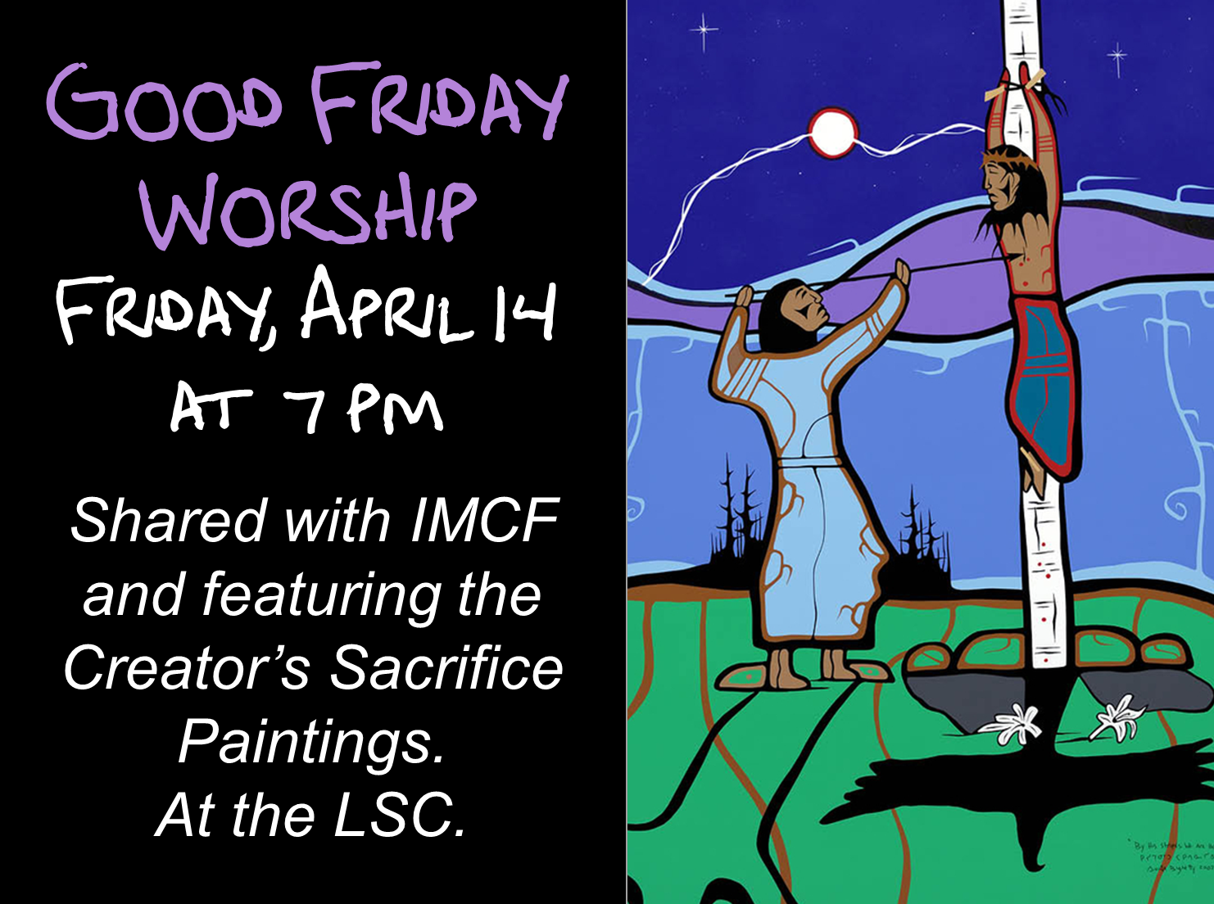
Congregational Care Speaker Series: Living out our Faith. Join us following potluck lunch next Sunday, March 26 as we hear from Jim Fallows about his work with Regina Open Door Society.
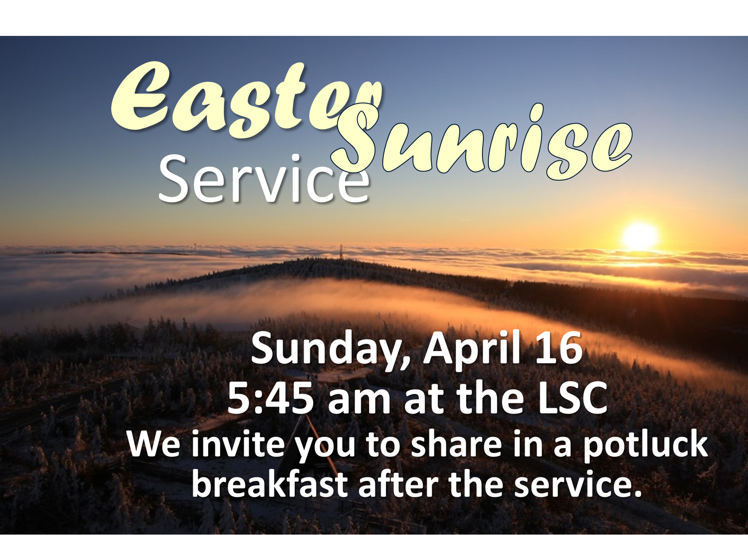
A Night for St. Andrew’s Gala Dinner and Fundraiser, Tuesday, April 18, 2017 at the Wascana Country Club, 6500 Wascana Parkway. Gathering 5 pm, dinner 6:15 pm. Tickets $110 (partial tax receipt), ticket deadline April 10. See Leona Martin or contact the church office if interested. This year’s fundraiser includes an address by Right Reverend Jordan Cantwell, UCC Moderator, and music by Lori Erhardt and Corinne Groff!

TIME OUT FOR BLESSINGS: A Christ-centred yoga retreat presented by Connie Moker Wernikowski of Big Fish Yoga. Friday, April 28 at 6 pm to Saturday April 29 at 5 pm. At the living Skies Retreat Centre in Lumsden, SK. This retreat will offer both active and restorative yoga; meditation; some free time for walking, resting, visiting; Christian chanting; and an intro to the First Ignation Spiritual Exercise. Cost is $193. Please complete a registration form found on any of the LSC bulletin boards, or by emailing mokerw@sasktel.net.

All are welcome to join the Faith Exploration group as we visit the holy places of other faith traditions: Saturday, April 1 at 4 pm, Sikh Temple at 3905 Princess Drive; and Friday, April 7 at 7 pm, Hindu Temple at 3307 Pasqua Street.

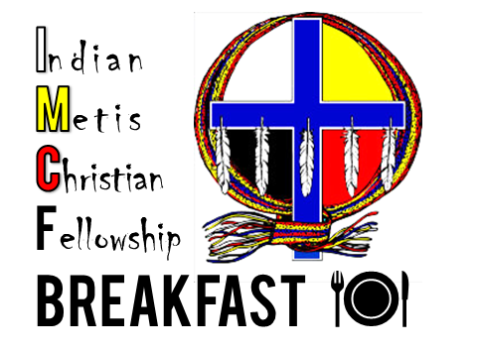
IMCF Breakfast: Saturday, March 25 from 9 am to 12 noon. Looking to get involved in a rewarding, family-friendly outreach ministry? This is just for you! We need volunteers to help set up, serve, and clean up breakfast the fourth Saturday of each month. Please contact Peter Braun to learn more.

St. James United Church Players are holding their Annual Dinner and
Dessert Theatre, "Honestly, Now!", a comedy by Jack Sharkey. March 24, 25, 30, 31, April 1, 7, 8. Doors open at 5:30 pm, performance at 6 pm. Tickets $35, includes dinner. Dessert Theatre dates are March 26 and April 9. Doors open at 1:30 pm, performance at 2 pm. Tickets $20.
Reserve your tickets by calling St. James United Church office at 306-543-2626.
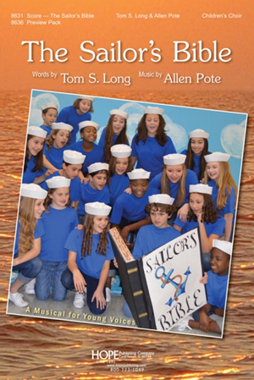
Join us for another LBC Musical
Cast members needed! May gathering intro with fall
rehearsals and performance before December.
Let Russell know if interested!

Join us for our weekly Lenten service Wednesday evenings at 7 pm. The focus of our services this year will be "Do not fear", a timely reminder as our worries for the world can at times become overwhelming. These short services take place in the East Sanctuary. All are welcome!

Community Easter Egg Hunt, Saturday, April 8, 2017.
Last year's Easter Egg Hunt was a huge success and we would really like to be able to offer this event to our community again this year. Unfortunately Terri Lynne, our lead volunteer on this ministry, has had to step down, and we are in need of one or two individuals to take over coordination duties. We also need helpers the day of and donations of chocolate. Let's work together to ensure this unique and popular event continues as a gift to our neighbourhood families! Let Russell know if you can help.
JOIN US FOR LENTEN SOUP: Wednesday, April 5 at 6 pm, Munch Café and Catering is again providing a simple soup meal prior to our evening Lenten worship. Vegetarian and meaty soup options and bread will be served. RSVP to eastsideunited@sasktel.net. $5 per person.

Information is now available for the 2017 Youth Rally being held at St. Andrew’s United Church in Yorkton from March 24 – 26. The theme for this rally is do Justice, Love Kindness, Walk Humbly and is for all youth in grades 7 – 12. Cost is $30 up to March 3 (early bird deadline) and $40 after that.
www.sk.united-church.ca/wp-content/uploads/2016/01/YouthRally2017Poster.pdf
www.sk.united-church.ca/wp-content/uploads/2016/01/YouthRally2017Registration.pdf

Congregational Care Speaker Series: Living out our Faith. Join us following potluck lunch next Sunday, March 26 as we hear from Jim Fallows about his work with Regina Open Door Society.
A Night for St. Andrew’s Gala Dinner and Fundraiser, Tuesday, April 18, 2017 at the Wascana Country Club, 6500 Wascana Parkway. Gathering 5 pm, dinner 6:15 pm. Tickets $110 (partial tax receipt), ticket deadline April 10. See Leona Martin or contact the church office if interested. This year’s fundraiser includes an address by Right Reverend Jordan Cantwell, UCC Moderator, and music by Lori Erhardt and Corinne Groff!

TIME OUT FOR BLESSINGS: A Christ-centred yoga retreat presented by Connie Moker Wernikowski of Big Fish Yoga. Friday, April 28 at 6 pm to Saturday April 29 at 5 pm. At the living Skies Retreat Centre in Lumsden, SK. This retreat will offer both active and restorative yoga; meditation; some free time for walking, resting, visiting; Christian chanting; and an intro to the First Ignation Spiritual Exercise. Cost is $193. Please complete a registration form found on any of the LSC bulletin boards, or by emailing mokerw@sasktel.net.

All are welcome to join the Faith Exploration group as we visit the holy places of other faith traditions: Saturday, April 1 at 4 pm, Sikh Temple at 3905 Princess Drive; and Friday, April 7 at 7 pm, Hindu Temple at 3307 Pasqua Street.

IMCF Breakfast: Saturday, March 25 from 9 am to 12 noon. Looking to get involved in a rewarding, family-friendly outreach ministry? This is just for you! We need volunteers to help set up, serve, and clean up breakfast the fourth Saturday of each month. Please contact Peter Braun to learn more.

St. James United Church Players are holding their Annual Dinner and
Dessert Theatre, "Honestly, Now!", a comedy by Jack Sharkey. March 24, 25, 30, 31, April 1, 7, 8. Doors open at 5:30 pm, performance at 6 pm. Tickets $35, includes dinner. Dessert Theatre dates are March 26 and April 9. Doors open at 1:30 pm, performance at 2 pm. Tickets $20.
Reserve your tickets by calling St. James United Church office at 306-543-2626.
Join us for another LBC Musical
Cast members needed! May gathering intro with fall
rehearsals and performance before December.
Let Russell know if interested!

