REGULAR MEETING
MARCH 19, 2014

A Regular Meeting of the Town Board of the Town of Hampton, County of Washington and the State of New York was held at the Town Hall, 2629 State Route 22A, Hampton, New York on the 19th day of March, 2014.

PRESENT: David K. O’Brien----------Supervisor
Tamme Taran--------------Councilwoman
David Jensen---------------Councilman
Donald Sady----------------Councilman
Andrea Sweeney-----------Councilwoman
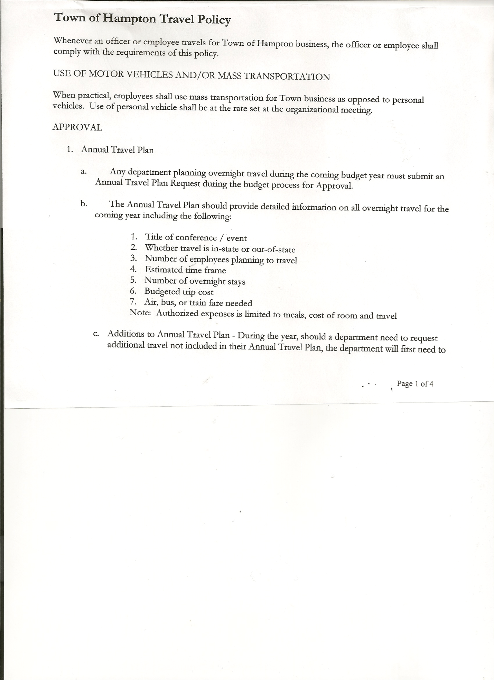
Rebecca Jones--------------Town Clerk
Herbert Sady, Jr.-----------Highway Superintendent

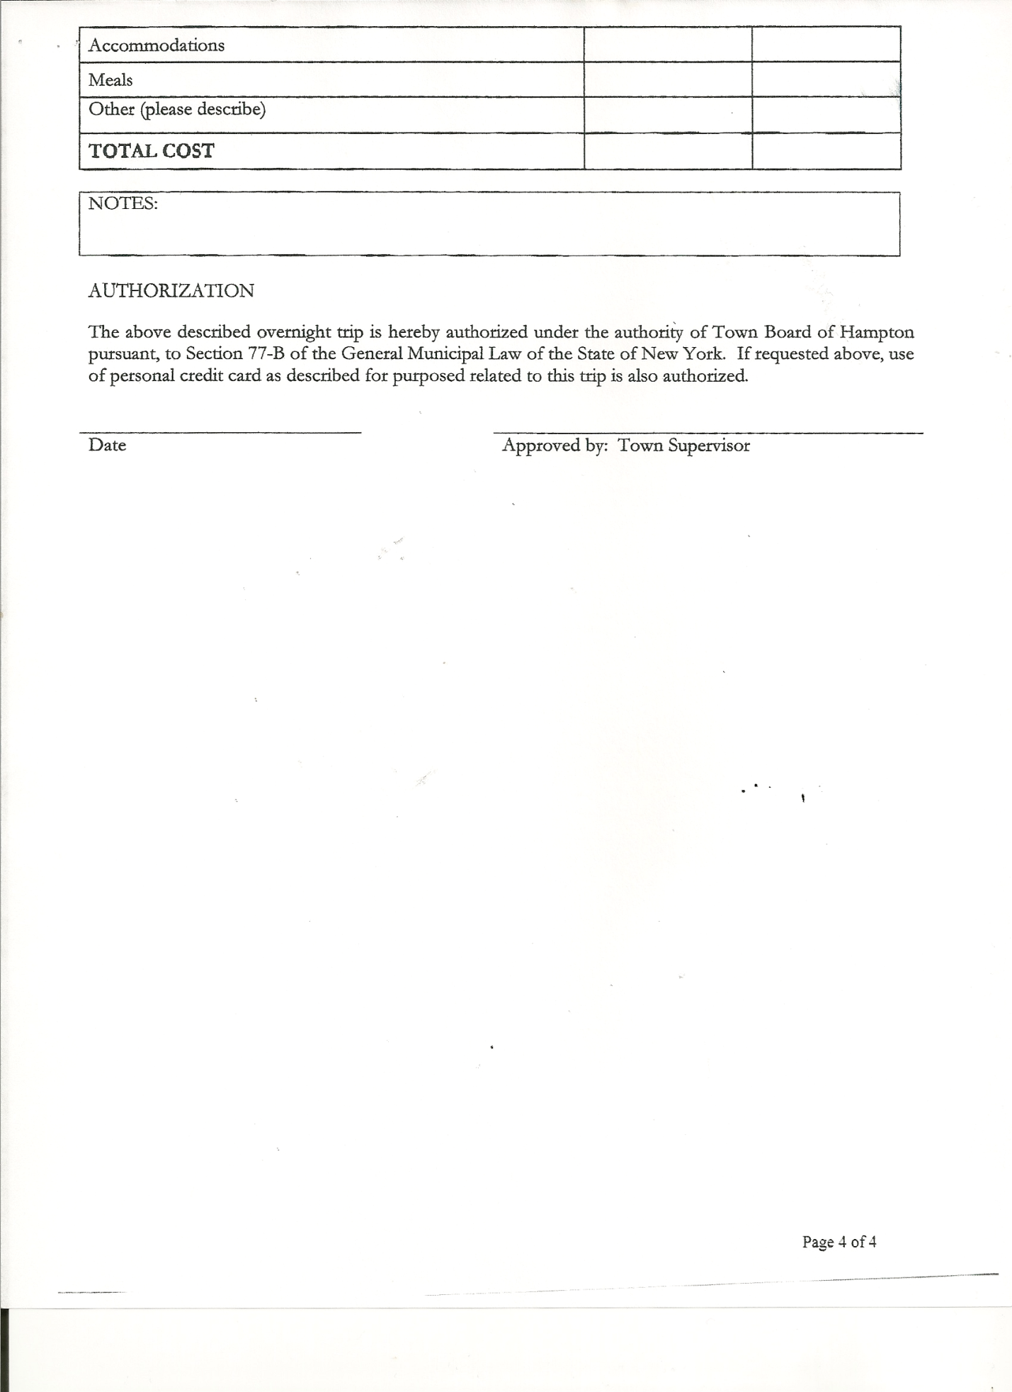
Planning Board Member(s): Bonnie Hawley, Chair and Francis Baker

Also present: Derek Liebig, Whitehall Times Reporter and Matthew Pratt

The meeting was called to order by Supervisor O’Brien at 7:32pm followed by the Pledge of Allegiance. Location of Fire Exits were given.

RESOLUTION NO. 30-2014
APPROVAL OF THE MINUTES
On a motion of Councilwoman Taran, seconded by Councilman Sady, the following resolution was
ADOPTED: Ayes 5 O’Brien, Taran, Jensen, Sady, Sweeney
Nays 0
RESOLVED that the Regular Town Board Minutes for February 19th, 2014 be accepted.

RESOLUTION NO. 31-2014
CORRECTION TO FEBRUARY 19TH, 2014 MINUTES
On a motion of Councilman Sady, seconded by Councilman Jensen, the following resolution was
ADOPTED: Ayes 5 O’Brien, Taran, Jensen, Sady, Sweeney
Nays 0
RESOLVED that the date for the previous Planning Board Meeting was February 25th, 2014 not January 25th, 2014.

RESOLUTION NO. 32-2014
APPROVAL OF MINUTES AS AMENDED
On a motion of Councilwoman Taran, seconded by Councilman Sady, the following resolution was
ADOPTED: Ayes 5 O’Brien, Taran, Jensen, Sady, Sweeney
Nays 0
RESOLVED that the Regular Town Board Minutes for February 19th, 2014 be amended with the above correction.

Planning Board Report…Bonnie Hawley, Chair gave report
- Next meeting will be Tuesday, March 25th, 2014 at 7:00pm at the Town Hall

TOWN BOARD MEETING
MARCH 19, 2014 PAGE 2

No Dog Officer report was submitted.… Regarding the “5th Annual DCO/ACO Conference 2014” that he was interested in attending in Guilderland, NY is not going to go now, because the Town Board wouldn’t pay all the expenses he requested.

Herbert Sady, Jr., Highway Superintendent gave his report: (a copy is attached)
- plowing and sanding roads
- Received more sand from the County
- Waiting for the glass door for the loader from Winmill’s
- Replaced new batteries and alternator on the grader
- John Deere bucket tractor needs a new water pump bearing
- Continuing to do maintenance on equipment to keep it in good running order.
- Searching prices for used and new trucks and on a new gas skid tank
Discussion on closing Staso Road in the wintertime, some other suggestions were
- Limit vehicle use
- Make it one way
- Don’t maintain “the hill” portion in the wintertime
Supervisor O’Brien handed out McKinney’s Vehicle and Traffic Law for Board Members to read over and discuss at next meeting.

RESOLUTION NO. 33-2014
BUDGET AMENDMENT
On a motion of Councilman Sady, seconded by Councilwoman Taran, the following resolution was
ADOPTED by Roll Call Vote: Supervisor O’Brien AYE
Councilwoman Sweeney AYE
Councilman Sady AYE
Councilwoman Taran AYE
Councilman Jensen AYE
RESOLVED the following Budget Amendment to the General Fund is approved:
Increase Other Unclassified Revenue A2770 in the amount of $1409.31
Transfer to Garage Contractual Expense A5132.4 the amount of $1409.31

RESOLUTION NO. 34-2014
APPROVAL OF SUPERVISOR’S MONTHLY REPORT
On a motion of Councilwoman Taran, seconded by Councilman Jensen, the following resolution was ADOPTED Ayes 5 O’Brien, Taran, Jensen, Sady, Sweeney
Nays 0
RESOLVED that the Supervisor’s Monthly report be accepted as submitted for FEBRUARY 2014.
01/31/14 02/28/14
ACCOUNT BALANCE RECEIPTS DISBURSEMENTS BALANCE
General Fund $124130.11 $ 12207.91 $ 52399.97 $ 83938.05
Highway Fund $104458.38 $ 71012.64 $ 31760.79 $ 143710.23
Equipment Reserve $ 64166.73 $ 20914.46 $ 0.00 $ 85081.19
Building Fund $ 1349.21 $ 60.10 $ 1409.31 $ 0.00
Fire #1 $ 0.00 $ 31985.00 $ 0.00 $ 31985.00
Fire #2 $ 0.00 $ 4724.00 $ 0.00 $ 4724.00
Totals $ 294104.43 $140904.11 $ 85570.07 $ 349438.47

TOWN BOARD MEETING
MARCH 19, 2014 PAGE 3

All Board Members present signed Supervisor’s Report.

Fire Department Lease…Fire Department has met with their Insurance Company. Supervisor O’Brien and Hampton FD President Justin Perry will meet Thursday or Friday (3/20 or 3/21) to finalize items on the lease…will bring to next Town Board Meeting for discussion.

RESOLUTION NO. 35-2014
AMEND CREDIT CARD POLICY
On a motion of Councilman Sady, seconded by Councilman Jensen, the following resolution was ADOPTED Ayes 5 O’Brien, Taran, Jensen, Sady, Sweeney
Nays 0
RESOLVED that the Town of Hampton’s Credit Card/Charge Account Policy be amended as follows,
Previous Policy read…
Credit Card or Charge slips will be turned into the Town Supervisor or his authorized agent within five (5) days of purchase. After receipts are reviewed they shall be vouchered by the Department. Subsequently the Town Clerk shall prepare the warrants, submit the warrants along with all statements and receipts to the Town Board for Audit and Approval. After payment has been prepared warrants and accompanying documentation will be returned to the Town Clerk.

New Policy reads:
Credit Card or Charge slips will be turned into the Town Supervisor or his authorized agent by the Thursday prior to the Monthly Board Meeting. Any vouchers not presented for payment in a timely manner will not be included or payment during that month. The Department Head shall prepare the Vouchers. Any Vouchers required for General Accounts shall be prepared by the Town Supervisor or his agent. The Supervisor and the Budget Officer shall review the vouchers. Subsequently the Town Clerk shall prepare the warrants, submit the warrants along with all statements and receipts to the Town Board for Audit and Approval. Any questions on or changes to account numbers shall be reviewed with the department head responsible for the account prior to any changes. After payments have been prepared, the warrants and accompanying documentation will be returned to the Town Clerk for storage.

Use of Town Hall discussion….Mary Holland, resident and member of the non-profit group “Heron Brook Haven” has asked permission to use the Town Hall for a few meetings. The Town Board discussed and decided that the group could use the Town Hall and instead of charging them for the use, they would be asked to make a donation to the Hampton Fire Department. Town Board Member Donald Sady is going to work on a Policy for use of the Town Hall, will discuss at future meeting.

Discussed the Proposed State… Real Property Tax Freeze and Circuit Breaker Programs (copy of outline is attached).

Discussed the difference between Resolutions and Motions.
Motions are an Aye or Nay/
Resolutions require roll call vote each time-Adopting policies and money matters

TOWN BOARD MEETING
MARCH 19, 2014 PAGE 4

Highway Superintendent, Herb Sady inquired about getting a Debit or Credit Card.
Discussed pros and cons of Debit and/or Credit Cards…Supervisor O’Brien will set up another
separate account with limited funds and it could be used by Town Officials on an as needed base.

The Town Clerk’s report for February 2014 was submitted to the Board. The Town Clerk had Board Members review and sign bank reconciliation statements for the Town Clerk Account and Special Town Clerk Account dated February 28, 2014.

Deputy Tax Collector Jones submitted Tax Collector Report for February 2014.
She also had Board Members review and sign bank reconciliation statement dated February 28, 2014.

RESOLUTION NO. 36-2014

AUDIT OF CLAIMS
On a motion of Councilwoman Taran, seconded by Councilman Jensen the following resolution was ADOPTED Ayes 5 O’Brien, Taran, Jensen, Sady, Sweeney
Nays 0
RESOLVED that the bills have been reviewed by the Town Board and are authorized for payment in the following amounts.
General Fund No. 44 through No. 53 $ 4636.41
Highway Fund No. 26 through No. 44 $ 28046.29
Building Fund No. 1 $ 1409.31
Total both funds $ 34092.01

On a motion of Councilman Sady, seconded by Councilman Jensen, the meeting adjourned at 9:36pm. All in favor Aye.

Respectfully submitted,

Rebecca S. Jones, RMC
Town Clerk

