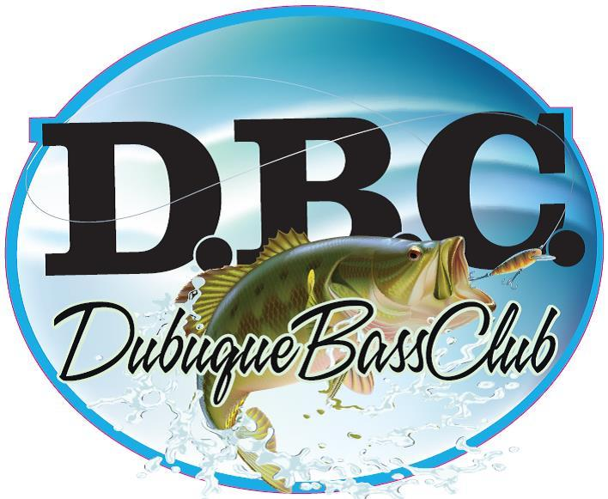
Dubuque Bass Club
2018 Tournament Entry Form

EVENT SIGN-IN,
PARTICIPATION WAIVER, AND RELEASE OF LIABILITY

I, HEREBY WAIVE AND RELEASE, INDEMNIFY, HOLD HARMLESS and FOREVER DISCHARGE Dubuque Bass Club (hereinafter the “Club”), its agents, employees, officers, directors, affiliates, successors and assigns, and any participant in this Club event, from any and all claims, demands, debts, contracts, expenses, causes of action, lawsuits, damages and liabilities, of every kind and nature, whether known or unknown, in law or equity, that I have ever had or may have, arising from or in any way related to my participation in this Club event or activities conducted by the Club at this event.

I hereby certify that I am at least 18 years old, and in the event I own a boat to be used in Club sponsored activities that I will have the necessary minimum coverage of $_____________ liability and $___________ property damage insurance coverage on my fishing boat. I further certify that I understand the activities in which I will participate are potentially dangerous and may cause serious bodily injuries, and damage to personal. On behalf of myself, my heirs, assigns and next of kin, I waive all claims for damages, injuries and death sustained to me or my property, that I may have against the aforementioned released parties to such activity.

By this WAIVER AND RELEASE, I assume any and all risk, and take full responsibility and waive any claims of personal injury, death or damage to personal property associated with but not limited to participating in boating or fishing related activities. I further understand that no claims or representations are made about fitness for use of the fishing and staging areas for any particular purpose and that I am using said property at my own risk.

This WAIVER AND RELEASE contains the entire agreement between the parties, and supercedes any prior written or oral agreements between them concerning the subject matter of this WAIVER AND RELEASE. The provisions of this WAIVER AND RELEASE may be waived, altered, amended or repealed, in whole or in part, only upon the prior written consent of all parties. This WAIVER AND RELEASE is a legally binding agreement and will be construed broadly to the maximum extent permissible under applicable law. Any provisions found to be void or unenforceable shall be severed from this agreement, and not affect the validity or enforceability of the remaining provisions.

CAUTION: THIS IS A RELEASE – READ BEFORE SIGNING!

I HAVE READ THIS WAIVER AND RELEASE AND FULLY UNDERSTAND ITS TERMS. I UNDERSTAND THAT BY SIGNING BELOW, I HAVE GIVEN UP CERTAIN RIGHTS, AND HAVE SIGNED IT FREELY AND VOLUNTARILY WITHOUT INDUCEMENT, ASSURANCE OR GUARANTEE BEING MADE TO ME.

- Boater’s Signature____________________________________________

- Non-Boater’s Signature_________________________________________

- Tournament Location________________

- Date of Tournament_______________
Entry fee for club tournaments is $80.
Entry form and fees must be received by mail at Mid-Town Marina at 285 5th Street, East Dubuque, Illinois, 61025, or submitted at pre-tournament meeting the Thursday before the event at 7:00PM at Mid-Town.

For answers to questions contact Junior Friedman at 563-542-4777, Jeremy McDowell at 563-590-8249, Brian Evanoff at 608-778-0932, Chad Breitsprecker at 563-599-9246, or can be posted on the Dubuque Bass Club Facebook page.

*Submission of entry form implies understanding and agreement on all tournament regulations listed on the back of this form.
**Make checks payable to Dubuque Bass Club

1. Rules. The following are the rules of this club and all tournaments and will remain unchanged for the year. Decisions of officers and tournament officials shall be final in all matters. Interpretation of these rules shall be left exclusively to the Officers and tournament committee, not involved in dispute.  2. Participation and Eligibility : Tournament registration and entry fee is due on the Thursday before the tournament date. There will be a pre-tournament meeting Thursday night at 7:00PM at Mid-Town Marina before each weekend tournament. All members are welcome and encouraged to attend. All participants must be members of the club unless otherwise stated in the individual tournament regulations (ie. Open tournaments). All adult and junior members must abide by all D.N.R. regulations applicable.  3. Laws and Safety : Every boat shall have standard Coast Guard Safety Equipment and must obey all Federal and State Laws. Safe Boating must be observed at all times by all tournament competitors. All boaters are required to wear a Coast Guard approved chest-type life preserver or PFD, and it shall be strapped or zippered securely and maintained in that condition until the combustion engine is shut off. Each boat shall have a kill switch with a lanyard attached to the pilots life vest or PFD. Violation of this rule shall be reason for immediate disqualification. (Coast Guard ruling dated November 1st 1972.)  4. Sportsmanship : Courtesy, safety and conservation are expected from each participant. Any infraction to these fundamental-sporting principles may deem cause for disqualification. All State and Federal Laws pertaining to alcohol shall apply. Unnecessary or vexatious complaints made by a tournament participant or club member may be grounds for disqualification from an event. Repeated violations of the sportsmanship rule may be grounds for removal from the club.  5. Tackle and Equipment : Baits shall be artificial lures only. Pork rinds are considered artificial. Only one casting, spin casting or spinning reel and rod can be used at any one time. All other type rigs and methods are prohibited. All bass must be caught live and in accordance with state regulations.  6. Live Wells : An aerated live well must be used to keep fish alive. The club suggests use of catch and release agents.  7. Boat and Motor : Boats that are 14 foot in length or more may be used. A smaller additional gas or electric motor may be used to maneuver while casting. Trolling is not allowed. Horsepower shall not exceed the limitations set by the Coast Guard in their ruling of November 1st 1972.  8. Permitted Fishing Locations: There will be no fishing within 50 yards, in any direction, of another competitor. All fishing must be done from the boat. Boats may be taken out of the water, but must stay at the tournament site. Fish must remain with a team member until fish are weighed in. No trailering of boat is allowed. No pool or lake will be closed prior to any tournament. Tournament pool and lake restrictions will be announced at check in, and may apply due to permit limitations. Federal, State & Local governmental restrictions & postings will be honored by club members.  9. Liability and Insurance: All members are required to carry a liability and insurance policy to cover any harm or damages caused by the participant. The Dubuque Bass Club is in no way liable for the actions of individual members or participants. | 10. Tournament Headquarters/ Weigh In : Shall be the tournament site. All participants must start & end each day at this site. Boats encountering mechanical trouble not allowing boat to return to tournament launch site under it's own power (running out of gas isn't a mechanical failure), must abide by the following: If fish are to be transported in another boat, that boat must be registered and participating in same tournament, 1 team member must stay with the fish. Any team not able to return with their boat must notify tournament director as soon as possible.  11. Dead Fish Penalty: Each contestant shall be expected to keep their fish alive. For each dead fish – there shall be a 1.0 lb. penalty taken off the total weight. No more than 2 dead fish can be weighed. Big Bass must be alive to be weighed.  12. Fishing Hours: Check in times are posted on schedules. Weigh in times to be announced before tournament launch.  13. Late Penalties: If you are late for tournament check in you are disqualified.  14. Scoring: Pounds accumulated will determine scoring during the day. Only Largemouth, Smallmouth and Kentucky bass will be accepted. At no time shall any boat have more than the legal limit. To qualify for the Classic Event members must pay entry fees for 50% of the point earning events that year.  15. Weigh-in: there will be a limit of FIVE (5) bass per team, unless lowered by the tournament committee or Director the day of the tournament. Bringing more than the club limit to the scales is automatic disqualification. All competitors boats must be equipped with a measuring board.  16. Total Weight Ties: will be determined by big fish. In the event of ties in big fish weight, money will be split among both teams.  16. Measurement : All fish shall be measured with a flat measuring board, mouth closed. All fish weighed become the property of the club.  17. Short Fish : Any contestant weighing a short fish shall be penalized the short fish plus his/her BIGGEST fish.  18. Blast Off: Will be done in line by draw. The boat with highest number is the last to leave and the starter boat.  19. Cheating: (if proven) is grounds for automatic disqualification, forfeiture of fees, club dues and banishment from future club activities. A Poly graph examination may be required, at the discretion of the executive board, and may subject team involved to criminal charges.

