Current Used Inventory (November 2015):

Model: BH7480
Quantity: 5
Manufacture Date: 2015
Condition: Excellent, no scratches, dings or dents and performs perfectly, froze test mix in 10 mins from room temp.
Warranty: 1 year non-consumable parts
Price: $5450/unit
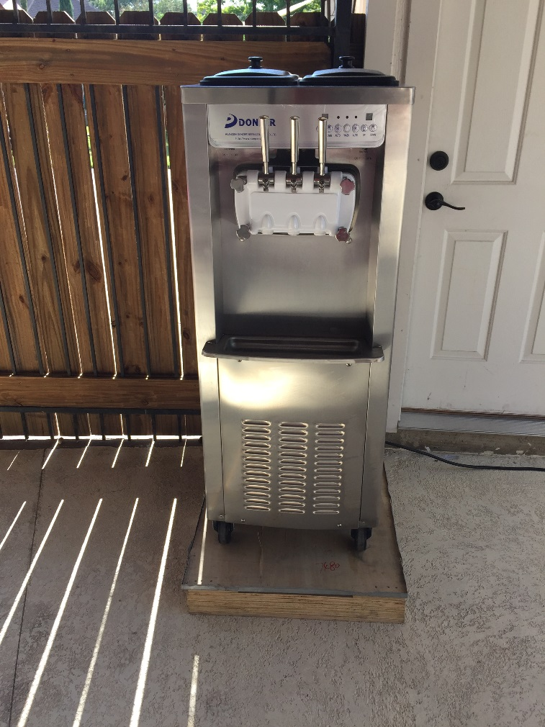
Model: BH7480
Quantity: 1
Manufacture Date: 2014
Condition: Excellent condition, minimal visible wear, tested and working like new with fast freeze times
Warranty: 1 year non-consumable parts
Price: $4250/unit
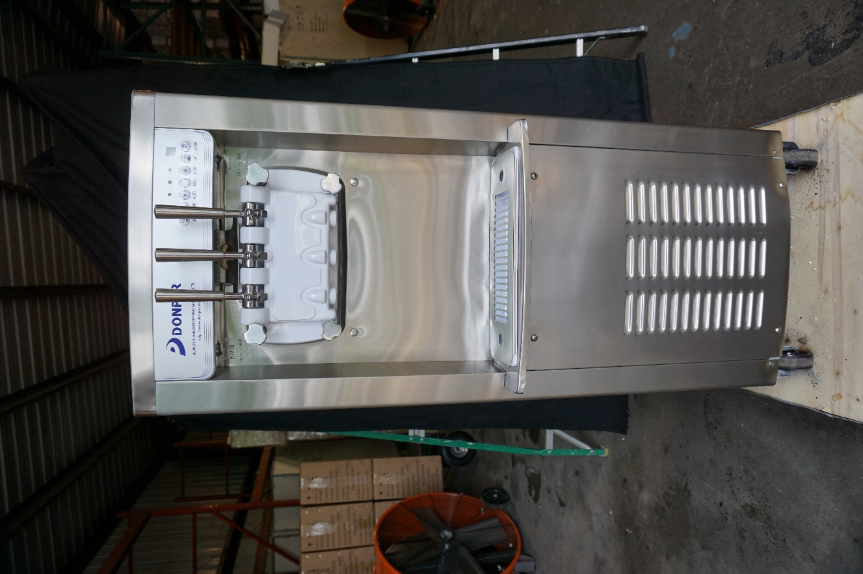

Model: XF124
Quantity: 2
Manufacture Date: 2015
Condition: Excellent condition, minimal visible wear, freezes just like new.
Warranty: 1 year non-consumable parts
Price: $2750/unit
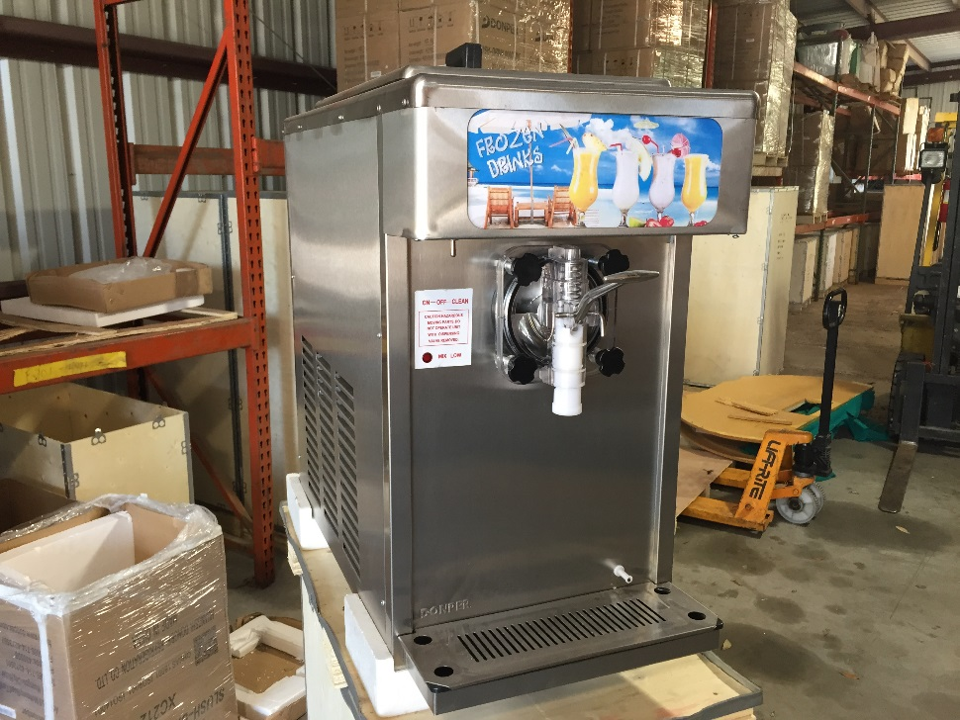

Model: XC224
Quantity: 1
Manufacture Date: 2014
Condition: Excellent condition, no visible wear, freezes and cycles normally.
Warranty: 1 year non-consumable parts
Price: $1325/unit
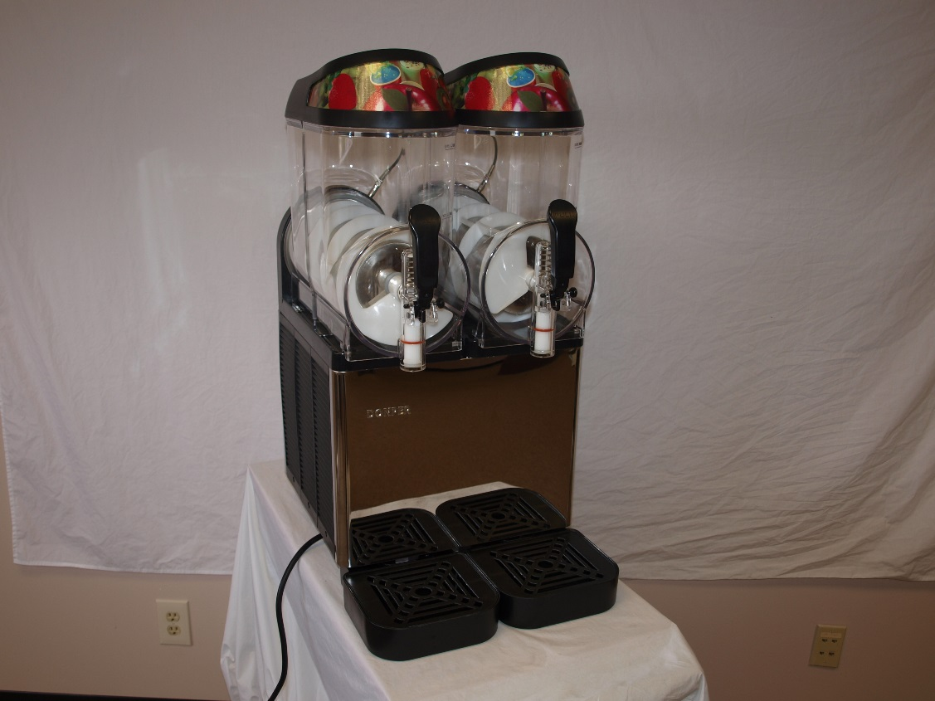

Model: XC112
Quantity: 3
Manufacture Date: 2015
Condition: Excellent condition, no visible wear, freezes just like new.
Warranty: 1 year non-consumable parts
Price: $950/unit
