Meet & Greet Events and Q & A

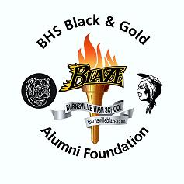


2014 Meet & Greet Event
BHS All Class Meet & Greet Event
When: Saturday, July 26, 2014. Starts at 7pm, entertainment at 9pm.
Where: Neisens in Savage, MN (Free event)
What: Format will be The Beatles tribute
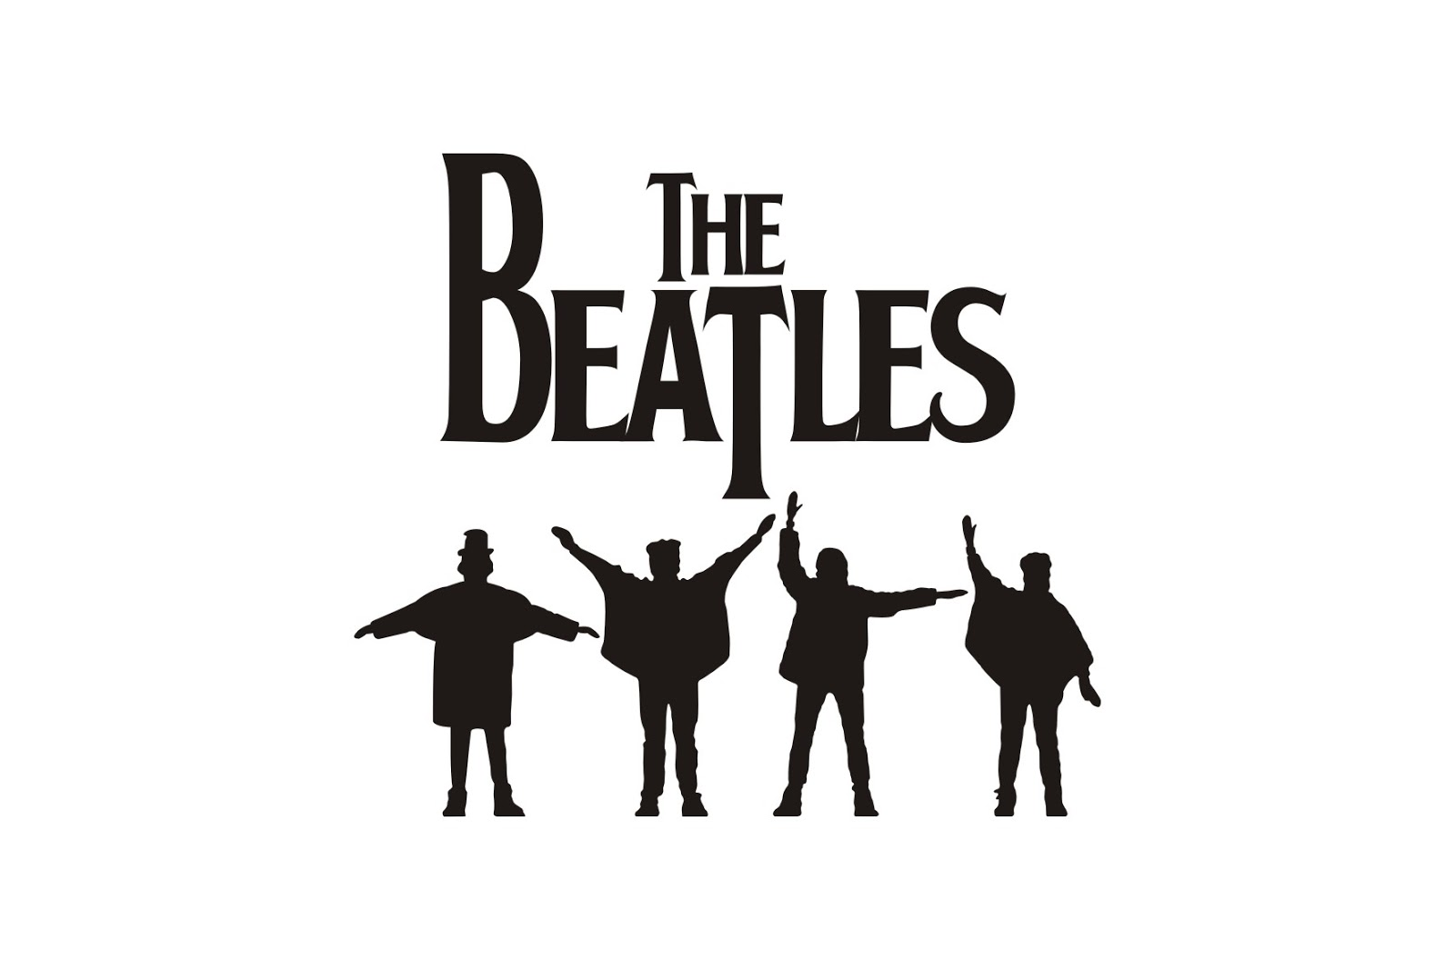
2015 Meet & Greet Event
BHS All Class Meet & Greet Event
When: Saturday, July 25, 2015 at Neisens in Savage, MN

2016 Meet & Greet Event
BHS All Class Meet & Greet Event
When: Saturday, July 23, 2016 at Neisens in Savage, MN

Q & A
What does the Meet & Greet cost?
The event is free to all. All expenses are paid by the BHS Black & Gold Alumni Foundation and Neisens including room rental and entertainment. We encourage BHS class sponsors.
What is the Meet & Greet event?
The meet and greet event is a once a year gathering of Burnsville High school alumni, community and friends of Burnsville High School and the
Burnsville/Savage/Eagan school District 191.
It is meant to be used by BHS classes as a casual gathering for alumni who are looking for a low key, less structured environment that requires less planning and formal commitment on reunion committees. This is a 21+ event.

When is it held?
The Meet & Greet will be held toward the end of July. At least 2 advance year dates will posted for planning.
What is available for reunion committees?
Class lists, class sites and email list manager software is available for committees. You can also reserve the event room for an early dinner for your class only before the start of the Meet & Greet.
History
In 2006 the BHS Black & Gold Alumni Foundation put on what was to be a “one time” event for the 50th anniversary of the Burnsville High School. It was a success with close to 5,000 alumni attending over the 3 day event. Out of the event came the “The Hall of Fame” inductions held by a separate committee. Also a loosely “All BHS Alumni dance” was started with minor fundraising. With moderate success it had attendance in the range of 150 to 450. After 5 years it was suspended in 2013. After discussion with fellow alumni it was decided to bring it back under the “Meet and Greet" format. To offer a free casual event open to all and have it be as simple to operate as it could be with a flexible format. Discussions including moving it to the July time frame to avoid over lapping of the MN State Fair dates, Sturgis, Wefest and other late summer events. Meet an old friend, invite the old team or club and enjoy the memories while making new ones.
See you all at the Meet and Greet!
For more info email: bhsalumni@burnsvilleblaze.com
5yr, 10yr, 20yr, 25yr, 30yr, 40yr, 50yr reunions etc. please contact BHSalumni@burnsvilleblaze.com for us to publish the dates and include in the email blasts.

