

# LIBERATION PETANQUE CLUB

# CHARITY TRIPLES OPEN

# 17th October 2020

# In Aid of Jersey Childrens Charity

# [http://nebula.wsimg.com/854312a56bc5deae43e500746c50787f?AccessKeyId=C6E923731F1A482DD910&disposition=0&alloworigin=1](http://www.jerseychildren.co.uk/)

A Record 14 teams entered this year which was our limit due to Covid-19 restrictions with a few teams unlucky in not being able to take part as a result. The tournament was played in great spirits throughout the day.

Pre-tournament favourites Mark, Matt & Matt scraped through their first match with a 13 – 11 win over Vanessa, Keith and Kevin.

Two teams had to start with two players as James Rondel failed to turn up for his team of Toby and Matt Buesnel who were grateful of Keith Pinel for stepping in. Despite playing with only two players for the first 4 ends they were drawing 2 – 2 before Keith joined and went on to win 13 – 4.

Ross and Paul Bell also had to play with two players as Neil Selby was late joining the party but it didn’t help them as they lost heavily 13 – 3 to Christine, Paul Waters and Mike Ritzema. Last years Champions Dawn and Chris were joined this year by Natasha but lost heavily in their defence 13 – 1 to Colin, Gary & Wendy. They were not the only one’s though as 2018 champions Alan, Andrew and Lorna also lost 13 – 1 to 2017 champions Alice, Brigitte and David.

Round 2 saw Alice, Brigitte and David continue their great form losing just 5 points to Alex, Callum & Jean. Mark, Matt and Matt lost a great game to 12 – 13 to James, Geoffroy & Laurent and this was the result for Keith, Matt an Toby who came back from 12 – 7 down to win 13 – 12 with Toby shooting making the difference in the last two ends. Close win for Keith, Kevin and Vanessa 12 – 10 over Brian, Judy & Paul.

Keith, Matt and Toby matches continued to go to the final end but another win in round 3 as they overcame Alice, Brigitte and David 11 – 9 for 3 from 3. Keith, Kevin and Vanessa won again this time over Alex, Callum & Jean 13-4, a big win also for Neil, Paul and Ross 13 – 3 over Mikaela, Peter and Tommie.

Brian, Judy & Paul suffered the first 13 – 0 loss of the day and Neil, Paul and Ross moved into top gear. Two matches didn’t go the distance as Christine, Mike & Paul took a 11 – 7 win over Alice, Brigitte & David and Keith, Matt & Toby lost on the final end 10-8 as Toby fired the coche out by mistake handing a win the Geoffroy, James and Laurent.

In the final round, pre-tournament favourites Mark, Matt and Matt lost 11 – 10 to Colin, Gary and Wendy, but despite this still finished third with Colin, Gary and Wendy finishing second.

Keith, Matt & toby lost again with another match going to the end as Alan, Andrew and Lorna took seventh place with Keith, Matt & Toby finishing sixth.

Well despite winning the first two matches the 2017 champions Alice, Brigitte & David lost the last three to miss the cut but they lost this time to Keith, Kevin and Vanessa who did make the cut finishing fifth.

Despite losing the first two matches Neil, Paul & Ross won the last three in impressive style with the last match finishing 13 – 2 against Chris, Dawn and Natasha to finish 8th.

FINAL RANKINGS

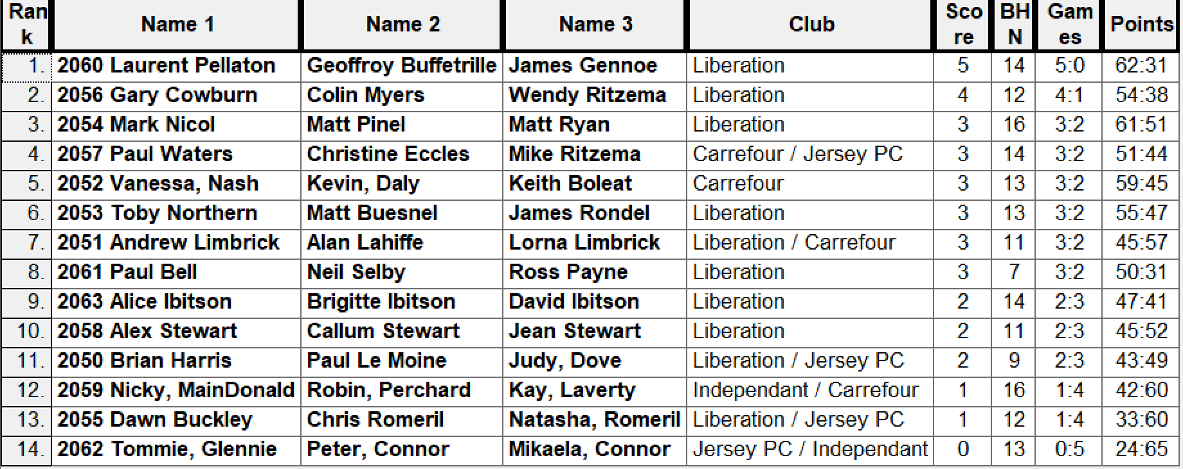

QUARTER FINALS

Ranked 1st Geoffroy, James & Laurent v Neil, Paul & Ross Ranked 8th

Ranked 2nd Colin, Gary & Wendy v Andrew, Alan & Lorna Ranked 7th

Ranked 3rd Mark, Matt P & Matt R v Keith, Matt B & Toby Ranked 6th

Ranked 4th Christine, Mike & Paul v Keith, Kevin & Vanessa Ranked 5th

Well the curse of the Swiss rankings reared its ugly head again as Neil, Paul & Ross beat top ranked Geoffroy, James & Laurent 13 – 11. Ranked 2nd also lost as 2018 champions Andrew, Alan & Lorna beat Colin, Gary & Wendy 13 – 8.

This wasn’t the case though for the third place though as Mark, Matt P & Matt R moved up several gears at the same time Keith, Matt B & Toby moved down several gears with the result a 13 – 0 win for Mark, Matt P & Matt R. Also, a big win for Christine, Mike & Paul 13 – 4 over Keith, Kevin & Vanessa.

SEMI FINALS

Ranked 3rd Mark, Matt P & Matt R v Andrew, Alan & Lorna Ranked 7th

Ranked 4th Christine, Mike & Paul v Neil, Paul & Ross Ranked 8th

Mark, Matt P & Matt R, were now in top gear as they inflicted the second successive 13 – 0 defeat this time to Andrew, Alan & Lorna to make the final. Neil, Paul & Ross also had a big win over Christine, Mike & Paul 13 – 5 to set up an exciting final.

Christine, Mike & Paul capped of a fine tournament finishing third with a 13 – 3 win over Andrew, Alan & Lorna.

Well the final looked to be an exciting close match, but for the third straight match it ended 13 – 0 to Mark Nicol, Matt Pinel and Matt Ryan for an unbelievable final three matches and made up for Mark and Matt Pinel losing last year’s final.

Many thanks to everyone who took part and donated on the day raising an initial total of £438 for Jersey Children’s Charity.

Thanks to all the committee and everyone else who helped set up and clear up, very much appreciated

The winners Pictured below.

Kind Regards

Toby Northern

Liberation Petanque Club