SECOND SUNDAY
IN ORDINARY TIME
January 18 & 19, 2020
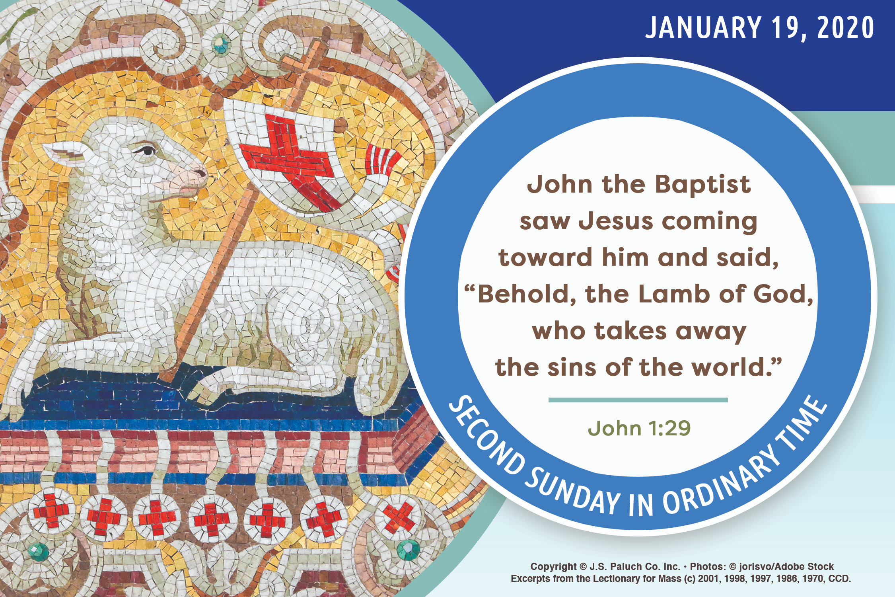
CALLED TO BE HOLY

With this Sunday we begin Ordinary Time. The readings tell us about God’s relationship with Israel and John the Baptist’s relationship with Jesus. Israel’s relationship with God is so close, so intimate, that it is through Israel that God’s “salvation [will] reach to the ends of the earth” (Isaiah 49:6). But we know from John the Baptist that for Israel to accomplish God’s will, it must also recognize that Jesus is the Son of God. During these weeks, we also get to know Jesus. We begin to understand more deeply our relationship to Jesus and what that relationship means for us, who are “called to be holy” (1 Corinthians 1:2).

SPEAKING TRUTH
By Dennis Tavares

A part of mental health is flexibility in talking to persons with differing perspectives and cultural views. Lack of flexibility may be a psychological disorder manifesting itself as confusion between annoyances with strange ideas and feeling injustice for being made uncomfortable. The Catholic Faith grounds us in fundamental realities that go to the root of being human, so Catholics should not fear dialogue with people with different views; we are safe in our understanding of life. We should not become part of the culture of victimhood, which more and more permeates society. America is one big free speech zone in which any idea can be discussed and which promotes pursuit of truth. Politically correct speech censoring is simply an attempt to keep ideas out of circulation for ideological reasons. We should all speak freely but courteously, and with the serious pursuit of truth in mind.

PRAY FOR OUR FAMILY AND FRIENDS THAT ARE IN THE MILITARY SEVICE
María de la Luz Olvera, Rebeca Sánchez, José Araiza Jr., Edgar Toscano, Marina González, Alondra Jara, Sonia Jara, Jason Lorenz, Matt Mills & Jared Schoeder.

PASTORAL RUMINATIONS
By Father Andre Querijero

"The family is the foundation of co-existence and a remedy against social fragmentation. Children have a right to grow up in a family with a father and a mother capable of creating a suitable environment for the child’s development and emotional maturity" (Pope Francis).
Central to our parish mission is family evangelization. From parents, children learn their lessons on Christian faith, experience the daily practice of the virtues, and are formed in the Gospel values that morally shape both conscience and character at home (cf. CCC 1666). It is, therefore, my desire to reach out to as many families in our faith community and offer them a sound Catholic yet relevant spirituality, a practical expression of our faith that would address the present-day challenges of family life.
Five years ago, I invited a mission team of married couples from an international Catholic community called “Couples for Christ” (CFC). As married couples, their goal is to renew their commitment to God, to one another, and to their Christian family life. Gradually, their new life in Christ began to heal, strengthen, and solidify their family relationships. And as individual families are renewed, a network of equally committed Christian families are formed, building up the Church of which they are committed members.
Starting small with only 5 couples from the Hispanic community, we would meet once a week to pray and worship the Lord with songs of praise, listen and reflect on the Sunday Gospel reading, and share our insights and experiences. New members initially undergo a Marriage Enrichment Program, where couples are taught effective husband-wife communication skills and prayer for healing of marital relationships. Now the Parejas Para Cristo (Couples for Christ) has grown to a membership composed of 9 couples and 4 handmaids (a widow and three married women). The Christian values and virtues that parents pass on to their teenage sons and daughters would ideally form another evangelistic group— Youth For Christ. In addition, children have their own Kids for Christ, meeting separately as well.
I am involving the Parejas Para Cristo (PPC) in our Parish Marriage Preparation, Coaching, Counseling and Married Couple Accompaniment Program. On January 30, Deacon Dave and Carlin Gould, the Diocesan Family Life Ministry Directors will begin conducting a series of seminars to jumpstart this new parish ministry. The seminars will be open to interested English-speaking and/or bilingual couples with the hope of establishing a parish-wide CFC. Other upcoming PPC activities are the Valentine’s Day Party (Cena - Baile Show) on February 14th and a Marriage Enrichment Weekend Retreat at the Mount Tabor Monastery in Redwood Valley on February 15th to 16th.
May Jesus, our Lord, bless all families in our parish and allow this project to flourish for the good of our Holy Mother, the Church.

VALENTINEs DAY DINNER DANCE
Join us for an evening of live music, an exceptional three-course dinner, dancing, and more. Friday February 14, 2020 at the Michaelraj Hall. “GRUPO VENUS” from Aguililla Michoacan will be in charge of maintaining a romantic atmosphere for couples.
Tickets are available $50.00 per person dinner and dance or $25.00 dance only. For more information, please call the Parish Office at (707)964-0229.

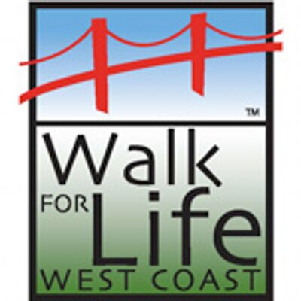
WALK FOR LIFE WEST COAST 2020

Join fellow Catholics and Pro-Lifers from all over California and beyond as we stand up for the littlest among us at the 16th Annual Walk for Life West Coast in San Francisco on January 25, 2020. There will be Mass at 9:30AM at St. Mary’s Cathedral celebrated by Archbishop Alexander Sample from Portland, OR. The rally begins at 12:30PM in San Francisco’s Civic Center Plaza, and the Walk, down Market Street, begins at 1:30PM. Last year’s Walk drew 50,000+ people. For complete information about the Walk, visit www.walkforlifewc.com or call 415-658-1793.

CATHOLIC SCHOOL PROJECT:
FIRST FUNDRAISER

Come help us plan our first official fundraiser for our new Parish School - a Dog and Beer Fest to celebrate Mardi Gras on Wednesday, January 29th, 6:00 pm at Classroom #5. This Project is a great experiment of reforming Catholic education and making it affordable for all our families. Let us share our God-given talents and creativity to pull it off! Together as a parish family, and with true faith in Jesus through our Lady, we can move mountains!

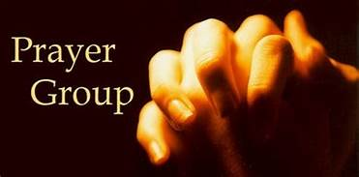
WE WOULD LIKE TO REMIND YOU/INVITE YOU THAT WE HAVE PRAYER GROUP (FOR SPANISH SPEAKING PARISHIONERS) EVERY TUESDAY AT 7PM IN THE CHURCH.
FOR MORE INFORMATION, PLEASE CALL
THE PARISH OFFICE AT 707-964-0229.

MASS INTENTIONS
JANUARY 20 - 26, 2020
Monday (20)  Tuesday (21)  Wednesday (22)  Thursday (23)  Friday (24)  Saturday (25)  Sunday (26) | 12:05pm  12:05pm  12:05pm  12:05pm  12:05pm  5:00pm  6:30pm  8:00am  10:00am | Francisco, Teresa & Bryan Serpa †  Evelyn Costa †  Manuela Martínez †  Moy Villalpando †  Ruben Villegas, Sr. †  Fred & Clara White †  Thomas Galemba †  Mauricio Escobedo †  Juan Olvera †  Maria de la Luz Fierro †  Eliazar Ramírez †  Arnulfo Santiago Solis †  Marcos Caamal †  Mauricio Escobedo †  Curt Crowder †  Familia Muñoz Mendoza †

WEEKLY COLLECTION
JANUARY 11 & 12, 2020…….$1,917.00
MAINTENANCE FUND…..$870.00
THIS WEEKEND’S SECOND COLLECTION:
CHURCH IN LATIN AMERICA
NEXT WEEKEND’S SECOND COLLECTION:
AMA (ANNUAL MINISTRY APPEAL)
THANK YOU FOR YOUR SUPPORT & CHRISTIAN GENEROSITY

PLEASE PRAY FOR OUR SICK PARISHIONERS
Salud Olvera, Antonia Garcia, Betty Cox, Antonia Rentería, Pauline Ortiz, Ana María López, María Cristina Reyes, Karma Mendez, Juan Hernández, Frank Richards, Lisa Wright, Ricardo Contreras, Florencia Chávez, Refugio Yáñez, Tarcicio García, Sofía García, María de Jesús Mendoza, Antonio Cazares, Ana García, Ryan Moore, Marianne Brannan, Lilia Parrish, Nancy Smith, Julián Palomar, Jennifer Vera, John Braet, Kim Koskinen, Margaret Valencia, Matthew Marcoulier, Dennis Tavares, Jose Freitas, Alfredo Sousa, Juana Arreguín, Aron Yasskin, Victoria Walzer, Fidela Yáñez Jara, Erika Ramos, Carla Tomas, Erasmo Yáñez, Memo Soria, Patricia Vargas, Fidela Yáñez, Elvia Flores, Yonel Ruíz, Angie Freitas, Russel Bryant, Derrick Heater, Luis Angel, Juan Barrera-Terán, Gabriel Hurtado, Gerald Butler, Helen Reynolds, Toni Clark, Ann Gallagher, Brianna Lopez, Margaret Milliken, Gina Pivirotto, Nick Quin, Mary Servis, Denis Sousa, Victor Venegas, Matty Walker, Charles Lorenz, Rebecca Lorenz, Ofelia Ibarra, Leonardo Naal, Gina Leal.

OUR LADY OF GOOD COUNSEL MEMORIAL TREE
In the vestibule of the Church, on the southern wall,
is a beautiful Memorial Tree.
Its bright leaves represent permanent memorials to the departed of our Parish.
For the sum of $200.00, you can give to the Parish Secretary, the correct spelling and dates of the departed and in due time the leaf is printed and attached to the tree: a permanent reminder of a loved one who is gone.
For more information, call the Parish Office at 964-0229.

OUR LADY OF GOOD COUNSEL HAS AMAZON SMILE.
WHEN YOU MAKE ANY PURCHASES THROUGH AMAZON, MAKE SURE YOU CHOOSE AMAZON SMILE AND “SELECT” OUR LADY OF GOOD COUNSEL CATHOLIC CHURCH A CORPORATION SOLE.
YOU WILL BE ABLE TO MAKE A DONATION TO OUR CHURCH IN EVERY PURCHASE.
FOR MORE INFORMATION, PLEASE CALL
THE OFFICE AT 964-0229.

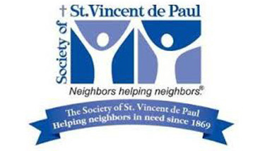
Saint Vincent de Paul Ministry

Free Lunch Program
Every Sunday after the 10 am Mass, the St. Vincent de Paul Ministry of Our Lady of Good Counsel prepares 30-40 sack lunches to be handed out to those in need in our community. We start immediately after Mass and start handing out the lunches at 12 noon-1 pm.
The Ministry provides all the food and supplies needed. All we need is YOUR help! There’s a sign-up sheet on the bulletin board in the vestibule of the Church on North wall. This is a great Ministry to share with your family and friends to carry out our directives to care for the poor and the hungry as Jesus has asked of us. Catechism and Confirmation students can earn 1.5 hours community service by volunteering to help!
The Ministry also needs donations of granola bars, juice packs, small individual bags of chips and cookies, and tax-deductible donations (we actually assist families in financially difficult times).
Let St. Vincent de Paul assist you in your Catholic mission of caring for those less fortunate and in need!
For more information, please call Will Lee at 707-367-8060 or Lynn Black at 707-734-0087

A CALL TO ACTION
WE ARE UPDATING OUR PARISH REGISTRATION LIST.
PLEASE TAKE A FORM AND GIVE US
YOUR CURRENT INFORMATION.
YOU CAN PUT IT IN THE COLLECTION BASKET,
RETURN IT TO THE OFFICE, CALL US AT 707-964-0229
OR EMAIL US AT olgcinfb@gmail.com

