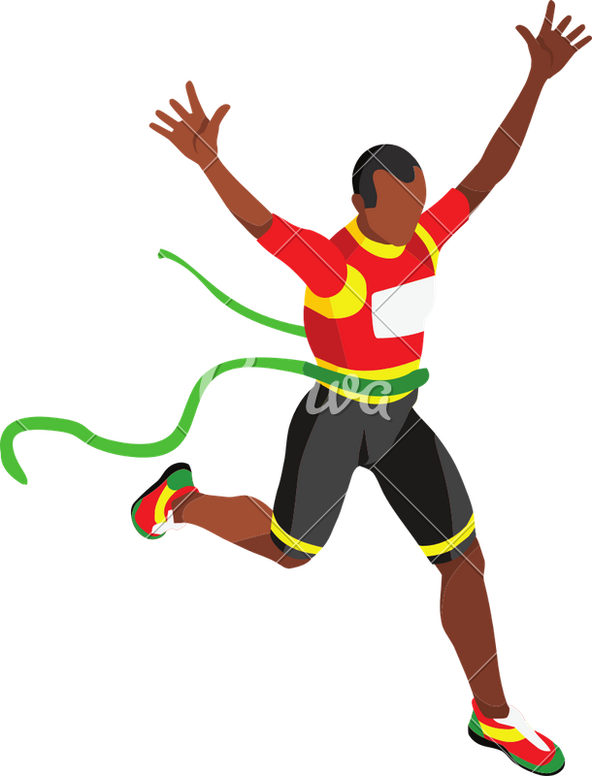
Breast Cancer Awareness 5K
Fun Run, Walk, or Team Effort
Come on out, have some fun and help us raise money for Breast Cancer Awareness
Sunday October 20th, 2019
Registration 2:00- 2:55 pm
Race begins at 3:00 pm
Meade District Hospital Parking Lot
510 E. Carthage, Meade, KS 67864
Open to ALL ages!
(The run can be split up between team members, however you choose)
Entry Fee- $25 per person or $30 per team (Includes 1 free shirt)
Late entries through race day! (Bring your form and money to the race by 2:30 p.m.)
Name or Team Name: ___________________________________________________________________
T-shirt size (circle one) Youth- S M L Adult- S M L XL 2XL
Purchase extra shirts for $15 each! Write down the shirt sizes below: _____________________________________________________________________________
Return your form and payment to Meade District Hospital 510 E Carthage/PO Box 820 Meade Ks
by October 12th to receive a shirt.
For any questions call LaDonna Trujillo at 620-873-7589
ONE ENTRY PER APPLICATION- WAIVER OF LIABILITY
I know that running/walking a road race is a potentially hazardous activity. I should not enter unless I am medically able and properly trained. I agree to abide by any decision of a race official relative to my ability to safely complete the event. I assume all risks associated with this event including, but not limited to falls,
contact with other participants, the effects of weather, traffic, and conditions of the road, all such risks being known and appreciated by me. Having read this waiver and knowing these facts and in considerations of you accepting my entry, I, for myself and anyone entitled to act on my behalf; waive and release Meade District Hospital, and all volunteers associated with this event for all claims or liabilities of any kind arising out of my participation in this event even through that liability may arise out of negligence or carelessness on the part of the persons named in this waiver.

Signature: ___________________________________ Date: _________________________

