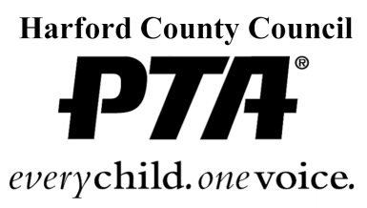
Harford County Council of PTA, Inc.
P.O. Box 435
Bel Air, Maryland 21014
www.hccpta.org
e-mail: hccpta@hccpta.org

Harford County Council of PTAs, Inc.
Board of Directors Planning Meeting
Bruce Butz’s Home, 323 Red Pump Rd, Bel Air, MD
July 17, 2016

Call to Order: Sandra Monaco, President

Items to be covered today:
- Plans of Work
- Short- and long-term goals
- Calendar dates and locations for meetings/trainings
- Mentor Assignments
- Training Assessment
- Budget
- Newsletter dates
- Updates to website
- Duties as assigned

Next meeting:

Adjourned

