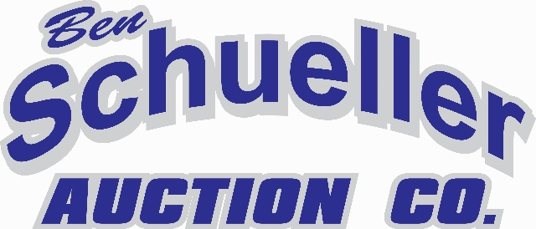

Real Estate Auction Terms & Conditions

Terms & Conditions

Property Address & Seller(s): Wayne Nolting Estate
3752 366th Ave
Preston, IA

Sale Date: Thursday, April 29th @ 5:30 PM
Location: 123 McKinsey Drive, Maquoketa IA 52060

Sale Method: All bids are open for advancement until the Auctioneer announces that the real estate is sold or that the bidding is closed. Bidding increments are solely at the discretion of the Auctioneer. All decisions of the Auctioneer are final. Property will be offered as 4 different tracts and then as 1 whole tract (See Mapping). Final sale or combination of tracts shall be determined by the Seller/Seller Representative(s). These tracts will be sold by the acre. Any survey required will be at Sellers expense.

Earnest Payment: A 10% Non-refundable earnest money payment is required on the day of the auction. The earnest payment may be paid in the form of cash, check or credit card. All funds will be held by the sellers attorney.

Property Taxes: Sellers to pay all real estate taxes current and pro-rated to closing date. Gross property taxes $10,943.76 (2020)

2021 Rents – The property is contracted for rent for the 2021 farming season. Any rents received shall be prorated to closing. Buyer shall received a credit for the remaining year rent at closing.
2021 Rental income $65K MOL

Conditions: Each Bidder is responsible for conducting, at their own risk, their own inspections, inquiries, and due diligence concerning the property. The property is being sold “AS ISWHERE IS” basis with no warranties or guarantees, either expressed or implied by the Seller, Sellers attorney or other representative, or Schueller Auction Co.

Contract and Title: Immediately upon conclusion of the auction the higher bidder(s) will enter into a real estate contract. Sale is not contingent upon Buyer financing, appraisal or inspections. Final sale is subject to the approval of the Seller/Seller Representative(s). The Seller will provide an updated abstract

Closing and Possession: Closing shall be within 45 days from sale date or sooner. The balance of the purchase price will be payable at closing by certified check, bank certified check, or by wire transfer.

Announcements: Property information provided herein was obtained from sources deemed reliable. Schueller Auction Co., the Seller or their representatives makes no guarantees as to its accuracy. All prospective bidders are urged to fully inspect the property, its condition and to rely on their own conclusions.

Any announcements made auction day will take precedence over any previous material or oral statements. Bidding increments are solely at the discretion of the Auctioneer. Sellers have the right to reject any and all bids. No absentee or telephone bids will be accepted at the auction without prior approval of Schueller Auction Co. or the Sellers. All decisions of the Auctioneer are final.

Sellers Attorney: Bradley & Riley PC
Maureen A Gronstal
207 First Ave SE
Cedar Rapids, IA 52406

Schueller Auction Co.
Ben Schueller - Auctioneer (563) 357-9901

