Vacation Bible School Registration 2017

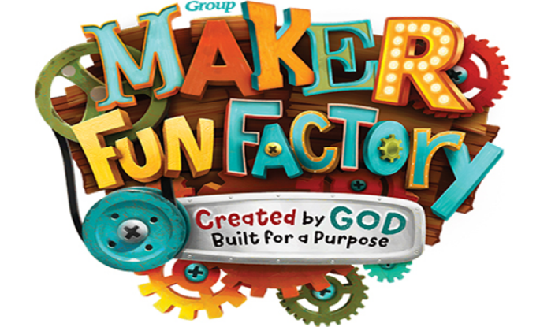

Elkins Park Presbyterian Church
234 Cedar Road, Elkins Park, PA 19027
215-887-2544 elkinsparkchurch@verizon.net www.eppchurch.org
Child’s Name: _______________________________________________ Child’s Gender: M F
Child’s age: ________ Child’s Grade in School as of Sept. 2017: K 1st 2nd 3rd
Mailing Address: ______________________________________________________________
Phone Number: _______________________ Email: _________________________________
Name of Parent/Guardian: _______________________________________________________
Emergency Contact: _____________________________ Phone: ________________________
Home Church: _________________________________________________________________
Allergies or other pertinent medical information: ____________________________________
Adult/s permitted to pick up this child from the program:
_____________________________________________________________________________
May your child’s photograph be used by the church? (Names will not be published) Yes No
For instance in a Facebook post, church newsletter, or on a church bulletin board
Dates of this program child intends to be present: July 11 July 13 July 15 July 18 July 20
When will your child be joining us for the pre-VBS meal at 6:15 pm? 7/11 7/13 7/18 7/20
Will you be joining us for the Free Pancake Breakfast on July 15th at 9:30 am? Yes No If yes, how many people will be joining us? _____________
Please specify any special needs of your child we need to be aware of: _____________________________________________________________________________
Parent/Guardian Signature: _____________________________________ Date: ___________
Please return this completed registration form to the church office before June 4, 2017.

