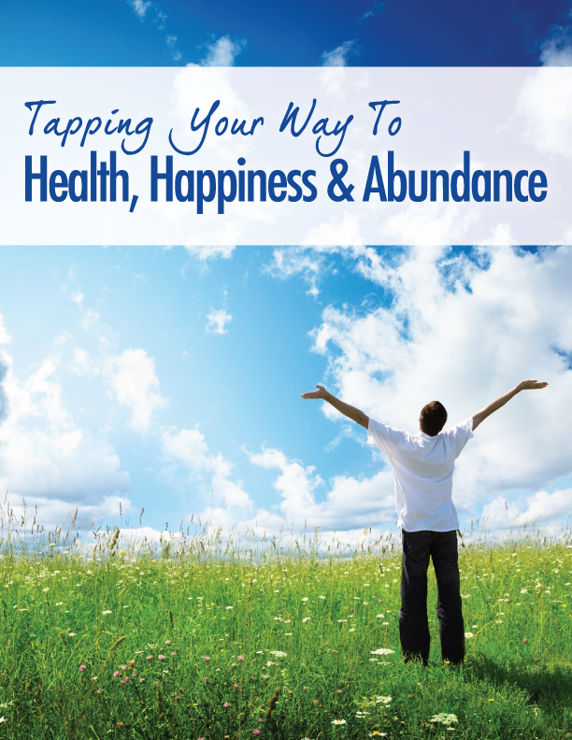

Disclaimer
The information presented in this e-book is not intended to represent that EFT is used to diagnose, treat, cure, or prevent any disease or psychological disorder. EFT is not a substitute for medical or psychological treatment. Any stories or testimonials presented in this e-book do not constitute a warranty, guarantee, or prediction regarding the outcome of an individual using EFT for any particular issue. While all materials and links to other resources are posted in good faith, the accuracy, validity, effectiveness, completeness, or usefulness of any information herein, as with any publication, cannot be guaranteed.

Serenity Wellness, accepts no responsibility or liability whatsoever for the use or misuse of the information contained in this e-book including, but not limited to, EFT demonstrations, training, and related activities. We strongly advise that you seek professional advice as appropriate before making any health decision.

The content of this e-book is educational in nature and is provided only as general information. By proceeding to read this e-book, you are agreeing to the following statement:

As part of the information presented in this e-book, I understand that I will be introduced to a modality called Emotional Freedom Techniques("EFT") a technique generally referred to as a type of energy therapy. Due to the experimental nature of EFT, and because it is a relatively new healing approach and the extent of its effectiveness, as well as its risks and benefits, are not fully known, I agree to assume and accept full responsibility for any and all risks associated with reading this e-book, and with using EFT as a result of reading this e-book. I understand that my choice to use EFT is of my own free will and not subject to any outside pressure. I further understand that if I choose to use EFT, it is possible that emotional or physical sensations or additional unresolved memories may surface.

Table of Contents

What is Tapping? | 4
The Roots of Tapping | 6
The Science Behind Tapping | 8
How to Tap | 10
What Can I Use Tapping For? | 16
Resources and Case Studies | 17
Testimonials | 19
Conclusion | 20

What is Tapping?

What are you up against?

To get right to the point, EFT is the easiest way to make big changes in your life, and not just the ones you want to make, but the ones you need to make.

Usually, those are the hardest ones.

For so many of us today, there’s one thing in our life that we just can’t get over, a pesky obstacle to our progress and happiness that holds us back and won’t go away no matter what we try.

It could be a problematic romantic relationship you’re stuck in; it could be the trouble you’re having losing weight. It might be something as simple as anxiety over a deadline you’re up against at work or at the other end of the scale, it could be stress regarding a major illness you or a loved one are facing.

Whatever “it” is, it’s holding you back, and life would be so much easier if you just had a surefire way to deal with it, right?

That’s where EFT Tapping can make all the difference in the world.

This revolutionary healing modality is based on ancient medical principles drawn from Traditional Chinese Medicine (TCM), as well as the profound insights of modern Western psychotherapy. It’s further bolstered by incredible cutting-edge medical research about the body-mind connection.

In short, it’s an amazing healing tool that combines both the history and future of healing around the world and puts this power in your hands.

The most beautiful thing about this incredible technique is how simple and quick it is. It doesn’t take much time to learn or use it, and quite often the results are immediate. There are instances in which it’s advisable to see a practitioner, but for the most part, it’s a fast and easy technique you can perform by yourself to get the relief that you’re so desperately in need of.

When you use EFT, you’re literally “tapping” into your body’s natural ability to right itself. In the process, you directly address those troublesome emotions that make your life difficult and might even have been making you sick. By tackling your emotions first, you can:

- Finally make the money and reach the abundance you so deserve
- Work out the love troubles you’ve been faced with, whether you’re single, in a relationship, or married
- Shed the excess weight that you’ve been struggling with through endless diets and exercise plans
- Transform your stressful work life into a satisfying one, or maybe even start your own business
- Get rid of your chronic headaches, joint aches or back pain

The truth is, with tapping, you can work on just about anything that’s holding you back.

By the end of this book, you’ll have learned where tapping comes from, just why it works, and most importantly, you’ll learn how to tap yourself. You’ll also discover incredible resources to aid you as you progress through this empowering healing journey.

Are you ready to change your life? Let’s begin.

The Roots of Tapping

As mentioned earlier, Tapping has its roots in Traditional Chinese Medicine (TCM), a realm of healing that for centuries has aimed to treat the cause of illnesses and disorders rather than merely responding to their symptoms, like so many approaches to healing today.

The true magic of this technique doesn’t lie solely in history, however; it resides at the point where these ancient principles intersect with modern insights about how our body and psyche work in unison.

In the 1970s, these two streams of thought came together in the office of a psychologist named Dr. Roger Callahan. Although he observed traditional protocol in his work, he found himself deeply intrigued by Traditional Chinese Medicine, specifically the principles of the body’s meridian lines.

In TCM, these meridian lines run throughout the body and are pathways for the flow of “ch’i” or life force. When the flow of ch’i becomes impaired due to trauma of some kind, the blockage can give rise to a whole host of injuries or illnesses. By manipulating various points along these lines – as acupuncturists do with needles – the flow of ch’i can be restored and the problems eliminated.

Callahan was fascinated by these principles but saw no need to incorporate them into his practice. That is, until he met Mary.

Mary would prove to be one of Callahan’s more confounding patients. She suffered from a severe water phobia, and nothing that Callahan tried seemed to help. Her fear was so intense that she even had trouble bathing her children.
Callahan was stumped.

One day, Mary mentioned that when she thought about water, she felt a throbbing discomfort in her stomach. When she revealed this, Callahan had a flash of insight. He recalled that TCM held that one of the meridian points that corresponded with the stomach could be found right beneath the eye. On a hunch, he asked Mary to tap on this spot when the stomach pain arose.

Mary did as he suggested. Her discomfort was quickly replaced by utter astonishment; the pain was gone. Better yet, she was no longer afraid of water!

Thrilled by this discovery, Callahan experimented with various meridian points and eventually distilled his findings into what he called Thought Field Therapy. A wild success, TFT attracted many students in the 1980s, one of whom was Gary Craig.

An eager pupil, Craig immersed himself in the technique, but soon came to believe that it was unnecessarily complicated. He in turn began to conduct his own experiments and soon boiled TFT down into a simpler, quicker routine that proved even more effective. He termed his streamlined modality Emotional Freedom Techniques, or EFT for short.

In the decades since, EFT has grown immensely, with new revelations emerging every day on just why it is so effective. In the next chapter, we’ll take a look at some of these discoveries that explain just how Tapping can work the seeming miracles that it does.

The Science Behind Tapping

There’s nothing mystical or magical about tapping, although the results are often so astounding that it’s understandable why some people come to this conclusion. That said, the grounded science behind it is just as wondrous.

Tapping is so effective thanks to an almond-shaped part of your brain called the amygdala. It’s responsible for determining and activating your body’s response when you’re faced with excessive stress of any sort. When threatened, it signals your body to release hormones such as adrenaline and cortisol – commonly known as “the stress hormone” – that prepare you for danger. This is what’s commonly called the ‘fight or flight’ response, and it’s responsible for nothing less than our evolution as a species. It’s what would have alerted our ancient ancestors to run for their lives when confronted by carnivorous predators!

There’s just one problem: in our modern world, we are faced with external stressors on a daily basis. And if that weren’t enough to contend with, we’re often poorly prepared to deal with it all - we eat food that isn’t good for us, work much harder than we’re supposed to, and don’t rest nearly as much as we should. With this being the case, our amygdala is often on high-alert mode quite a bit more than it should be, trapping us in a lingering, low-grade fight-or-flight mode every day. Studies have shown that this type of stress can lead to a weakened immune system, emotional dysfunction, weight gain and a whole host of other problems.

In short, stress can make you very, very sick.

So where does tapping come into the picture?

In ancient Chinese medicine, it’s long been known that you can reduce the body’s stress response and many of the problems it gives rise to by manipulating the body’s meridian points. This is what acupuncturists do to this day. Thanks to modern science, we now have proof that this is indeed the case.

Studies done at Harvard Medical School in recent years have found that the amygdala’s reaction to external stressors and our body’s resulting stress response can be reduced by stimulating these very same meridian points that Traditional Chinese Medicine speaks of. [1]

These studies focused specifically on acupuncture, but follow-up, double-blind research proved that the needles were not necessary, and that light pressure – as we use in tapping – wasenough to produce these results.

Another study conducted by Dr. Dawson Church provided similar revelations regarding Tapping and stress relief. In a randomized controlled trial, Church and his team studied the cortisol levels of 83 subjects who underwent an hour-long tapping session, traditional talk therapy, or no treatment at all. The results were eye opening. For those who experienced a Tapping session, the average level of cortisol reduction was 24%, with a whopping reduction of almost 50% in some subjects! However,those who sat for an hour of traditional talk therapy experienced no significant cortisol reduction.

With each passing year, there are more and more studies revealing just how effective EFT can be. They go a long way towards establishing the technique’s legitimacy for those who question the efficacy of alternative or holistic healing modalities. For thousands of dedicated tappers around the world however, it simply confirms what we already knew to be true – that Tapping is the most effective way to reduce the effects of stress, pain and illness, so you can live a bountiful, fulfilling life!

1. J. Fang et al. “The salient characteristics of the central effects of acupuncture needling: Limbic_-paralimbic-neocortical network modulation.” _Human Brain Mapping 30, no. 4 (April 2009): 1196 –1206; K.K. Huietal. “Acupuncture modulates the limbic system and sub-cortical gray structures of the human brain: Evidence from fMRI studies in normal subjects.” _Human Brain Mapping 9, no. 1 (2000): 13 – 25.
How to Tap

This is where the adventure begins. Are you ready to learn how to tap?

For starters, let’s go over the meridian points that we use in EFT. There are several hundred meridian points all over your body, but when tapping, we focus on nine. They are:

Karate-Chop Point (KC)
This lies on the outer edge of your palm, on the opposite side from your thumb. Either hand is fine. Tap on this meridian point using two fingers.

Eyebrow (EB)
Use two fingers to tap the inner edges of the eyebrows, close to the bridge of the nose.

Side of eye (SE)
Use two fingers to tap on the hard ridge between the corner of your eye and your temple. Be careful and gentle!

Under eye (UE)
Staying in line with your pupil, use two fingers to tap on the hard bone under the eye that merges with the cheekbone.

Under nose (UN)
Use two fingers to tap on the point centered between the bottom of the nose and the upper lip.

Chin (CH)
This point is in line with the previous one, and is centered between the bottom of the lower lip and the chin.

Collarbone (CB)
Tap just below the hard ridge of your collarbone with four fingers.

Underarm (UA)
Use four fingers to tap on your side, just about four inches beneath the armpit.

Top of Head (TH)
Use four fingers to tap on the crown of your head.

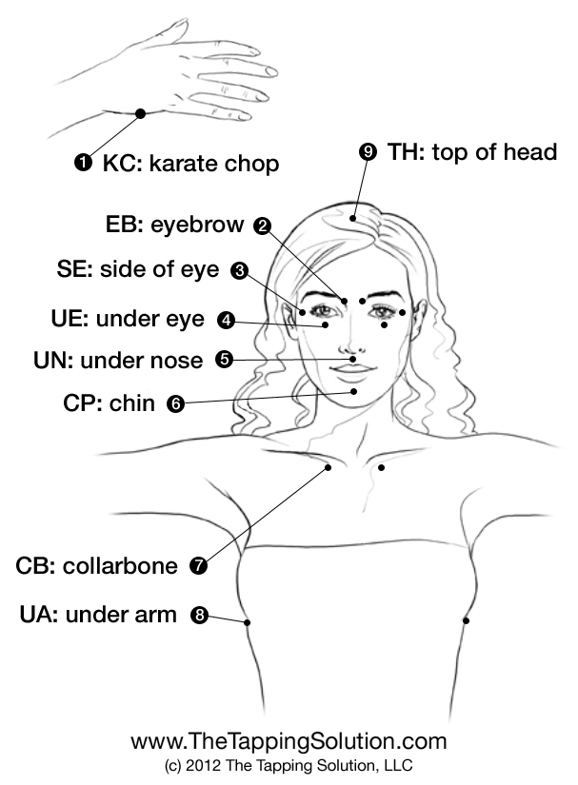

As you’ve seen earlier, tapping can be used to address just about any problem you’re facing, whether it’s financial, romantic, or health related. For the sake of demonstration, here’s a simple routine addressing general stress. It will help you get a feel for how tapping works, and also help you deal with anything you might be stressed out about!

1. How do you feel? This is question you always want to start with. If it’s helpful, write down your feelings in a sentence or two, or simply bring them to the focus of your attention. Also, take a moment to figure out exactly what it is it that you’re stressed out about. It’s OK if you’re not certain. Simply knowing that you’re feeling some stress that you want to get rid of is good enough.

2. Just how intense is thisstress? Rate your stress level on a scale from 0 to 10, with 0 being the lowest level of stress and 10 being the highest.

3. Now you’re going to use your feelings to compose a set-up statement. This is simply an acknowledgement of the fact that you’re feeling stressed out, followed by utter acceptance and compassion foryourself in spite of this fact. For example:

- "Even though I’m so stressed out, I completely accept myself."
- "Even though I'm feeling so stressed about my new job, I absolutely love and accept myself and these feelings."
- "Even though my stress is at an all time high because of my rocky marriage, I deeply and completely love, accept and forgive myself."
- "Even though I’m so anxious about my financial situation, I deeply and completely love and accept myself."
- "Even though I’m so stressed out and I have no idea why that is, I deeply and completely love and accept myself."
- "Even though I’ve tried everything to reduce my stress and nothing seems to work, I deeply and completely love and accept myself.”

4. Here’s where you’re going to use that set-up statement. Take four fingers on one hand and tap the Karate Chop point on your other hand. As you’re doing this, say your set-up statement three times (either out loud or silently to yourself.)

5. Here’s where the actual tapping begins! Here are a few quick tips:

- You’re basically going to be tapping in a loop, starting at your eyebrow, working down through your face to your chest, under your arm and back up to the top of your head. You begin again at your eyebrow.
- Be sure to tap with your fingertips, not your fingernails. You want your taps to be firm but gentle, as if you were drumming your desk or tapping on a friend’s shoulder to get their attention.
- You can use all four fingers, or just the first two (the index and middle fingers). Four fingers are generally used on the top of the head, the collarbone, under the arm... wider areas. On sensitive areas, like around the eyes, you can use just two.

6. Now, starting at the eyebrow, tap 5-7 times on each of the meridian points as you follow the script below, repeatingeach phrase at its designated point:

EB: “I’m so stressed out.”
SE: “I can’t take it anymore.”
UE: “It’s just too much for me to handle.”
UN: “It’s making everything such a mess.”
CH: “I can’t focus on anything.”
CB: “I’m so tired and anxious.”
UA: “I just want this stress to go away!”
TH: “I just want to relax.”

Return to the eyebrow:

EB: “Why do I have to be so stressed out?”
SE: “I just can’t cope anymore.”
UE: “Something has to give.”
UN: “I can’t spend every day this stressed out.”
CH: “It’s too much for me to deal with.”
CB: “I can’t handle the stress.”
UA: “I feel so burdened.”
TH: “I feel so much pressure.”

7. How are you feeling now? Has the intensity of the feeling reduced at all? Rate your current stress level on the 0 to 10 scale and compare it to how you were feeling before.

8. If your stress is still higher than "2", you should probably do another round of tapping. Ideally, you want to keep tapping until your stress is completely gone, ranking at 0. Did any thoughts or insights about your stress arise while you were tapping just now? Use these realizations as phrases to repeat aloud as you tap. It might also help to use these thoughts to compose a new set-up statement, such as:

- "Even though I now have a better understanding of why I’m so stressed, I deeply and completely accept myself."
- "Even though this stress runs deeper than I initially thought, I deeply and completely accept myself."
- “Even though I don’t know how I’m going to stop feeling so stressed out, I deeply love and accept myself.”

9. Here’s the fun part. Once you’ve gotten rid of your stress, you’re going to want to replace those icky feelings with some positive, uplifting ones that will help you move forward and keep future stresses at bay. You may have heard about positive thinking before and just how effective it can be, but it’s exceptionally powerful when you use it in conjunction with tapping.

So often, people try to think non-stop positive thoughts without first dealing with their negative emotions or limiting beliefs. By doing this, they set their mind at war with itself, and it’s often exhausting. With tapping, you’re first dispelling the negative thoughts that have been weighing you down so that you have space for your positive affirmations to take root. This is a far more effective way of putting the law of attraction and positive focus to work in your life

Return to your eyebrow:

EB: “The stress is slipping away
SE: “I’m beginning to feel free again.”
UE: “I feel so much lighter.”
UN: “I can breathe so much easier.”
CH: “I’m OK.”
CB: “I don’t have to worry so much.”
UA: “Who am I kidding, this is just temporary.”
TH: “No it’s not, I know how to deal with my stress now.”

Return to the eyebrow:

EB: “There’s always something to be concerned about.”
SE: “But that doesn’t mean I have to get stressed out.”
UE: “It’s not the end of the world.”
UN: “I can handle everything without stressing out.”
CH: “I know how to calm myself now.”
CB: “I know how to handle the pressure.”
UA: “I feel so liberated!”
TH: “Things are going to be different now.”

EB: "Everything is going to be OK.”
SE: "I can handle the stress.”
UE: "I can prevent it from becoming so intense.”
UN: "I’m not as stressed out anymore.”
CH: "I’m so much more relaxed.”
CB: "I can take it as it comes.”
UA: “Everything is going to be alright.”
TH: “I can handle things.”

Pretty easy, right? Pat yourself on the back; you’re now a tapper!

What Can I Use Tapping For?

There’s a simple answer for this question: you can tap on everything, including:

- Post-traumatic Stress Disorder *
- Disorganization and Clutter
- Food Cravings
- Envy
- Homesickness
- Divorce
- Heartbreak
- Depression*
- Children’s Anxiety*
- Dissatisfaction with Body Image
- Weight Loss
- Childhood fears
- Family strife
- Insomnia
- Headaches
- Back and Joint Pain
- Bad Memory
- Loneliness
- Fear
- Anxiety
- Nicotine Addiction
- Remorse
- Paranoia
- Allergies
- Nail-Biting
- Gambling/Alcoholism/Addiction *
- Deteriorating Eyesight

Whatever is bothering you, you can tap on it. All you need to do is to take stock of how you’re feeling, and you can use it to begin tapping for relief. Be adventurous and expect to be amazed!

* Although you can certainly address these issues on your own, we suggest you first tackle them with a practitioner. Should you decide to deal with any of them alone and your emotions become too much to handle, continue to tap until the emotion is lessened, then seek assistance.

Resources and Case Studies

Some of the world’s foremost experts on EFT have shown just how Tapping can help people find relief from just about any personal problem or illness. Here are a few examples.

Post-Traumatic Stress Disorder

A recentstudyrevealed thatEFTcan help those suffering with Post-Traumatic Stress Disorder.

The findings were published in the February 1, 2013 edition of the Journal of Nervous and Mental Disease. In the study, a randomized control trial, veterans afflicted with PTSD were divided into two treatment groups. One received traditional talk therapy, while the other received traditional talk therapy in addition to 6 sessions with an EFT practitioner. The results were astounding: 90% of those who were treated with EFT as well as traditional therapy no longer displayed symptoms of PTSD. On the other hand, only 4% of those who went through talk therapy alone experienced any measurable relief.

Eyesight

A landmark study on how EFT can be used to repair eyesight problems, forced many people who previously scoffed at Tapping to finally take it seriously.

In the study, 120 people went through an 8-week Tapping program, which required them to use the technique to work through difficult emotions, such as fear and anger. Through this work, many of the participants revealed that they had been hesitant to work on their vision as it might result in greater “clarity” in their life, thus forcing them to take responsibility for issues they were trying to avoid. Others reported that by letting go of their anger, their vision improved considerably. It was clear that the emotions of the participants were affecting their vision.The results confirmed this: at the completion of the study, a whopping 75% of the participants experienced an improvement in their vision.

Pain Relief

The Tapping Solution movie followed Patricia, who had fractured her L-1 vertebrae in a boating accident. Although she had been through surgery to fix her back, she still experienced crippling pain for which she was told there was no remedy. As the film documents, EFT finally gave Patricia an effective way to remedy her pain and live life as she had before!
Testimonials

“EFT is destined to be a top healing tool for the 21st Century…”
— Cheryl Richardson, New York Times best-selling author of Take Time for Your Life

“Put away your skepticism; this really works.”
— Dr. Wayne W. Dyer, author of Wishes Fulfilled

“Emotional Freedom Techniques (EFT) has vastly improved the quality of my life and my work... Don’t miss this healing opportunity...”
— Kris Carr, New York Times best-selling author of Crazy Sexy Kitchen

“EFT is the most powerful new transformational technology to come along in years.”
— Jack Canfield, co-author of Chicken Soup for the Soul

“Nothing comes closer to ‘magic’ than the positive results I have personally witnessed using EFT on thousands of my patients who suffered from physical and emotional pain and illness...”
— Dr. Mercola, founder of Mercola.com, most visited natural health site in the world

“I believe EFT to be one of the biggest breakthroughs in psychology and medicine in a century.”
—Dawson Church,Ph.D., author of The Genie In Your Genes

“In my darkest year, I discovered tapping, and, miraculously, this unorthodox approach to making sense of my life moved me out of the fog and into the sunshine.”
— Chip Conley, founder of Joie de Vivre Hotels and author of PEAK and Emotional Equations

Conclusion

We take stress for granted in our modern world, but as illustrated here, it lies at the root of so much of what ails us, be it our dysfunctional romantic relationships, our troubles with money, or even our illnesses. Sometimes, the stress itself is too much to bear.

There are many different types of practitioners in a wide variety of modalities – everything from psychotherapy to acupuncture – who can help you deal with whatever you’re facing, but very often the cost is prohibitive and it takes a long time to see true results.

But there is a better way to deal with it.

With EFT Tapping, you have the opportunity to work with a practitioner who will not only help you heal, but also teach you how to use the technique on your own.

Now that you understand how powerful Tapping can be, don’t hesitate to try it on everything. As a personal care tool, its effectiveness is unparalleled, and you can radically change your life for the better almost immediately. Expect to be amazed. The power is literally in your hands.

Are you ready to let go of what’s limiting you from feeling your best? You can start right now by working an EFT Practitioner! Here’s how:
I look forward to working with you and showing you how powerful EFT can be!
Contact me today:
Website: www.SerenityWellnessAbq.com
E-mail: vjop_22@msn.com
Phone: (505) 750-1214

