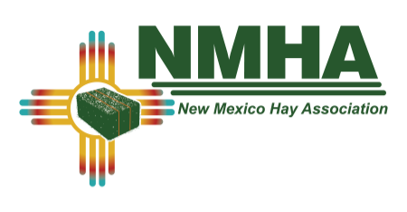
2020 VENDOR PRE REGISTRATION
SOUTHWEST HAY & FORAGE CONFERENCE & TRADE SHOW
RUIDOSO CONVENTION CENTER, JAN 29TH- 31ST 2020.
PLEASE FILL IN ALL REQUESTED INFORMATION

COMPANY:
NAME OF PERSON(S) ATTENDING:
ADDRESS:
CITY: | STATE: |  | ZIP:
EMAIL: |  | PHONE:

CHECK ALL THAT APPLY BELOW:
- STANDARD BOOTH EXHIBIT SPACE: $500.00 | $
-TYPICAL TABLE DISPLAY
-INCLUDES REGISTRATION & MEALS FOR TWO
- LATE REGISTRATION FEE (AFTER DEC 31ST 2019): $525.00 | $
- LARGE MACHINERY SPACE: $120.00 | $
(EX:SWATHER, BALER, STEAMER, TRACTOR, ETC.)
- SMALL MACHINERY SPACE: $70.00 | $
(6'X8')
- OUTDOOR MACHINERY SPACE: $95.00 | $
(APROX 20'X30')
- NMHA ANNUAL MEMBERSHIP: $55.00 | $

OPTIONAL CONTRIBUTIONS:
- DOOR PRIZE CONTRIBUTION:
- SILENT AUCTION CONTRIBUTION:

SPONSORSHIP DONATION LEVELS:
- ”PREMIUM HAY”-$1000.00 OR MORE | $
(example): MAJOR SPEAKER, MEAL SPONSOR, ETC.)
INCLUDES BOOTH SPACE, REGISTRATION, DUES
- "DAIRY HAY”-$500 – $999 | $
(example): COFFEE BREAK, HOSPITALITY HOUR, ETC.)
INCLUDES NON-EXHIBIT REGISTRATION AND DUES
- ”GOOD HAYSPONSOR" $300 - $499 | $
(example): PARTIAL COFFEE BREAK, ETC.)

- PAINTING CLASS WITH PEGGY KRANTZ (THURSDAY 1/30/20 AFTERNOON) $30.00  LOCATED ACROSS THE HALL FROM THE MAIN CONFERENCE ROOM | $

TOTAL REMITTED | $

PLEASE RETURN THIS FORM ALONG WITH YOUR CHECK/ OR ONLINE PAYMENT COMFRIMATION # TO:
NMHA PO BOX 982 DEXTER, NM 88230 POST-MARKED BY DECEMBER 31th, 2019 TO AVOID LATE REGISTRATION
CONVENTION CENTER DOOR WIDTH IS 16FT NMHA IS NOT RESPONSIBLE FOR EXTRA ITEMS (electric cords, etc.) NEEDED FOR DISPLAYS THANK YOU FOR SUPPORTING THE NEW MEXICO HAY ASSOCIATION!

