Name: | Company:
Phone: | Email address:
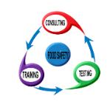
Location: Food Safety Consulting, Training & Testing LLC (FSCTAT) ~ 8980 N Dixie Drive ~ Dayton, OH 45414 ~ Butler Township ~ Contact: Betty Zakeri at bettyzakeri@fsctat.com (937) 541-1744
Mark an X beside the Level you need
______ Level II Manager Course & Exam DATE: ___________________
The ServSafe® Food Safety program is designed for managers, chefs, owners and others with supervisory responsibilities in the food industry.
Topics covered: personal hygiene, foodborne illness, receiving, storing, preparing and serving foods; food safety regulations and more.
Class Includes: 15 hours/2 days of Hands On Training by a Certified ServSafe Instructor and Proctor, ServSafe exam voucher and ServSafe Manager Certificate – $275 per person

______Level I Food Handler Course DATE: ___________________
Food sanitation program that is designed for food preparers, food servers and other frontline staff.
Topics covered: basic food safety, personal hygiene, cross-contamination and allergens, time and temperature control, and cleaning and sanitation
Class Includes: 4 hours of Hands On Training by a Certified ServSafe Instructor, ServSafe food handler guide, and ServSafe Food Handler Certificate – $60 per person

_______Level II Manager Certification Exam Only DATE: ___________________
$85 per person
IMPORTANT….
- Registration and Payment DUE 10 days prior to class.
- Cancel within 48 hours of the class, you will be charged 50%
- Cancel within 24 hours of the class, you will be charged 75%
- Cancel the day of the class, you will be charged 100%

I accept the terms & conditions above:
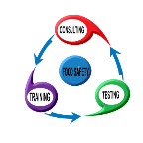
Signature: ___________________________________________________ Date:_____________

