CLINTON COMMONS SEPTEMBER 2019
SUNDAY | MONDAY | TUESDAY | WEDNESDAY | THURSDAY | FRIDAY | SATURDAY
1 | 2  LABOR DAY  BUSINESS OFFICE CLOSED  RESTAURANT CLOSED | 3  10:00 Exercise (MP),  11:00 Game Hour (MP)  11:30 – 12:30 BLOOD PRESSURE CLINIC  6:00 INTRO TO  GENEALOGY – (MP) | 4  10:00 Exercise (MP)  11:00 Bingo (MP)  11:00 REFLECTIONS SALON | 5  10:00 Exercise (MP)  11:00 Game Hour (MP) | 6  10:00 Sunshine Café  2:00 HAPPY HOUR | 7  11:00 Family Bingo (MP)
8  11:00 Worship Service (MP) | 9  10:00 Exercise (MP)  11:00 Bingo (MP)  6:30 Bible Study (MP) | 10  10:00 Exercise (MP)  11:00 Game Hour (MP)  11:30 – 12:30 BLOOD PRESSURE CLINIC  6:00 INTRO TO GENEALOGY – (MP) | 11  10:00 Exercise (MP),  11:00 Bingo (MP),  11:00 REFLECTIONS SALON | 12  10:00 Exercise (MP)  11:00 Game Hour (MP)  6:00 BOOK CLUB (MP) | 13  10:00 Sunshine Café | 14
15 | 16 10:00 Exercise (MP), 11:00 Bingo (MP)  6:30 Bible Study (MP) | 17 10:00 Exercise (MP), 11:00 Game Hour, 11:30 – 12:30 BLOOD PRESSURE CLINIC 3:15 BRIGGS LIBRARY  6:00 INTRO TO GENEALOGY – (MP) | 18  10:00 Exercise (MP)  11:00 Bingo (MP)  11:00 REFLECTIONS SALON | 19 10:00 Exercise (MP)  11:00 Game  Hour (MP) | 20  10:00 Sunshine Café | 21  11:00 Family Bingo
CLINTON COMMONS SEPTEMBER 2019
SUNDAY | MONDAY | TUESDAY | WEDNESDAY | THURSDAY | FRIDAY | SATURDAY
22  11:00 Worship Service (MP) | 23 10:00 Exercise (MP)  11:00 Bingo (MP)  6:30 Bible Study | 24  10:00 Exercise (MP)  11:00 GAME HOUR  11:30 – 12:30 BLOOD PRESSURE CLINIC  11:00 OUT TO LUNCH BUNCH  6:00 INTRO TO GENEALOGY – (MP) | 25  10:00 Exercise (MP)  11:00 Bingo (MP)  11:00 REFLECTIONS SALON  1:00 PIZZA PARTY | 26  10:00 Exercise (MP)  11:00 Game Hour (MP)  6:00 BOOK CLUB (MP) | 27  10:00 Sunshine Café  2:00 HAPPY HOUR | 28  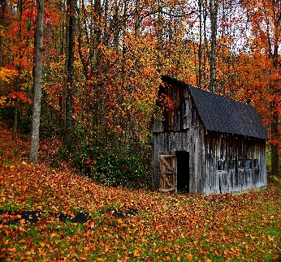
29 | 30  10:00 Exercise (MP)  11:00 Bingo (MP)  6:30 Bible Study (MP) | SEPTEMBER BIRTHDAYS  JIM KITSON 9-5  JOAN GOSS 9-17  RON ROBERTS 9-21  CAROLYN WILBERDING 9-26

