Valley Lake Family Fun Run
Presented by Troop 54804
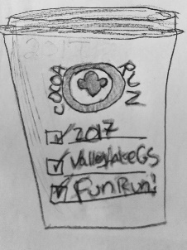
Artist rendering patch
O The Cocoa Run O
When: November 12th – 1:00 – 1st heat
Where: Scott Highlands Middle – Apple Valley
Who: All Girl Scouts, their Friends & Families!
(please help us spread the word, all are welcome)
What’s included? The Run - T-shirt, Patch, Hot Cocoa, treats. We will have music, and a craft station. Registration is $20.00 per person.
We will be assigning start times/heats for each group. That way you don’t have to wait around much for your start time if it’s later than event start. Please dress for the weather, and use something to protect gloves/coats from the liquid, part of the run will be to not spill your cup!
(plastic gloves may be available while supplies last)

Cocoa Run Registration

Troop # ________ Grade Level:________
Total Runners: _____ Leader Name: ___________
Leader Email:__________________________
Amount Enclosed:______________
Troop 54804 is requesting donations of Fleece blankets & art supplies (unused, can be home made) to donate to the children’s hospital.

Shirt Sizes – Please indicate how many of each size your troop needs.
YS__YM__ YL__AS__ AM__AL__AXL__ A2XL__ A3XL__
Submit to: Troop 54804 C/O Sara Garoutte
12685 Germane Ave. #2 AV, MN 55124
Registration Cut Off: October 26th
_________________________________________
For Troop use Only:
Assigned to Heat ______
Emailed Confirmation____
Total Patches:___ Total Shirts:___
Bag Checked By: ______________

