Eco Orca’s 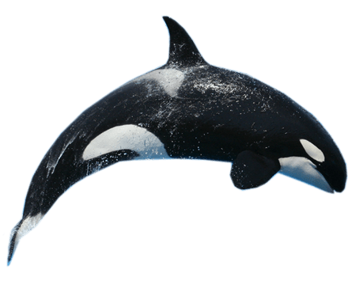 DECEMBER 2023 Community Helpers and Christmas
SUNDAY |  |  |  | MONDAY | TUESDAY | WEDNESDAY | THURSDAY | FRIDAY | SATURDAY
 |  |  |  |  |  |  |  | 1 | 2
Rainbow
Park
 | 3 |  |  | 4  Mill Hill Trail | 5 | 6 | 7 | 8 | 9
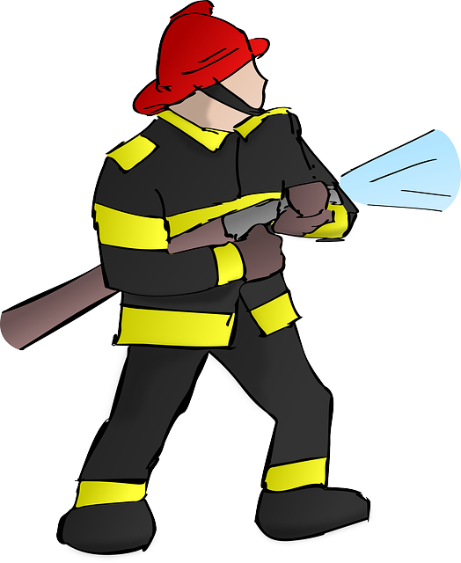 |  |  |  | Mill Hill  Trail | Westhills  Park | Gyro  Park | Beckwith  Park | Whiffin Spit Walk
 | 10 |  |  | 11 | 12 | 13 | 14 | 15 | 16
 |  |  |  | Honey Crisp  Park | Mt Doug Upper Trails | Aylard Farm Beach and Trails | Miniature  World $5 | Langford Centennial Park | 
 | 17 |  |  | 18 | 19 | 20 | 21 | 22 | 23
 |  |  |  | The Bay Christmas Tree’s $2 | GingerbreadHouse Tour $2 | Humpback Park | Christmas Party 1-2pm | Christmas Hill  Tree Decorating
 | 24 |  |  | 25 | 26 | 27 | 28 | 29 | 30
 |  |  |  | Closed  Christmas Day | Closed  Boxing Day | Closed | Closed | Closed
 |  |  | 31 | 1 | 2 | 3 | 4 | 5 | 6

